Cross-Domain
Recommender System
Movies → Games

IRS Project Report
A systematic experimental study of cross-domain recommendation
using the Amazon Reviews 2023 dataset
Leveraging movie preferences to recommend video games

1. Executive Summary
2. Introduction
2.1 Background and Problem Statement
2.2 Research Methodology and Experiment Design
3. Data
3.1 Data Source
3.2 Data Pipeline
3.3 Data Train/Test Splitting Protocol
4. Methodology
4.1 Evaluation Protocol
4.2 Single Domain Models
4.2.1 MF-BPR: Matrix Factorization with BPR
4.2.2 NCF (NeuMF): Neural Collaborative Filtering
4.2.3 LightGCN: Graph Convolution
4.3 Cross Domain Models
4.3.1 CMF: Collective Matrix Factorization
4.3.2 EMCDR: Cross-Domain Embedding Mapping
4.3.3 PTUPCDR: Personalized Transfer with Experts
5. Experiments and Results
5.1 Lesson 1: Explicit vs Implicit Ranking
5.2 Lesson 2: Low Overlap Kills CDR
5.3 Lesson 3: Overlap Filtering Rescues CDR
5.4 Lesson 4: Source-Rich / Target-Sparse
5.5 Lesson 5: Catalog Sharpening
5.6 Lesson 6: Cold-Start Protocol
5.7 Lesson 7: Content-Aware CDR (SBERT)
5.8 Lesson 8: Co-occurrence Reranking
5.9 Lessons Recap
6. Hyperparameter Tuning
6.1 CMF learning rate and α weight
6.2 EMCDR co-occurrence interaction
6.3 LightGCN propagation depth
6.4 PTUPCDR expert count and gate temperature
6.5 SBERT-CDR source weight
7. Discussion
7.1 Routing Decision Rule
7.2 Key Insights
7.3 Limitations and Threats to Validity
7.4 Recommendation Rows Design
8. System Design
8.1 High-Level Architecture
8.2 Recommendation Flow
8.3 Frontend Architecture
8.4 Refresh Architecture
8.5 Key Design Decisions
8.6 Model Selection Rationale
9. Conclusion and Future Work
10. References

1. Executive Summary
Abstract. We set out to investigate cross-domain recommendation (CDR) for transferring user preferences from movies to video games on the Amazon Reviews 2023 dataset. The central question is: can a user's movie history improve game recommendations, especially at cold-start? We run a systematic comparison benchmark across three model families — single-domain collaborative filtering (MF-BPR, NCF, LightGCN), cross-domain transfer (CMF, EMCDR, PTUPCDR), and content-based (SBERT, SBERT-CDR) — evaluated head-to-head on six purpose-built data cohorts.
Key Findings
- User Overlap is Critical: CDR models require high user overlap to outperform single-domain baselines. On the 100%-overlap subgroup, CDR models recovered a lift of +41% (EMCDR) to +750% (CMF) over the low-overlap baseline.
- Cold-Start Effectiveness: At true cold-start (zero game history, L6), CDR models achieved a 4× better Recall@10 than the single-domain baseline LightGCN (0.0067). EMCDR recovered to a Recall@10 of 0.033, while a simple popularity baseline was best-in-class at 0.038.
- Universal Reranking: A training-free co-occurrence reranking layer improved nearly every base model (5–49% lift on LLO) and successfully rescued single-domain models at cold-start (+289% for LightGCN).
- Niche Item Dominance: SBERT-CDR, a content-based approach, won 11x over collaborative models on niche/unpopular items (bottom-50% popularity).
The primary practical output is a context-aware Routing Decision Rule that justifies selecting the model based on the user's game history depth and item popularity, shipped as a nine-row hybrid demo.

Context-Aware Routing Rule
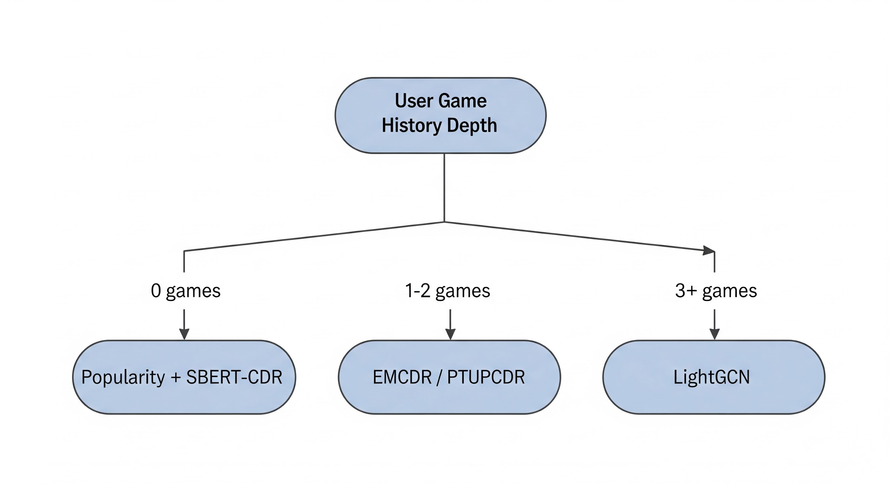

User State | Recommended Model (Base + Cooc Layer) | Justification
0 games (Cold-Start) | Popularity + SBERT-CDR | Popularity baseline tops the board; SBERT-CDR is used for content-based niche recommendations.
1–2 games (Sparse History) | EMCDR / PTUPCDR | Mapping-based CDR excels in the few-shot regime by leveraging rich movie history.
3+ games (Warm History) | LightGCN | Graph convolution dominates once sufficient in-domain target edges are available.

2. Introduction

2.1 Background and Problem Statement
Most production recommendation systems are single-domain: they recommend items based solely on a user's interaction history within that single domain. Cross-Domain Recommendation (CDR) relaxes this constraint — it transfers knowledge from a source domain (movies) to a target domain (games), which is especially valuable at cold-start: when a user has little or no target-domain history, CDR can still rank target items by leveraging their source-domain preferences.

Market Research
The entertainment industry is actively shifting from single-domain apps toward multi-domain platforms. Netflix has expanded from video streaming into mobile games, Amazon sells across every consumer category from a single storefront, and Spotify has merged music and podcast discovery into one unified feed. The industry accordingly has clear demand for multi-domain recommenders that can rank across an entire platform catalog, motivated by three measurable business outcomes — higher retention, stronger cross-sell, and happy-surprise discovery (Figure M1).
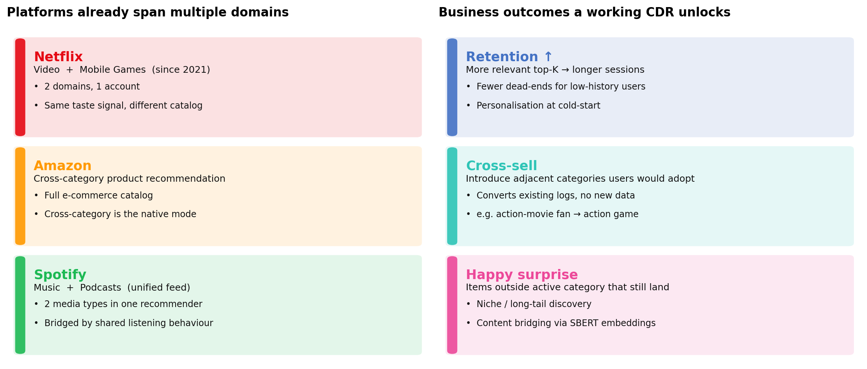
Figure M1: Platforms are already multi-domain; a working CDR converts existing logs into retention, cross-sell, and happy-surprise outcomes.

Why this matters: the limitations of traditional single domain recommender
Modern consumers engage with entertainment across multiple content categories — films, television, games, music, podcasts — often within a single session and almost always within a single platform account. Industry recommender systems, by contrast, have historically been architected on a per-domain basis: each model observes user behavior within the boundaries of its own domain and optimizes ranking against that domain alone. This is an engineering simplification, not a reflection of user behavior, and it leaves a large share of each user's observable preference signal untapped:

- Overlapping interests: action-movie fans often play action games; fantasy-film viewers often play RPGs. Single-domain models cannot use this link.
- Missed signals: source-domain behaviour (movies) is dense for most users; ignoring it throws away the best available preference data for a target-domain (games) cold-start.
- Cross-sell gap: without a cross-domain ranker, the platform cannot surface adjacent categories a user would naturally adopt.

Problem statement
We study this on movies → games as a concrete analogue of the Netflix-plus-games setting: given users who rate items in both domains, does cross-domain signal measurably improve recommendation quality over single-domain baselines, and under which conditions? The practical deliverable is a routing rule that picks the right model family per user based on target-domain history depth and target-item popularity, wrapped in a prototype that serves the rule end-to-end.
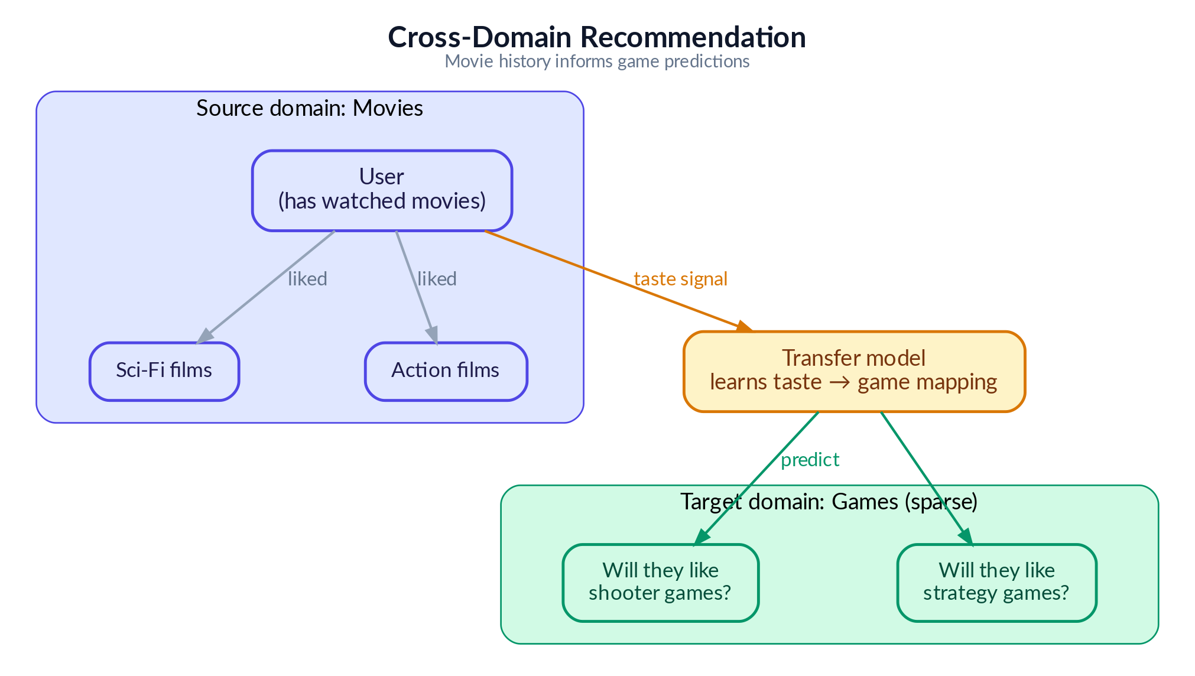
Figure 2: Cross-domain recommendation concept — transferring movie preferences to game recommendations

2.2 Research Methodology and Experiment Design
We present the experiments as a clean, progressive lesson series — but the path to this structure was far less linear. This section describes our actual research process, the challenges encountered, and how the final experiment design emerged from extensive exploratory work.

Phase 1: Model Selection and Infrastructure Setup
We began by studying the internal mechanisms of cross-domain recommendation algorithms — how models like CMF, EMCDR and PTUPCDR learn to map user preferences across domains, and how they differ from single-domain approaches like LightGCN that rely purely on within-domain interaction graphs. This informed our model selection: three CDR architectures (joint factorization, global mapping, personalized mapping), three single-domain baselines (matrix factorization, neural, graph-based) to ensure fair comparison across model families.
We picked these model algorithms to give us a systematic comparison across the three major families of recommender system architectures—single-domain, cross-domain, and content-based—and to ensure the final routing rule could cover all user states, including cold-start and niche item discovery.
Here are the rationales for choosing each set of algorithms:
Single-Domain Recommendation (SDR) Baselines:
We picked these models to cover the three major collaborative filtering paradigms, trained only on game rating data, to serve as strong competitive baselines for the Cross-Domain Recommendation (CDR) models.
- MF-BPR (Matrix Factorization with Bayesian Personalized Ranking): Chosen as a simple, well-understood, and fast-to-train baseline that captures linear feature interactions.
- NCF (Neural Collaborative Filtering): Selected to incorporate neural networks (MLPs) that can capture complex, non-linear patterns and subtle interactions that simple dot products (like in MF-BPR) cannot.
- LightGCN (Graph Convolution): Included because it consistently achieved the best single-domain performance, outperforming MF-BPR and NCF, by leveraging the full user-item interaction graph to blend neighbor's tastes (community wisdom).
Cross-Domain Recommendation (CDR):

We picked these models to cover the different ways knowledge can be transferred from the source domain (movies) to the target domain (games).
- CMF (Collective Matrix Factorization): Chosen as the simplest CDR architecture, representing joint factorization. It attempts to capture transferable traits by forcing a single, shared user profile to work for both domains.
- EMCDR (Cross-Domain Embedding Mapping): Represents a global mapping approach. It trains a single translator (a mapping network) to convert specialized movie user embeddings into game space, making it especially powerful at cold-start where a user has no game history.
- PTUPCDR (Personalized Transfer with Experts): Represents a personalized mapping approach. It enhances EMCDR by using a Mixture of Experts (MoE) architecture to provide a personalized translation rule for each user, which is highly effective in the sparse-history (few-shot) scenario.
Content-Based and Post-Processing:

These approaches were not part of the initial algorithm selection, but were discovered during Phase 4 (Discovering Complementary Approaches) of our exploratory work, proving simpler approaches yet unexpectedly powerful for specific recommendation regimes. They were subsequently included to address the known limitations of collaborative models, particularly for cold-start users and niche items.
- SBERT-CDR (Content-Based Semantic Matching): Used to assess content-based embeddings as a cross-domain bridge for niche items. We picked it because it is the only model that can recommend niche/unpopular items effectively (winning 9× over collaborative models on the bottom-50% popularity items) and works for brand-new users who have no rating history.
- Co-occurrence Reranking: Selected as a universal, training-free post-processing layer to capture obvious cross-domain behavioral patterns. It provides a model-agnostic score boost, improving every base model (5–49% lift), and successfully rescued single-domain models at cold-start.
We then built the base infrastructure: a data processing pipeline (from raw and high sparsity Amazon reviews to filtered and better-dense user’s reviews and item’s review), a standardized evaluation framework (Recall, HitRate, NDCG at K = 10), and a benchmarking harness that ensures all models are evaluated on identical data splits. All models were implemented using publicly available libraries (RecBole, RecBole-CDR, PyTorch, scikit-learn,...) to avoid re-inventing the wheel and ensure reproducibility.

Phase 2: Exploratory Benchmarking and the CDR Performance Disappointment
With the infrastructure in place, we ran extensive benchmarks comparing single-domain and cross-domain models across different data configurations. The initial results were consistently discouraging for CDR: LightGCN (a single-domain graph model) outperformed all CDR models in nearly every setting — including on user cohorts with rich movie history (>10 ratings) but sparse game history (3–5 ratings), precisely the regime where CDR is expected to excel.
We spent considerable effort trying different data configurations, different user subgroup filters, and hyperparameter settings. Unfortunately, the effort failed to increase the CDR performance. CDR models consistently failed to demonstrate a clear advantage over the single-domain baseline.
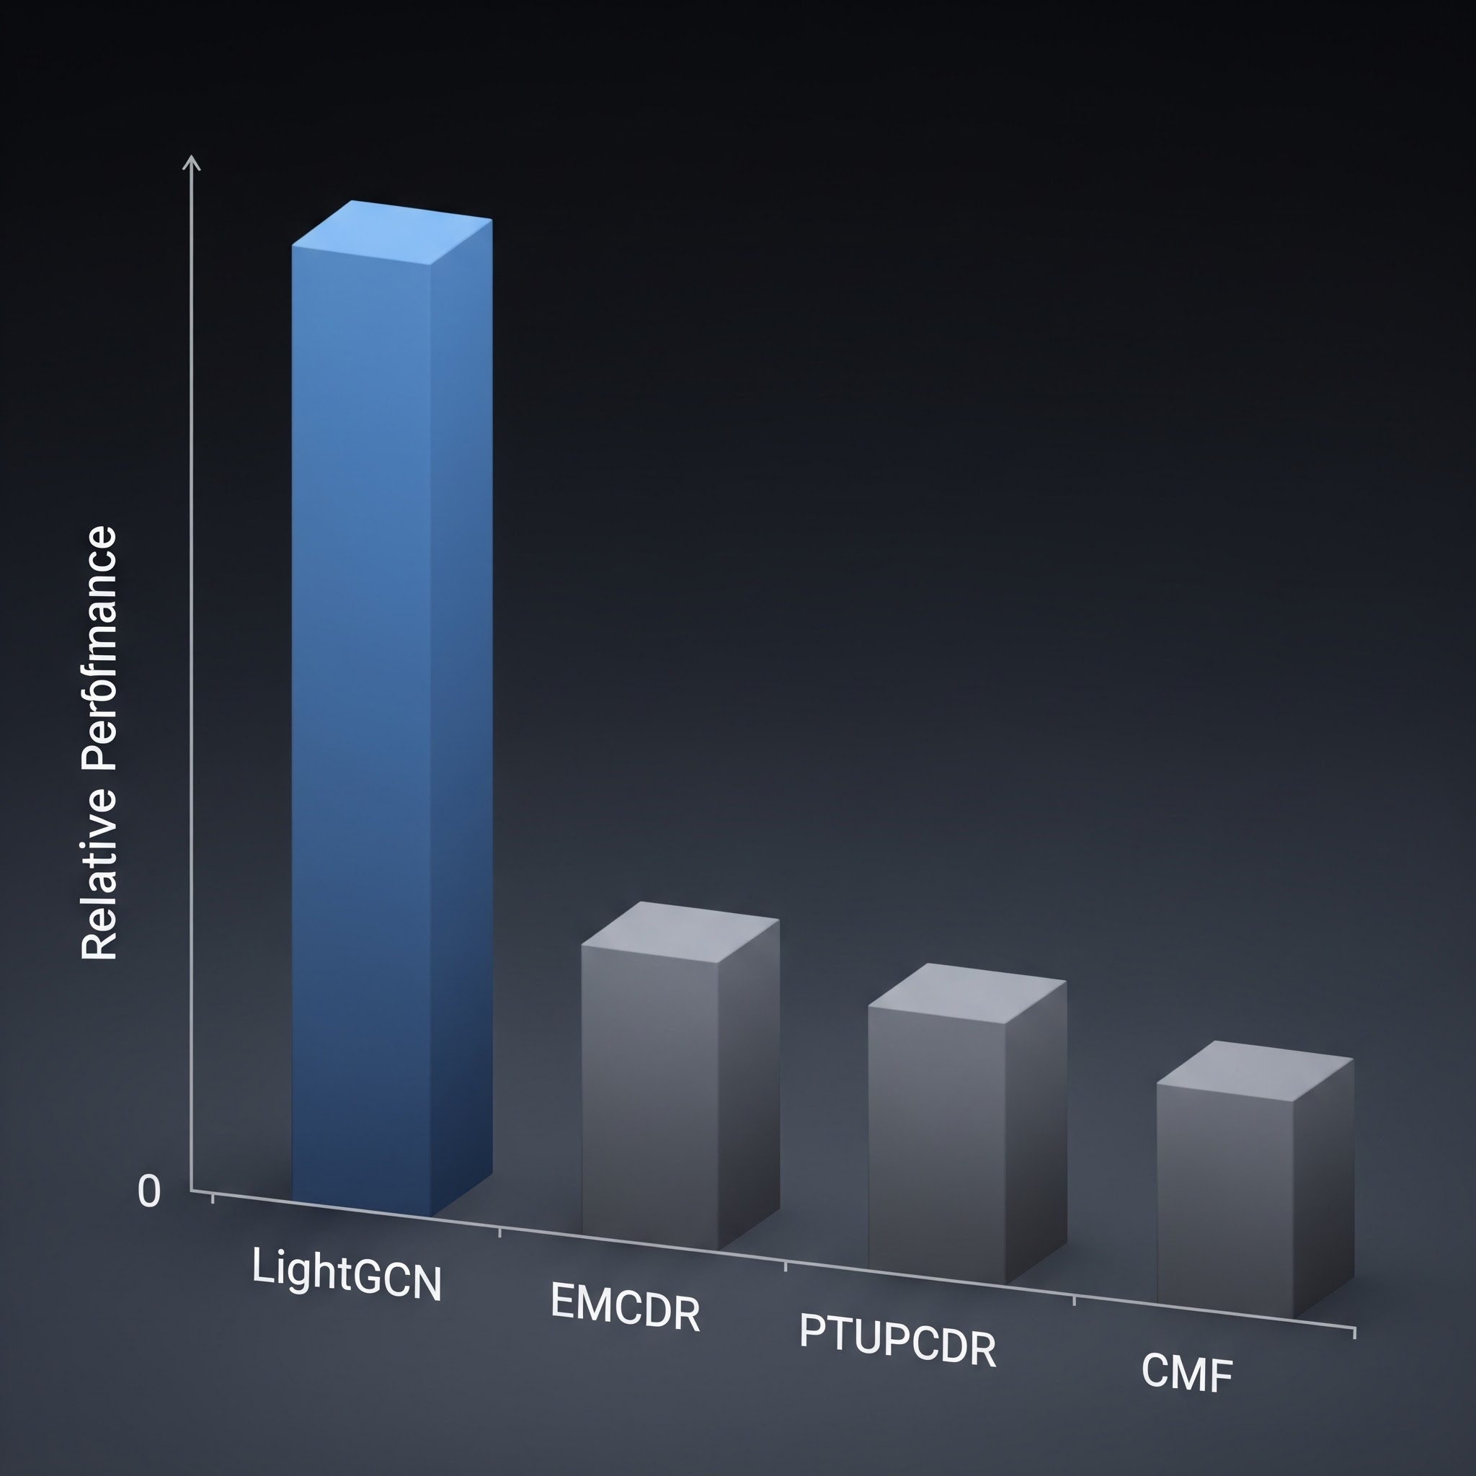
This raised a fundamental question: is the movie-to-game transfer signal in the Amazon dataset simply too weak for CDR to exploit? And to be honest, at one moment, we question whether to continue to pursue the project’s idea, because in the end, we could not conclude SDR wins CDR, this is undesirable and unexpected as many research papers have found that CDR might outperform.

Phase 3: Revisiting CDR Theory and Finding the Right Data Regime
Rather than concluding prematurely that CDR is ineffective — a conclusion contradicted by a large body of published research — we returned to the literature. Published CDR papers are evaluated under specific data conditions that we had not yet replicated: high user overlap between domains, rich source-domain history, and sparse or absent target-domain history.

Key Insight
The general-population Amazon dataset has only ~5.8% user overlap between movies and games — far too low for CDR mapping functions to learn from. Once we filtered to 100% overlap users and, crucially, tested on cold-start users with zero game history, CDR models finally outperformed their single-domain counterparts significantly. The algorithms were not broken — the data regime was wrong.

Phase 4: Discovering Complementary Approaches
Along the way, we made two additional discoveries. First, a simple content-aware recommendation approach (SBERT sentence embeddings) performed surprisingly well — matching LightGCN overall and dominating on niche/unpopular items. This clearly illustrates a simple lesson: a more sophisticated model architecture does not guarantee better recommendations, sometimes simple models win.
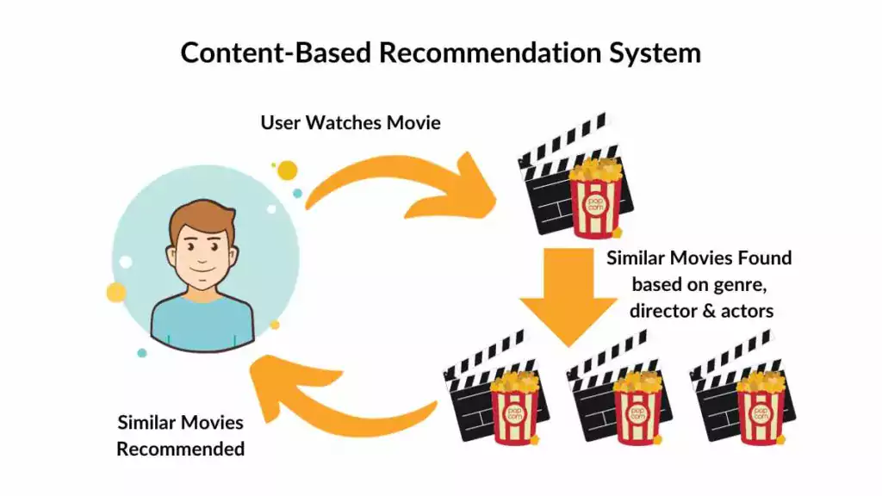
Second, we explored hybrid approaches to augment the base models. After experimenting with various score fusion strategies, we discovered that a simple reranking of game candidates based on their co-occurrence with the user's liked movies improved scores for every model universally. This cross-domain item co-occurrence reranking requires no training and works as a model-agnostic post-processing layer — another simple yet unexpectedly powerful result.

Phase 5: From Exploration to Structured Lessons
With all findings in hand, we designed the final lesson series to present our discoveries as a progressive and clear sequence. Each lesson isolates one experimental variable and builds on the previous lesson's conclusion. This structure was designed retrospectively — the actual research process involved many more experiments, several of which produced null or even negative results and thus were not included.
For example, in Lesson 5 (Source Domain Movie Sharpening), we hypothesized that removing long-tail movie items with very few ratings would produce denser, higher-quality source embeddings and improve CDR transfer. We tested more rigorous Movie genres filtering, overlap-user item filtering, and stricter movie popularity thresholds. The result was largely null — filtering hurt both single-domain LightGCN (smaller training catalog) and produced mixed results for CDR models.

Key Insight
So the exploration journey was not a linear, all happy-ending path, but a rather challenging and filled-with-roadblocks exploratory path.
In summary, our research methodology was deliberately exploratory: we ran a broad set of experiments, identified which factors genuinely drive CDR effectiveness (and which do not), and then distilled the findings into a curated lesson series that progresses from simple to complex.
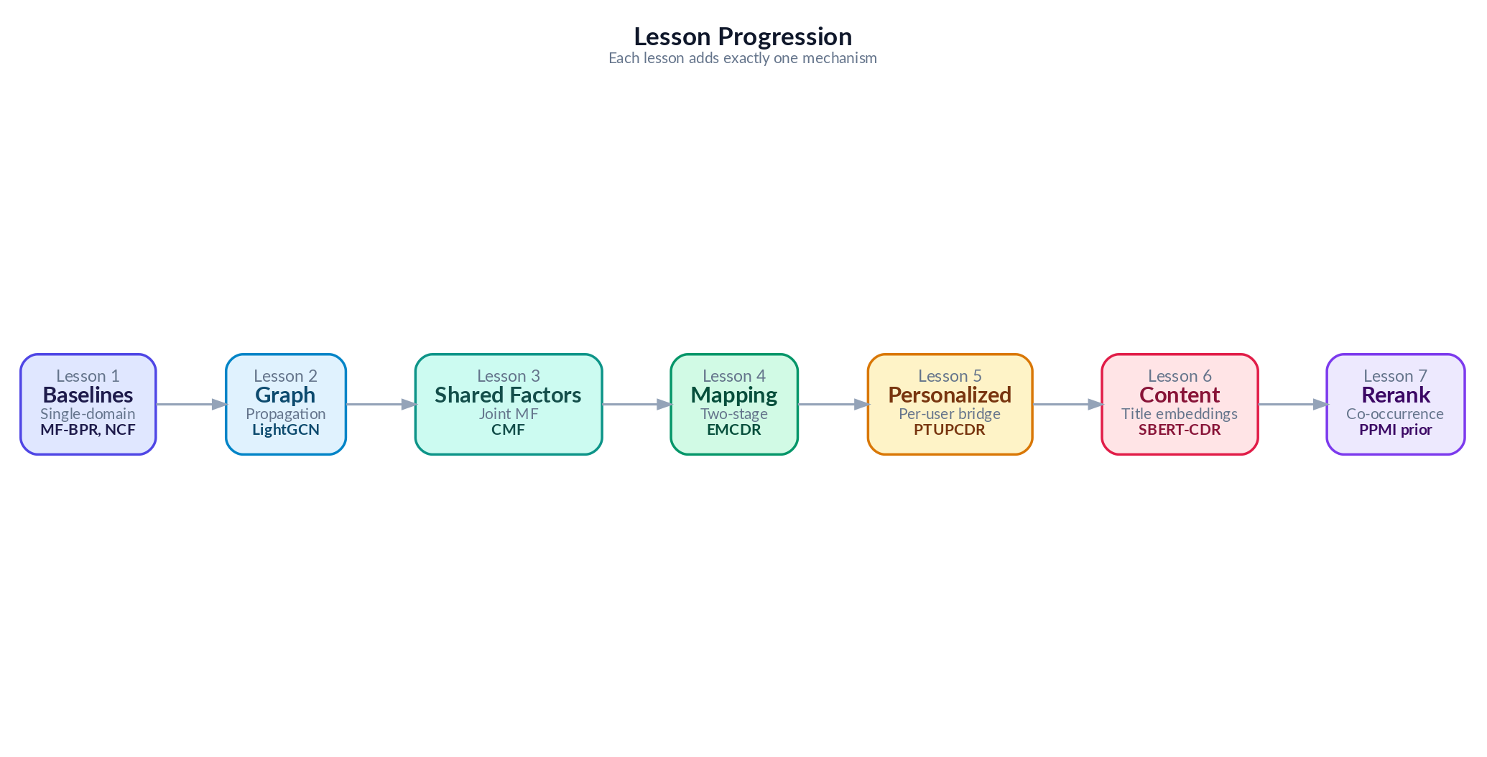
Figure 3: From Many Exploratory Experiments to 7 Curated Lessons

3. Data

3.1 Data Source
We use the Amazon Reviews 2023 dataset, a large-scale benchmark containing user reviews and ratings across multiple product categories. We focus on two domains: Movies and TV (user ratings of movies, DVDs, and streaming content) and Video Games (user ratings of video games across all platforms).

3.2 Data Pipeline
The data processing pipeline is responsible for converting the raw, sparse Amazon Reviews 2023 corpus into the standardized, dense, and implicit cohorts required for model training and evaluation.
Here is the table summarizing the key steps and their justifications:
Pipeline Step | Description/Value
Data Ingestion | Amazon Reviews 2023 dataset (Movies/TV as source, Video Games as target).  - Movie Ratings  - Game Ratings  - Movie Metadata  - Game Metadata
Data Filtering | For Game items, filter out items that are not real Games  For example:  - Xbox Gift Card, PS4 controllers… → removed
Data Merging | Merge items that are essentially same games/movies but different platforms  For example:  - The Avengers[Blue Ray] and The Avengers[Digital] -> Merge to The Avengers
Implicit Ratings Conversion | Ratings on a 1–5 star scale are converted to implicit feedback: ratings >= 4 stars are treated as positive interactions (POSITIVE_THRESHOLD = 4).
Density Filtering | Application of k-core >= 10 filtering to both items and users to increase rating density
Store In Files | Processed data stored as Parquet files for training, and final embeddings exported as NumPy arrays.
Split User Subgroups | Creation of specialized subgroups (Raw Mix, Overlap, Source-Rich, Cold Start) by applying specific filters (k-core, density, and overlap thresholds) to isolate experimental variables for lessons L1 through L7.

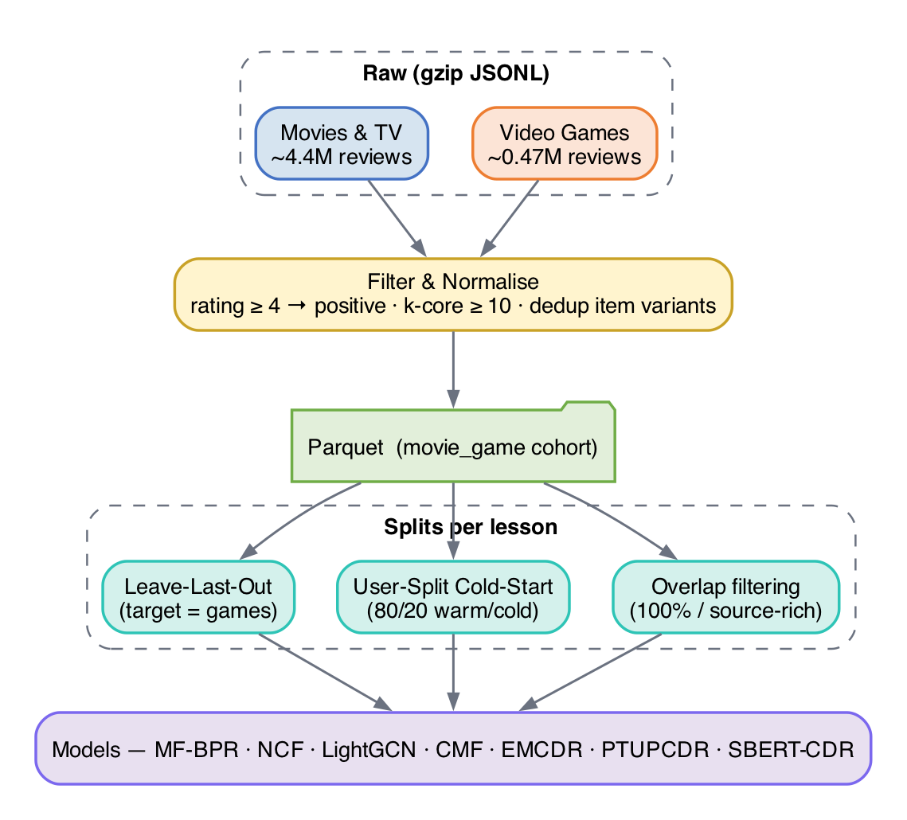
Figure 4: Data Processing Pipeline

Different lessons use different dataset configurations to isolate experimental variables:
Variant | Users | Movie Ints. | Game Ints. | Overlap % | Used in | Filter
Raw Mix | 1,000,000 | 45,933 | 11,706 | 5.2% | L1–L2 | No k-core
Overlap | 19,880 | 40,288 | 10,034 | 100% | L3 | movies≥5, games≥1
Source-Rich | 14,328 | 39,534 | 9,147 | 100% | L4,L7 | movies≥10, games≥1
Sharp | 14,328 | 10,311 | 9,147 | 99.8% | L5 | movie pop≥10
Cold Start | 12,654 | 40,288 | 10,034 | 100% | L6 | User split 80/20

3.3 Data Train/Test Splitting Protocol
Leave-last-out(LLO)
The figure below visualises the LLO split: for every user, the most recent interaction is held out as the test item and everything earlier is used for training.
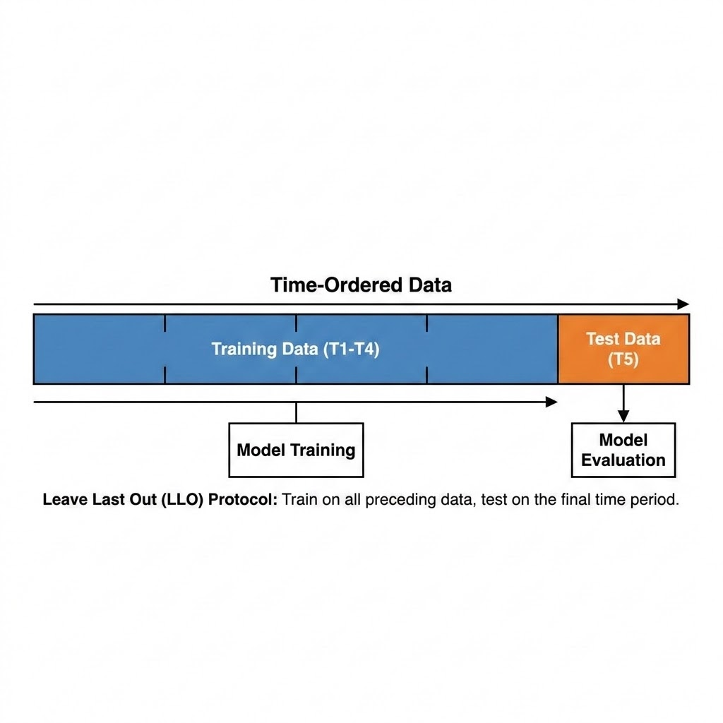
We use leave-last-out (LLO) splitting on the target domain (games): for each user, the last game interaction by timestamp becomes the test item, the second-to-last becomes the validation item, and all earlier interactions from the training set. This simulates a realistic next-item prediction scenario.
Figure 5.1: Data Splitting Visualization — Leave-Last-Out (LLO)
User-Split cold start protocol
For Lesson 6 (cold-start), we use a user-split protocol: 80% of users train with their full movie and game history, while 20% of users have their game history withheld entirely, testing whether their movie history alone can generate useful game recommendations
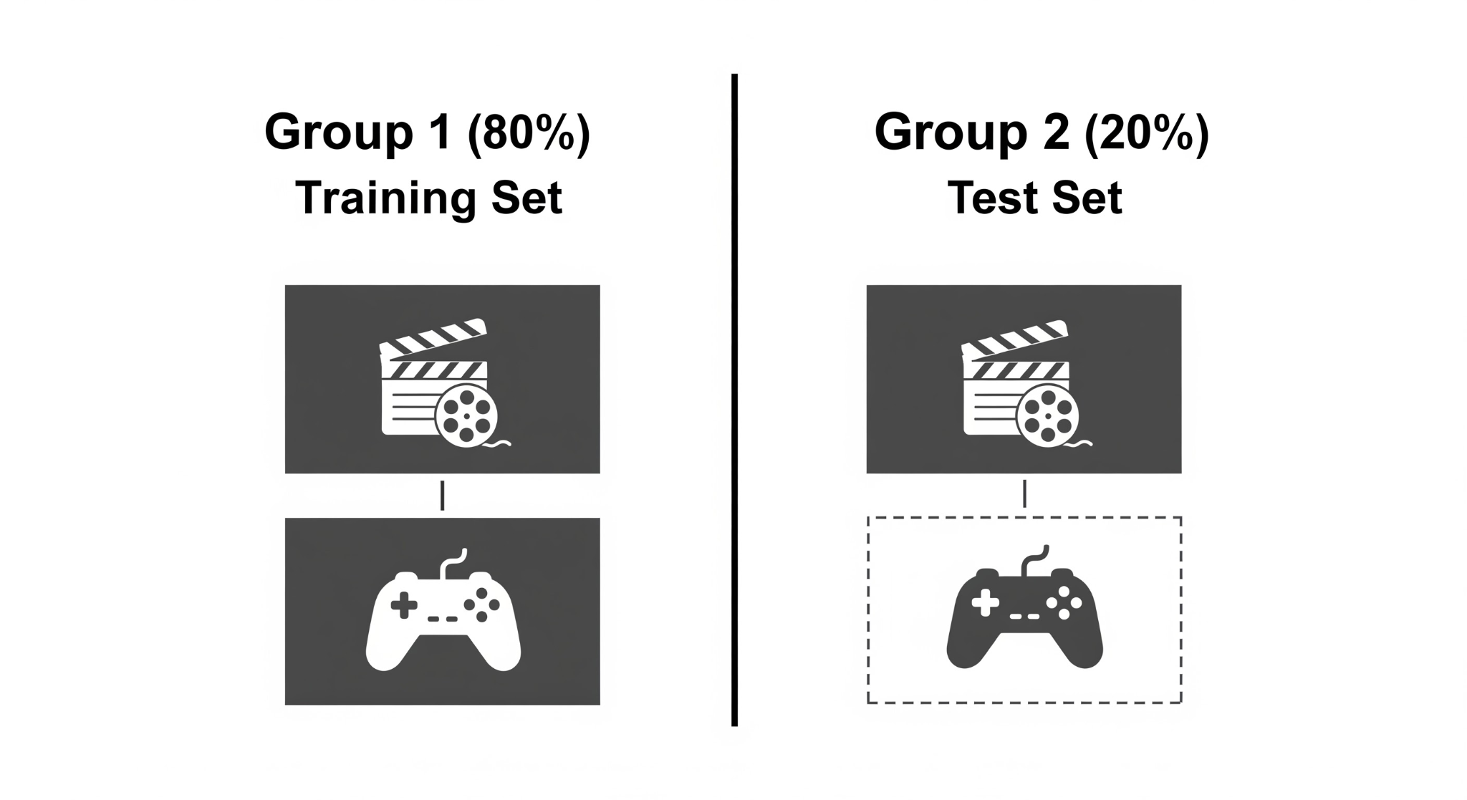
Figure 5.1: Data Splitting Visualization — Cold-Start User-Split

4. Methodology
This section explains every model we evaluate, starting from the simplest and building up to the most sophisticated. We assume no prior knowledge of recommendation systems — each model is introduced with an everyday analogy, then its mechanism and math are explained step by step. We group models into three families: single-domain models (trained on game data only), cross-domain models (trained on both movie and game data), and content-based models (using text descriptions rather than ratings).
Meet Maya. To make the progression easy to follow, every model in this chapter is illustrated through one running story about “Maya,” who runs a small neighbourhood rental shop called “Maya’s Corner” that lends out both movies and video games. Maya’s goal is to recommend the right games to her patrons — including the many who have only ever rented movies. Each algorithm in this chapter is a new tool Maya adopts to do that job better, and each analogy explains exactly what problem the previous tool left unsolved. Read the analogies in order and you will see a clear line from the simplest possible approach to the full cross-domain system we benchmark in this report.

4.1 Evaluation Protocol
To define the quality of the recommendations, we must first establish the difficulty of the retrieval task. The evaluation protocol measures how precisely a model can identify the single correct target item within the entire catalog. We utilize a full-rank evaluation protocol that requires the model to pick the correct answer from the complete catalog of approximately 9,000 items — akin to locating one specific needle in a massive haystack. All metrics are reported at K=10.
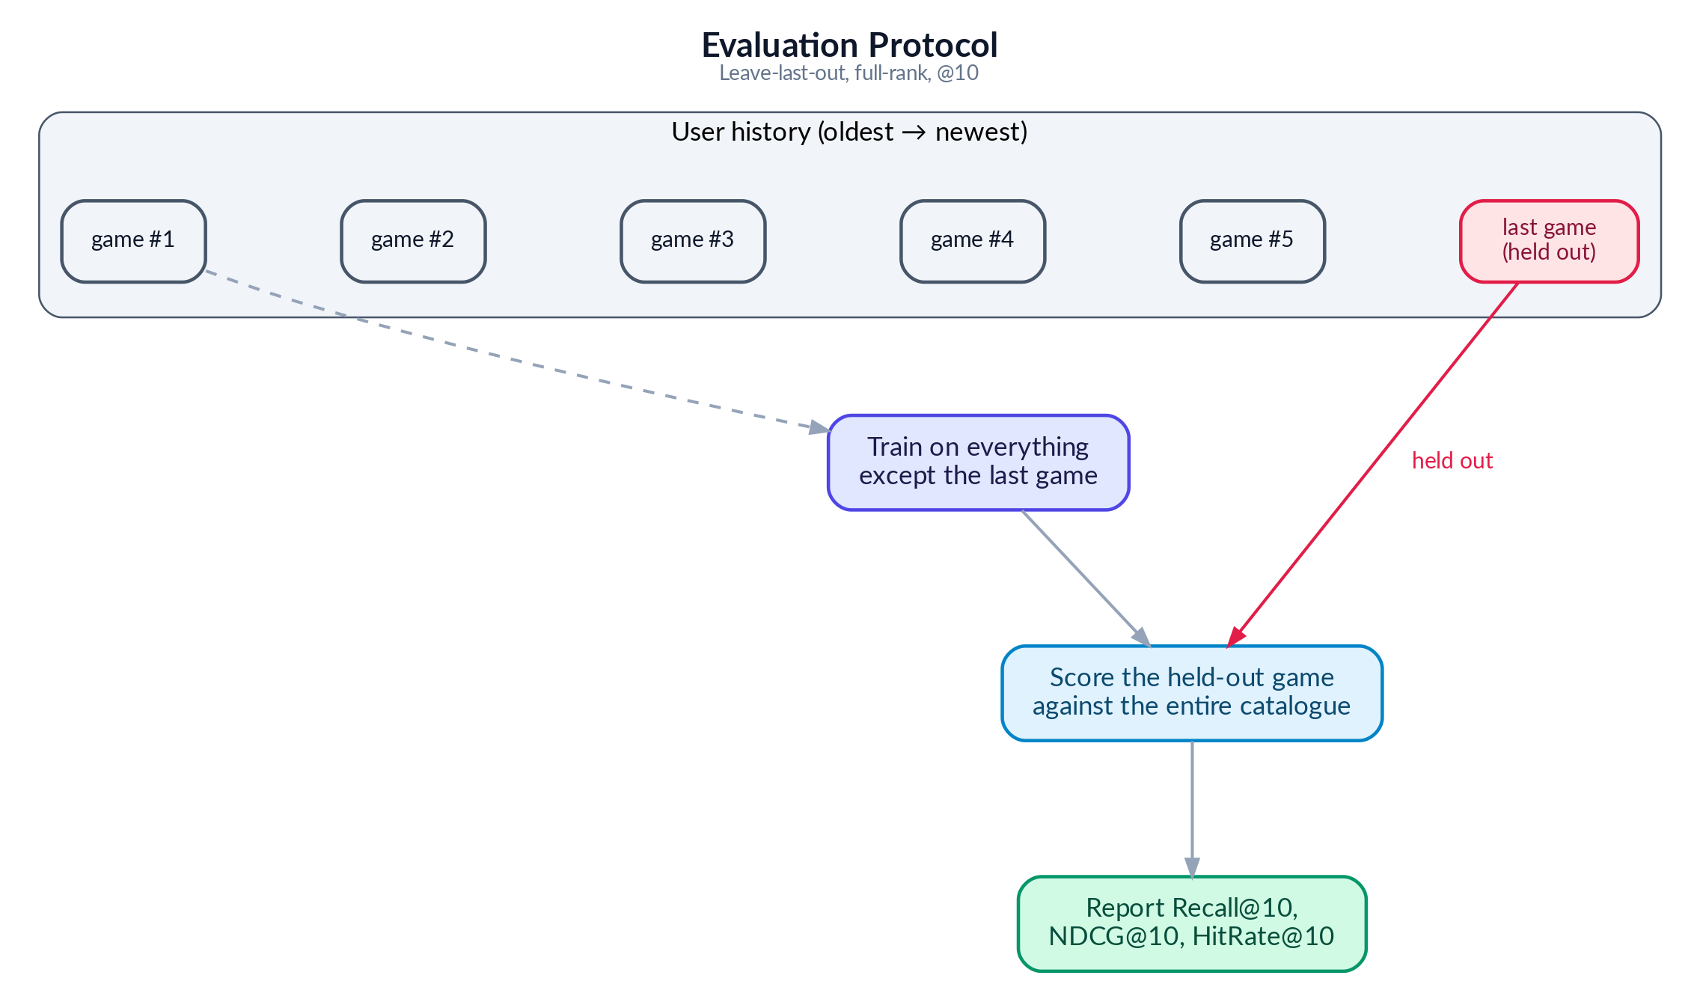
Figure 5: Evaluation Protocol

Recall@10 asks: did the correct item appear anywhere in the top 10? The ranking of the item is not important
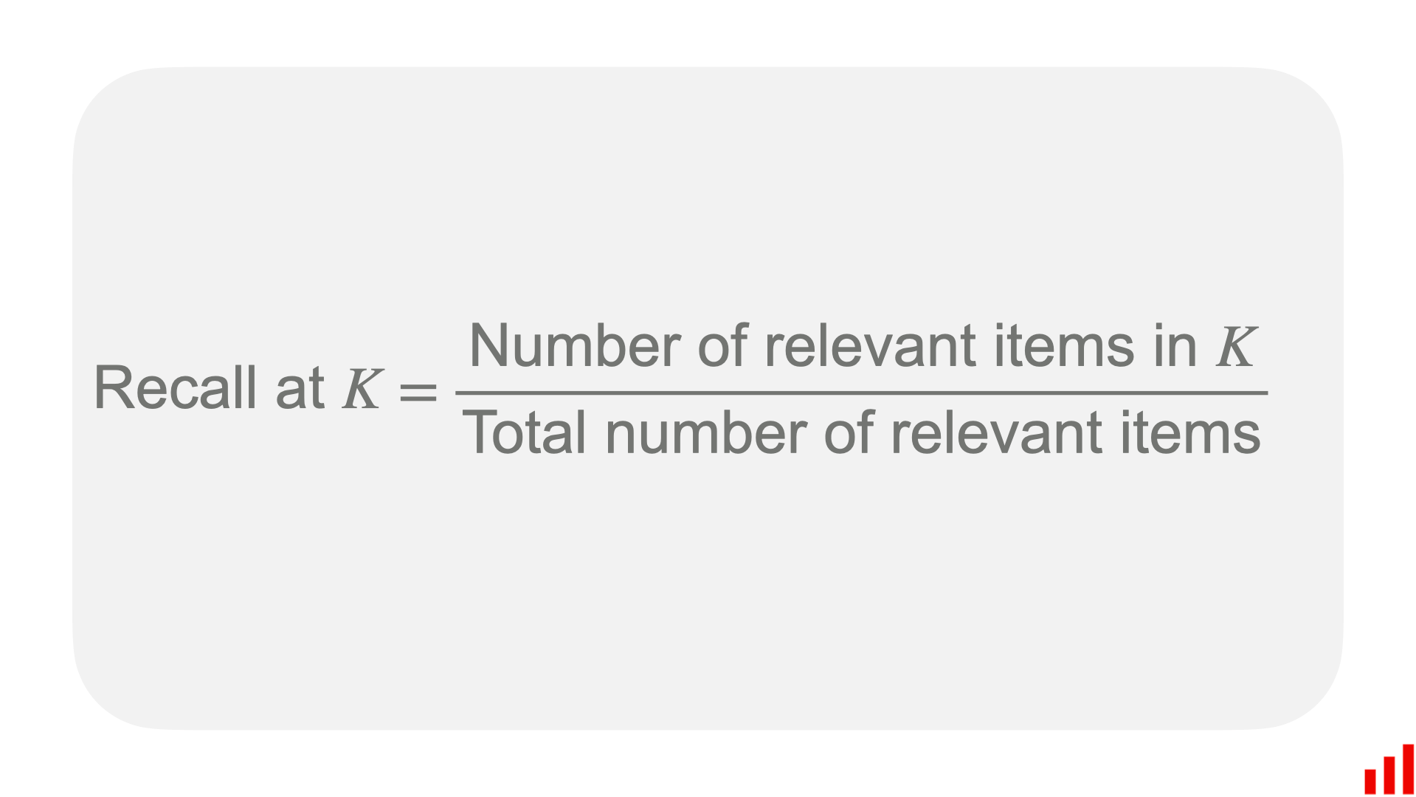
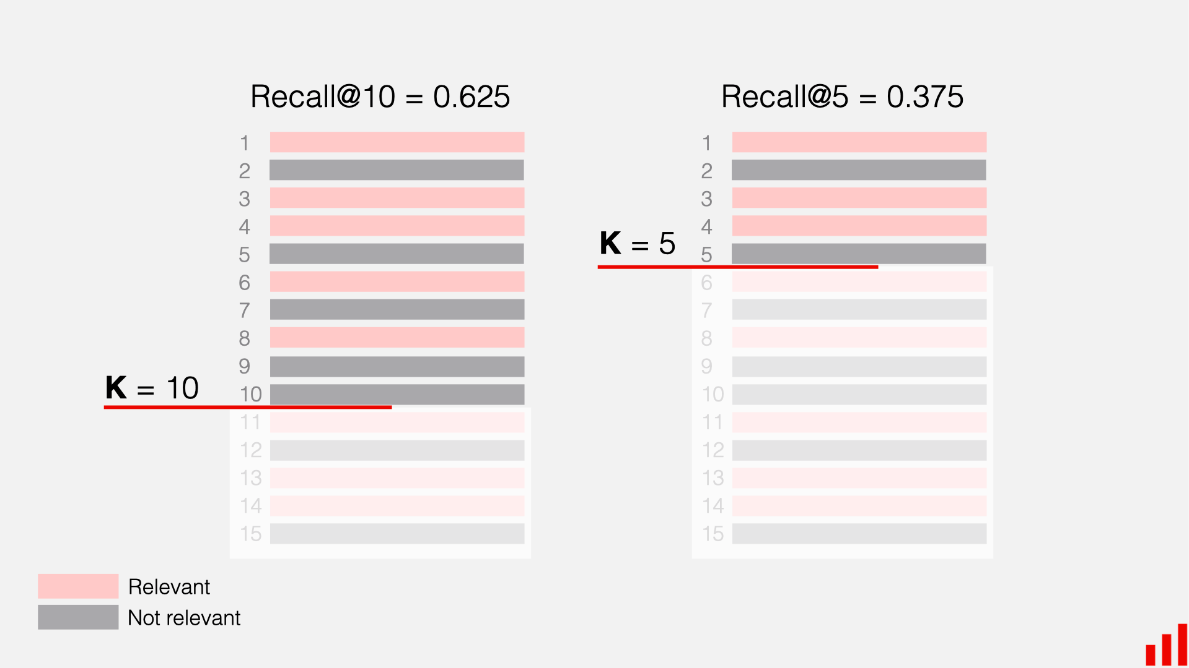
NDCG@10 goes further: was it ranked first (best), third (okay), or tenth (barely made it)? Higher positions earn more credit. Its mechanism assigns a score based on the item's position, using a logarithmic discount factor to heavily penalize lower-ranked correct items.
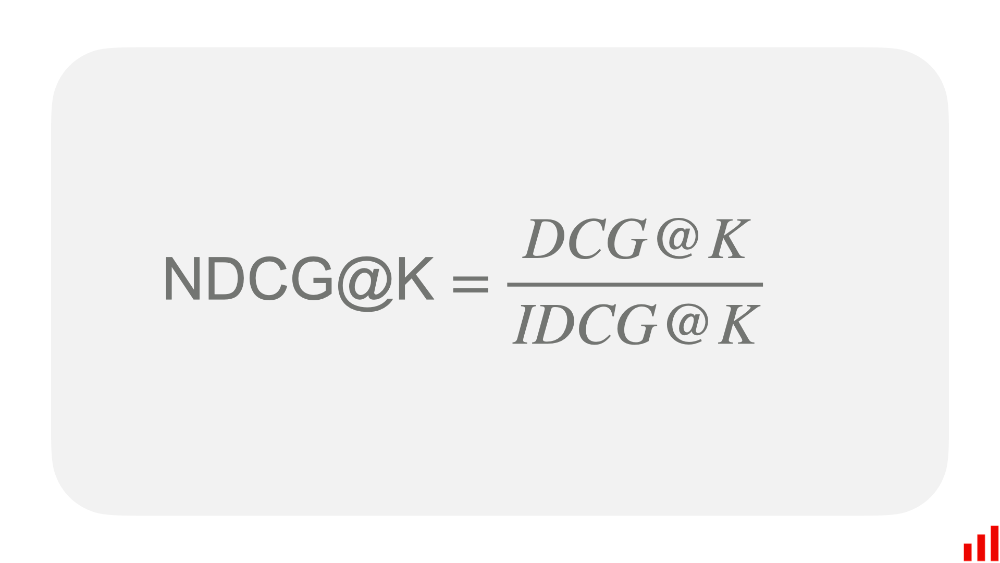
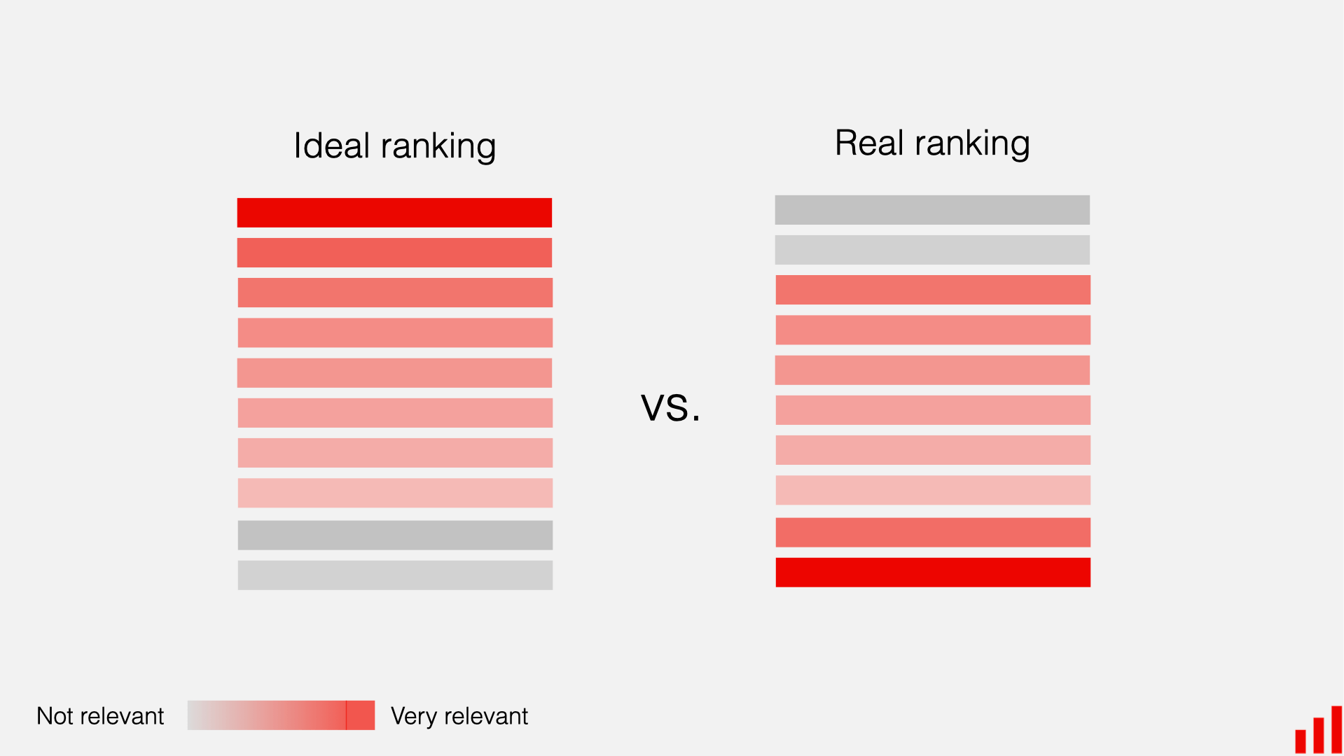

4.2 Single Domain Models
Single-Domain Models
The following three models are trained using game rating data only. They have no access to movie preferences. Think of them as specialists: they only know about games and recommend games based on what similar gamers have played.

4.2.1 MF-BPR: Matrix Factorization with Bayesian Personalized Ranking
Analogy — The Notebook Method.
On her first day, Maya starts simple. For every patron and every game on her shelf she scribbles a small “taste card” — 64 numbers that try to capture things like “likes fast pace,” “prefers dark tone,” or “enjoys puzzles.” To decide whether a patron will like a game, Maya just lines up the two cards side by side and multiplies them number by number. If the totals add up high, it is probably a good match. The cards themselves are not handed to Maya — she learns them over time by watching which games each patron actually rented. This simple notebook already works surprisingly well, but the only way it can ever compare two cards is straight multiplication, so it misses any taste that needs a more subtle combination of traits..

MF-BPR: Architecture
Each user u and item i has a single learnable 64-dim vector, uᵤ, vᵢ ∈ ℝ⁶⁴. The score for a (u, i) pair is the dot product s(u, i) = uᵤ · vᵢ. All parameters live in two matrices U ∈ ℝ^(|𝒰|×64) and V ∈ ℝ^(|ℐ|×64).

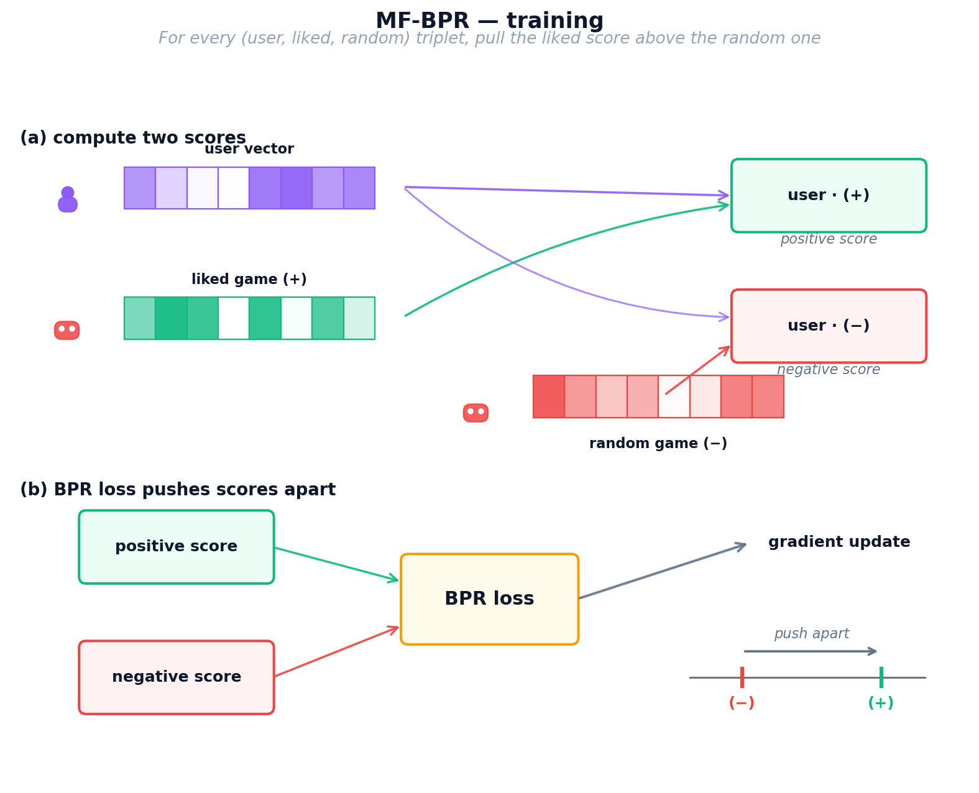
Figure 6: MF-BPR training process — user and item vectors learn from triplet sampling with BPR loss

MF-BPR: Training
We train for multiple epochs on sampled triplets (u, i⁺, i⁻), where i⁺ is an item rated ≥ 4 by u and i⁻ is a uniformly sampled unobserved item. The BPR loss (Equation 1) maximizes the margin uᵤ · vᵢ⁺ − uᵤ · vᵢ⁻ through a log-sigmoid, with L2 regularisation λ.
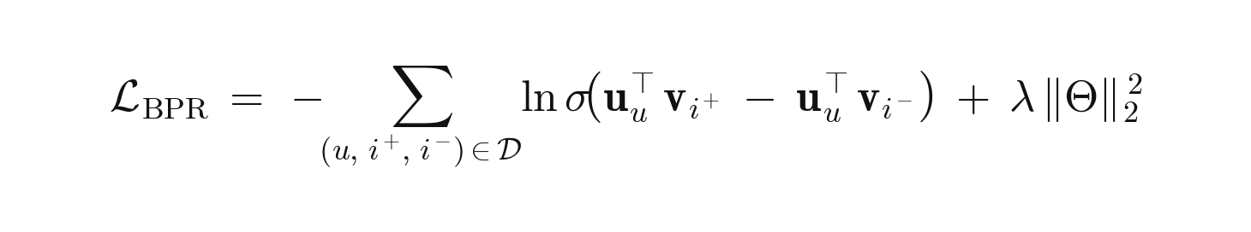
Equation 1: MF-BPR pairwise ranking loss.
where 𝒟 is the set of training triplets (u, i⁺, i⁻); uᵤ, vᵢ ∈ ℝ⁶⁴ are the learnable user/item vectors; σ(·) is the logistic sigmoid; Θ = {U, V} collects all parameters; λ is the L2 strength

MF-BPR: Inference
At inference, the scores for user u over the whole catalogue are sᵤ = uᵤ Vᵀ ∈ ℝ^|ℐ|; we return the top-K items. Artifacts are User’s and Item’s 64-dim embeddings.
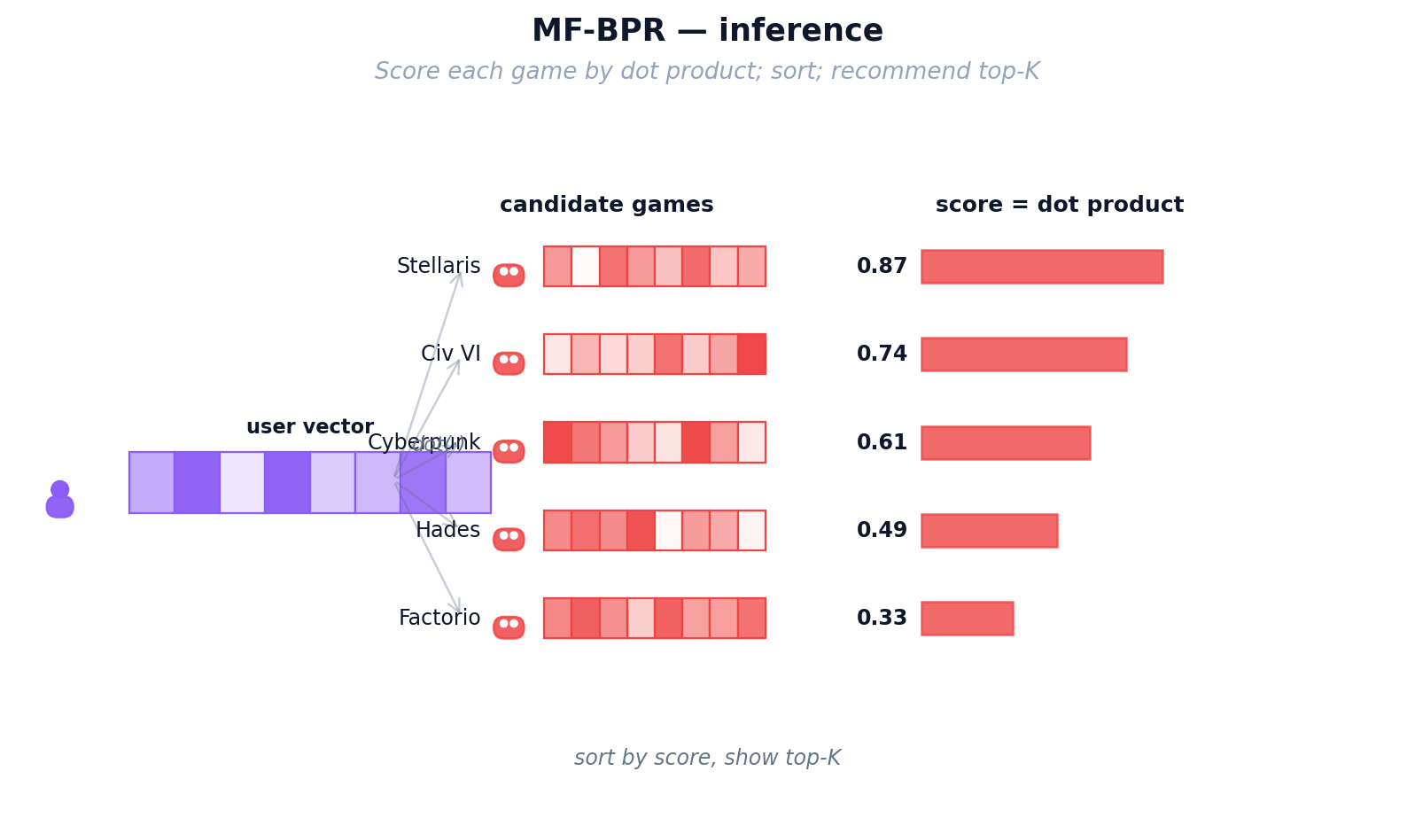
Figure 7: MF-BPR inference — dot product between user and item vectors produces ranking scores
Strengths: Simple, fast (≈2 min), a strong baseline.
Weaknesses: Every user and item is treated in isolation — no structural prior — and a user without a learned row cannot be scored (no cold-start support).

4.2.2 NCF (NeuMF): Neural Collaborative Filtering
Analogy — Maya Hires an Apprentice.
After a few months, Maya notices her notebook method keeps missing oddly specific tastes — some patrons love “cozy horror,” a combination no single number on the card captures on its own. Straight multiplication just cannot express “like this trait AND that trait, but only together.” So Maya hires a young apprentice (a small neural network) whose only job is to look at a patron’s card and a game’s card and use intuition to combine them in non-linear ways. She still keeps her original multiplication trick as a reliable baseline and lets the apprentice add a layer of judgement on top. Now Maya catches the subtle interactions her notebook missed — but her recommendations still only know what each individual patron has personally rented.

NCF (NeuMF): Architecture
NCF fuses two parallel branches over four independent 64-dim embedding tables (GMF-user, GMF-item, MLP-user, MLP-item). The two branch outputs are concatenated and passed through a sigmoid to produce ŷ ∈ (0, 1).
1. GMF branch. Element-wise product uᵤᴳᴹᶠ ⊙ vᵢᴳᴹᶠ → 64-dim. Equivalent to a matrix factorisation with per-dimension weights.
2. MLP branch. Concatenates uᵤᴹᴸᴾ and vᵢᴹᴸᴾ into a 128-dim input, then passes through ReLU layers 128 → 64 → 32. The non-linearity captures patterns a single dot product cannot.
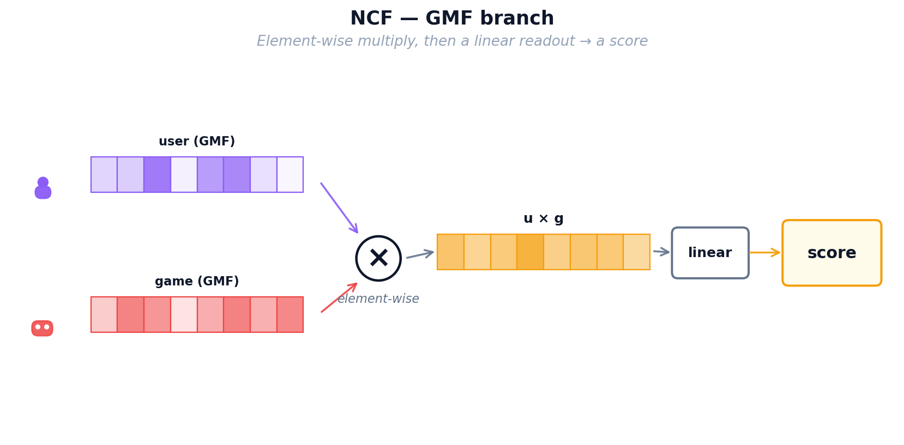
Figure 9: NCF — MLP branch: neural network layers learn non-linear user-item patterns
3. Fusion. Concatenate the GMF (64-dim) and MLP (32-dim) outputs, then apply a final linear layer with sigmoid activation to produce ŷ ∈ (0, 1).
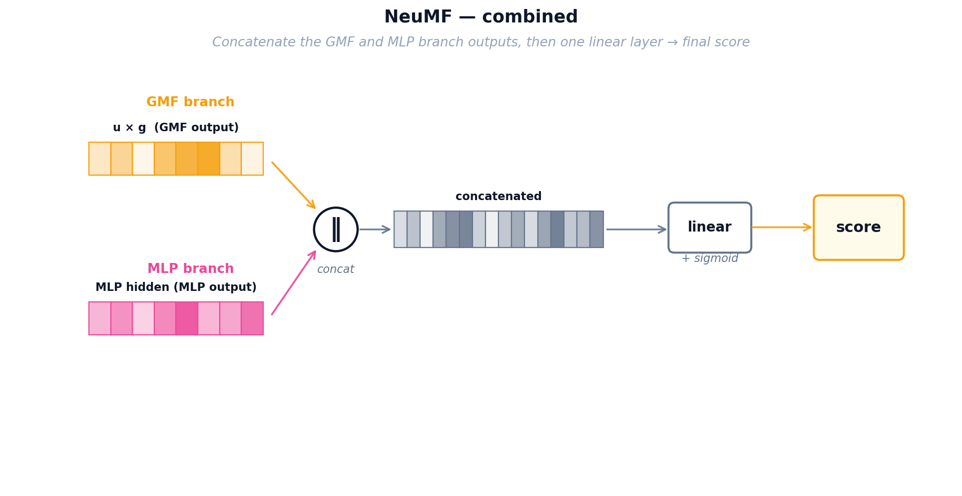
Figure 10: NCF — combined NeuMF architecture merging both branches into a final score

NCF (NeuMF): Training
NCF minimizes binary cross-entropy (Equation 2) over observed pairs (y = 1) and uniformly sampled negatives (y = 0).
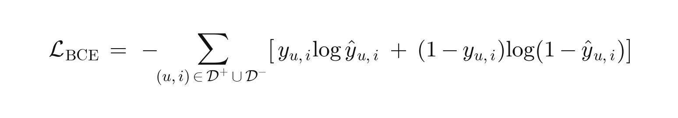
Equation 2: NCF binary cross-entropy loss on observed positives and sampled negatives.
where 𝒟⁺ is the observed-interaction set (y_{u,i} = 1) and 𝒟⁻ a same-size set of uniformly sampled negatives (y_{u,i} = 0); ŷ_{u,i} ∈ (0, 1) is the NeuMF sigmoid output from the fused GMF + MLP representation. A confident wrong prediction — e.g. ŷ = 0.9 on a true negative — contributes −log(0.1) ≈ 2.3 to the loss.

NCF (NeuMF): Inference
Scoring any (u, i) requires a forward pass through the fused network — there is no single matrix multiply. NCF is therefore slower than MF-BPR at inference but more expressive.

4.2.3 LightGCN: Graph Convolution for Recommendations
Analogy — The Shop Gossip Network.
Maya now realises her patrons are not isolated — they influence each other. Alice loved Zelda and also loved Witcher; Bob just loved Witcher; odds are Bob will enjoy Zelda too, even though he has never heard of it. Instead of looking only at each patron’s own rental history, Maya pins up a big gossip board that connects every patron to every game they rented and every game to every patron who rented it. Taste now flows along these lines: each patron’s card gets gently blended with the cards of their neighbours, and then the neighbours-of-neighbours, so the cards carry community wisdom rather than one person’s history. Maya’s three tools so far (notebook, apprentice, gossip board) all share one limitation though: they only know about GAMES. A patron who has only ever rented movies is still invisible to them.

LightGCN: Graph Architecture
Users and items form a bipartite graph where each interaction creates an edge. LightGCN initializes random 96-dimensional embeddings for every node, then propagates information through the graph in K=3 rounds ("hops"). In each hop, a node's embedding is updated to be the weighted average of its neighbors' embeddings, with weights normalized by the square root of both nodes' degrees to prevent popular items from dominating.
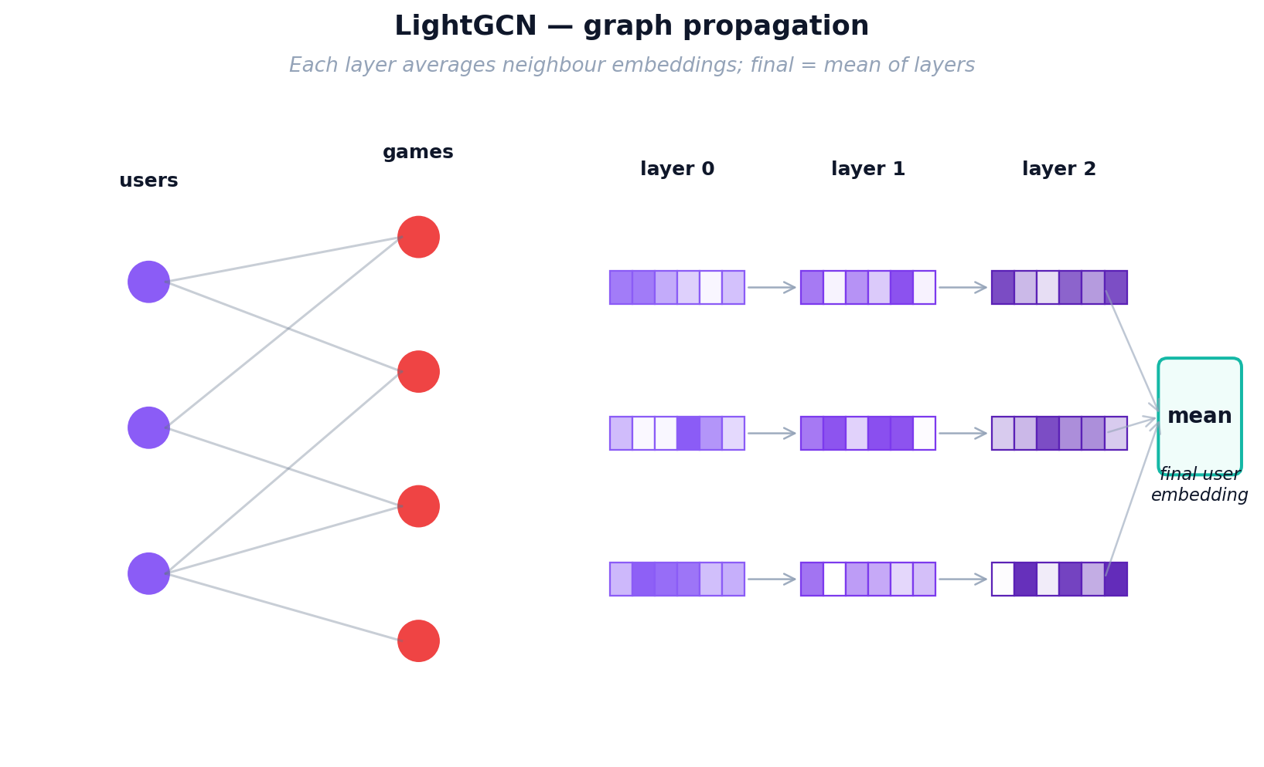
Figure 11: LightGCN graph propagation — information flows through multi-hop user-item connections
After K hops, each node has K+1 representations (from layer 0 to layer K). The final embedding is the simple mean of all layer representations. This layer-combination trick is critical: layer 0 captures the node itself, layer 1 captures direct neighbors, layer 2 captures 2-hop neighbors, and layer 3 captures 3-hop patterns. Averaging them balances local and global signals.

LightGCN: Training
LightGCN uses the same BPR loss as MF-BPR (positive items should score higher than random negatives), but the embeddings are first refined through graph propagation. In each training step: (1) sample a (user, positive, negative) triplet, (2) run K=3 layers of graph convolution to get refined embeddings, (3) compute dot-product scores, (4) compute BPR loss, (5) backpropagate gradients through all K layers back to the base embeddings. Only the base layer-0 embeddings are learnable; all propagation layers are parameter-free. This simplicity (no transformation matrices, no activation functions) is what makes LightGCN outperform more complex GCN variants.
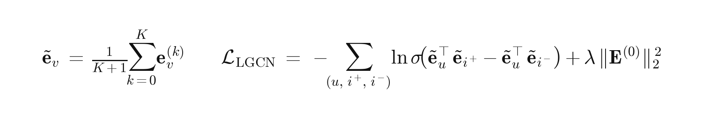
Equation 3: LightGCN layer-combined embeddings and BPR loss.
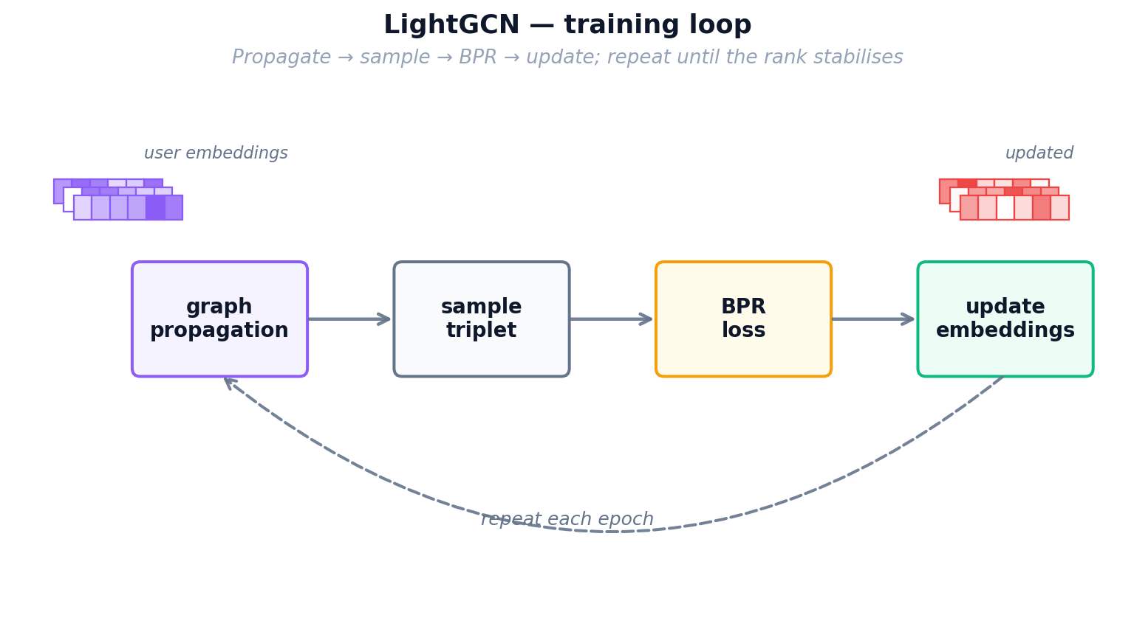
Figure 12: LightGCN training loop — graph propagation followed by BPR loss optimization

LightGCN: Inference
After training, we pre-compute the final embeddings for all users and items by running the full K-layer propagation once. Inference is identical to MF-BPR: a single dot product between the user's final embedding and all item embeddings, then rank by score.

4.3 Cross Domain Models
Cross-Domain Models
The following three models are trained using both movie and game data. They attempt to transfer knowledge from the movie domain to the game domain. Think of them as translators: they try to convert what they know about a user's movie taste into game recommendations. This is especially valuable for "cold-start" users who have watched movies but never played games.

4.3.1 CMF: Collective Matrix Factorization
Analogy — One Shared Customer Card.
Maya now faces her real problem: she wants to recommend games to movie-only patrons, but her movie ledger and her game ledger were always kept as two separate notebooks that never talked to each other. Her first attempt to bridge them is the simplest thing possible: throw away the two patron notebooks and keep ONE single taste card per patron that has to work for both sides of the shop. Whenever Maya learns something from a movie rental, she updates the same card she uses for games, and vice versa. This forces the card to capture traits that genuinely transfer — an “action lover” card now helps with both Die Hard and Doom. The downside is that cramming two very different worlds into one card waters each of them down: the shared profile can never specialise as deeply as a game-only or movie-only card could.

CMF Architecture
Shared user matrix. CMF keeps one user matrix U ∈ ℝ^(|𝒰|×96) shared by both domains, plus domain-specific item matrices Vᴹ ∈ ℝ^(|ℐᴹ|×96) for movies and Vᴳ ∈ ℝ^(|ℐᴳ|×96) for games. Every user has exactly one 96-dim vector used in both domains.
Item matrices stay private. Vᴹ receives only movie gradients, Vᴳ only game gradients; the shared U is therefore the sole transfer channel between the two domains.
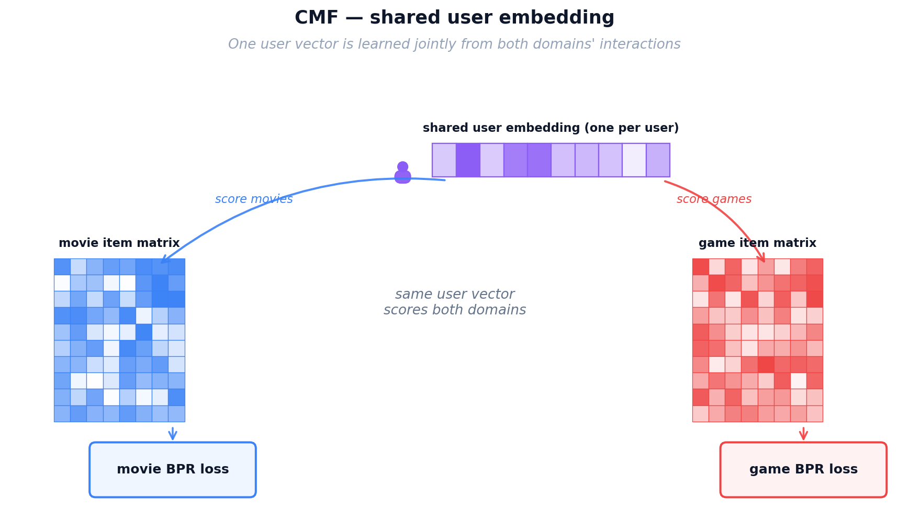

CMF Training
Sampling. Each step draws one BPR triplet per domain: (u, iᴹ⁺, iᴹ⁻) and (u, iᴳ⁺, iᴳ⁻) with uniform negatives. Users present in only one domain still contribute — their row of U is pulled by that domain's triplets alone.
Joint objective. The total loss is a convex combination of the two per-domain BPR terms sharing U (Equation 4). α ∈ [0, 1] trades movie signal (α → 1) for game signal (α → 0); our default is α = 0.5.

Equation 4: CMF joint two-domain loss with shared user matrix U.
where U is the shared user matrix; Vᴹ, Vᴳ are the domain-specific item matrices; L_BPRᴹ, L_BPRᴳ are the per-domain BPR losses (same form as Equation 1); α ∈ [0, 1] balances the two domains; Θ = {U, Vᴹ, Vᴳ}; λ is the L2 strength.

CMF Inference
Artifacts: U, Vᴹ, Vᴳ. For user u and game g, score(u, g) = uᵤ · v_g — identical to MF-BPR. Vᴹ is never touched at inference; it has done its job by shaping U during training. A cold-start game user with movie history still gets useful scores because uᵤ carries movie-derived signal.
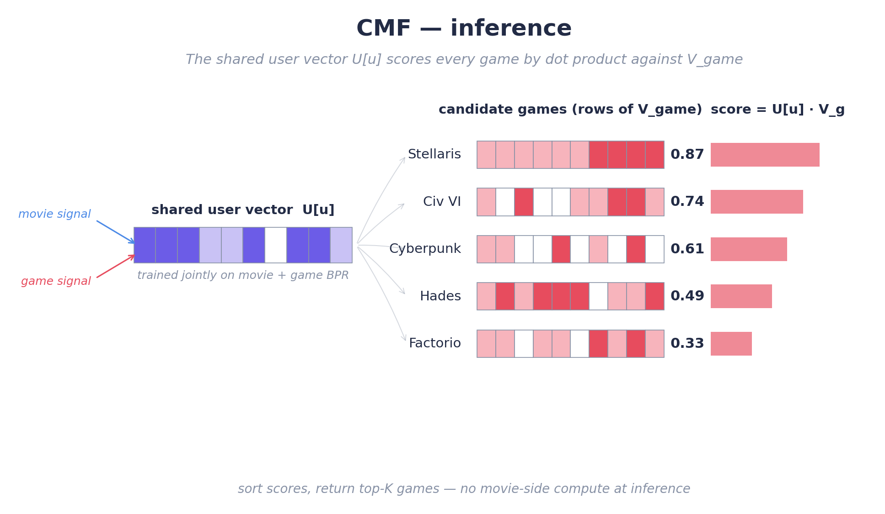
Figure 13b: CMF inference — the shared user vector scores every game by dot product against V_game.

CMF Limitations
The shared uᵤ is a compromise vector that must serve both domains and is therefore mediocre at each. In our experiments CMF produces the weakest CDR transfer — especially at cold-start, where uᵤ has been shaped almost entirely by movie data (≈95% of interactions).

4.3.2 EMCDR: Cross-Domain Embedding Mapping
Analogy — Maya Hires a Translator.
CMF taught Maya that one shared card sacrifices too much specialization. Her next idea is better: keep the two specialized notebooks (one perfectly tuned for movies, one perfectly tuned for games), then hire a translator who converts between them. For every patron who has rented in BOTH domains — the overlap customers — Maya can see the same person’s movie card AND their game card, so she can teach the translator: “when the movie card looks like this, the matching game card looks like that.” Once trained, the translator lets Maya take a movie-only patron’s card and translate it straight into a game-side card, so she can recommend games as if they had always been a game patron. This is a big leap over CMF because neither specialized card had to compromise. The weak spot is that Maya only hires one translator, and that one translator must use the same rules for every single patron.

EMCDR Architecture
Two independent spaces. EMCDR trains one MF-BPR per domain: Uᴹ, Vᴹ for movies and Uᴳ, Vᴳ for games. The same user occupies both Uᴹ and Uᴳ as two unrelated 64-dim vectors (uᵤᴹ ≠ uᵤᴳ).
A learned translator. A small MLP f_θ with two hidden layers of width 128 and ReLU maps movie-space to game-space: f_θ(uᵤᴹ) ≈ uᵤᴳ. Once fit, any user with a movie-side vector — including cold-start users — can be scored against Vᴳ.
Supervised by overlap. f_θ is trained only on overlap users 𝒰ₒ = {u : u has interactions in both domains}. In our data |𝒰ₒ| = 19,880 — without overlap the translator has no signal.
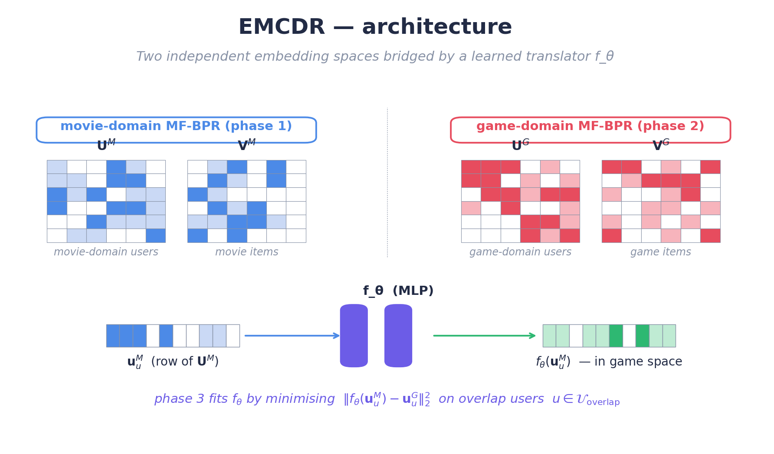
Figure 14a: EMCDR architecture — two independent MF-BPR spaces bridged by the learned translator fθ.

EMCDR Training
Training proceeds in three sequential phases:
Phase 1 — movie MF-BPR. Train MF-BPR on movies for 20 epochs to get U^{M} and V^{M} (64-dim each).
Phase 2 — game MF-BPR. Independently train a second MF-BPR on games for 20 epochs to get U^{G} and V^{G}. No parameters are shared with Phase 1.
Phase 3 — fit the translator. Freeze both MF-BPR models. Using the overlap users only, fit f_{θ} to regress u_{u}^{G} from u_{u}^{M} with the MSE loss in Equation 5. Adam, lr = 1e-3, 200 epochs, early stopping on a 10% overlap-user validation split.
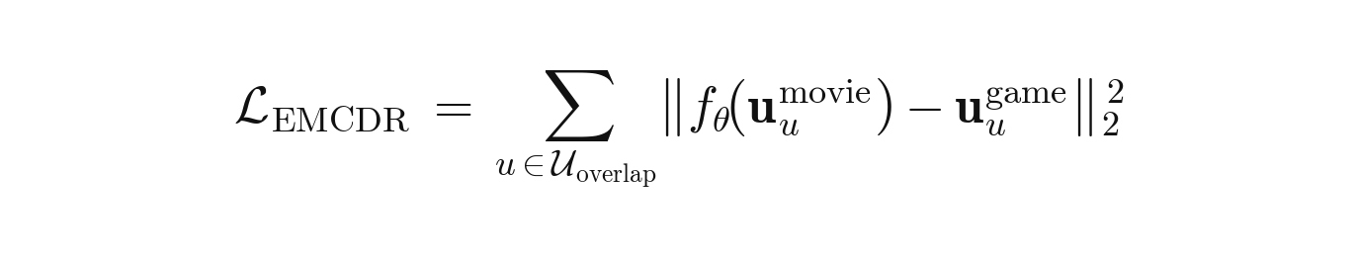
Equation 5: EMCDR phase-3 mapping loss (MSE on overlap users).
where 𝒰ₒ is the set of overlap users; uᵤᴹ, uᵤᴳ are the user embeddings learned independently in Phases 1 and 2; f_θ is the MLP translator fit in Phase 3 by regressing the game-side vector from the movie-side vector.
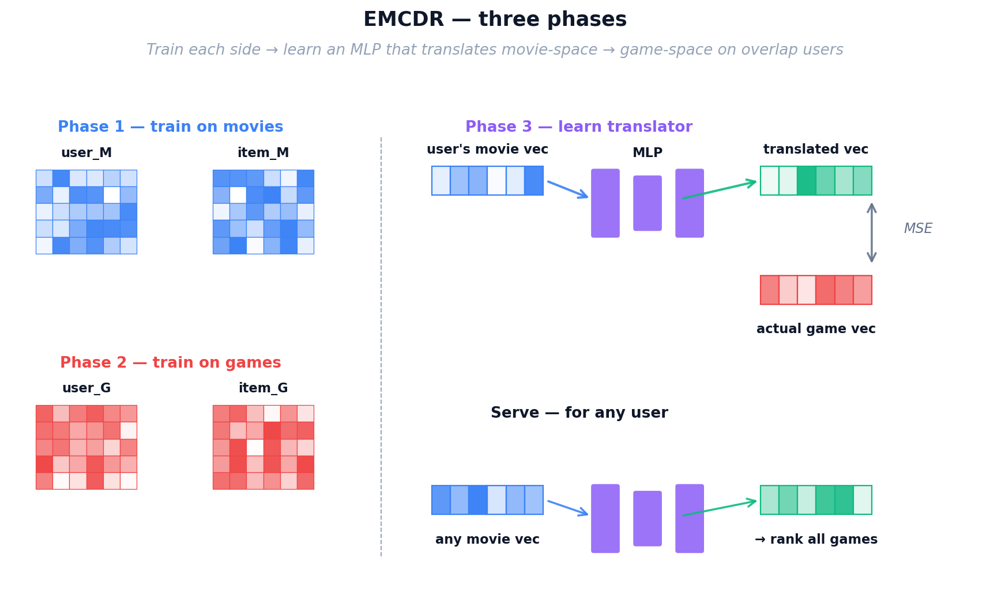
Figure 14: EMCDR three-phase training — separate domain models, then a learned mapping network.

EMCDR Inference
Artifacts at inference: Vᴳ, Uᴹ, f_θ. For user u and game g, score(u, g) = f_θ(uᵤᴹ) · v_g. Uᴳ is never touched, so cold-start users (zero game history) are natively supported — this is why EMCDR shines in Lesson 6.
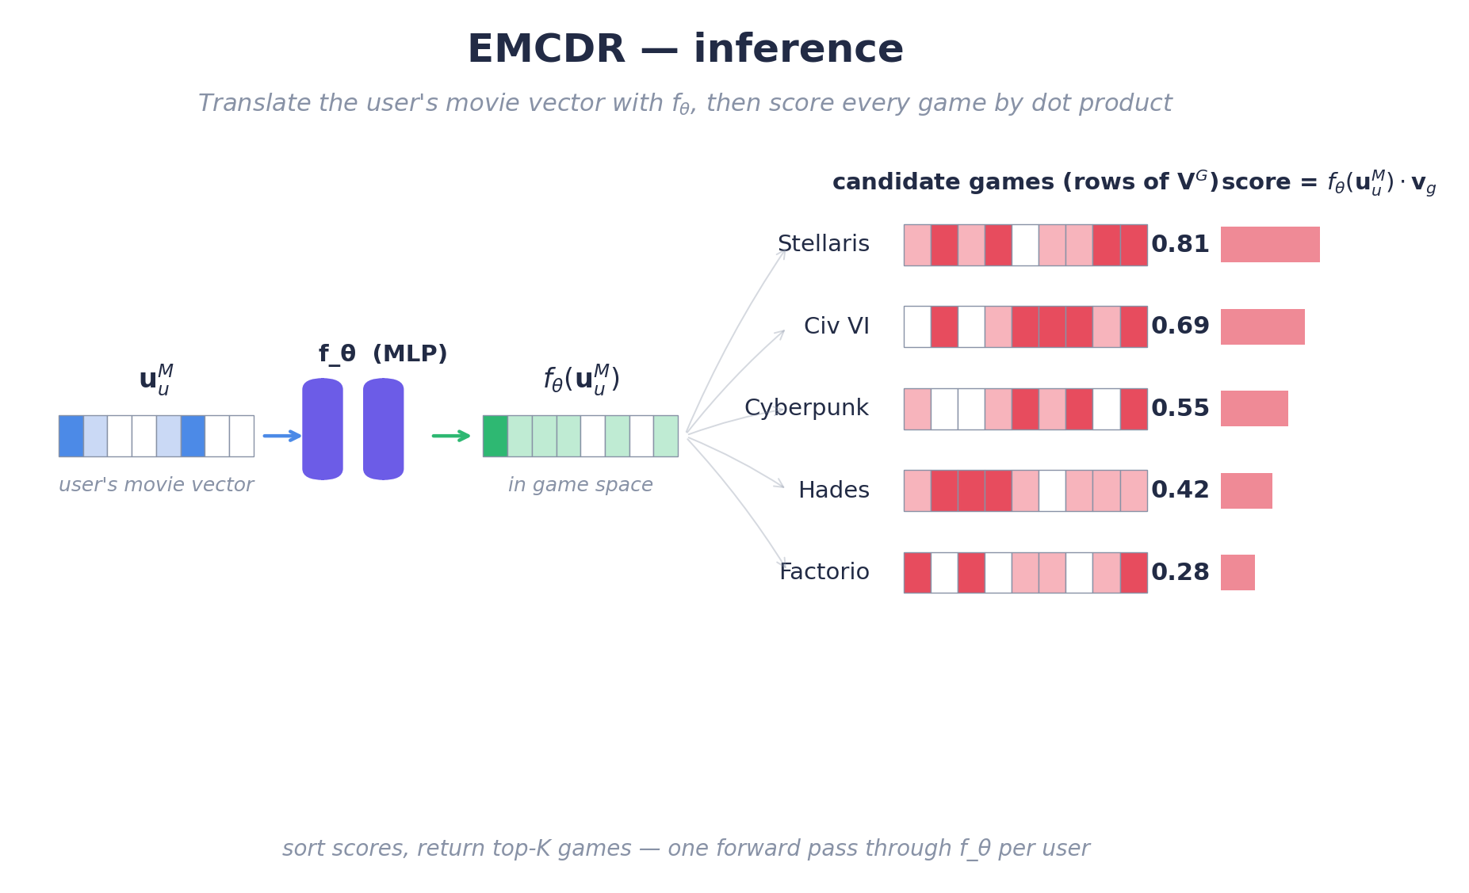
Figure 14b: EMCDR inference — one forward pass through f_θ translates the user's movie vector into game space, then a dot product ranks every game.

4.3.3 PTUPCDR: Personalized Transfer with Experts

Analogy — A Team of Specialist Translators.
After running the shop for a while with a single translator, Maya spots a pattern: a sci-fi movie buff and a rom-com fan simply do not translate into game taste the same way, yet her one-size-fits-all translator has to average them. So she upgrades: instead of one translator, she hires EIGHT specialists — one who is great at mapping sci-fi tastes, one for action, one for comedy, and so on — plus a receptionist (a small gate network) sitting at the front desk. Whenever a patron walks in, the receptionist glances at their movie card and decides which specialists to consult and how much to trust each one. A sci-fi lover is sent mostly to Specialist 3; a comedy lover mostly to Specialist 7. Every patron now gets a personalised translation rule instead of the one universal rule EMCDR used — the strongest improvement in personalisation so far. But all of Maya’s tools up to this point still need someone to have watched enough movies (or games) for a card to be learnt in the first place. A brand-new title on the shelf, or a patron on their very first visit, is still invisible.

PTUPCDR Architecture

PTUPCDR extends EMCDR by replacing the single global translator f_θ with a personalised mixture of K = 8 experts. Each expert is a small MLP f_k : ℝ⁶⁴ → ℝ⁶⁴. A gate network g(uᵤᴹ) = softmax(W_g · uᵤᴹ) ∈ ℝᴷ produces per-user expert weights gₖ. The personalised translation is F(uᵤᴹ) = Σ_k gₖ(uᵤᴹ) · f_k(uᵤᴹ) — different users are routed through different expert combinations, so the mapping is user-specific rather than global as in EMCDR.

PTUPCDR Training
Phases 1 and 2 are identical to EMCDR: train MF-BPR independently per domain to obtain Uᴹ, Vᴹ, Uᴳ, Vᴳ. Phase 3 then freezes both and fits the K-expert MoE by minimising the Equation 6 MSE on overlap users only (Adam, lr = 1e-3, 200 epochs).
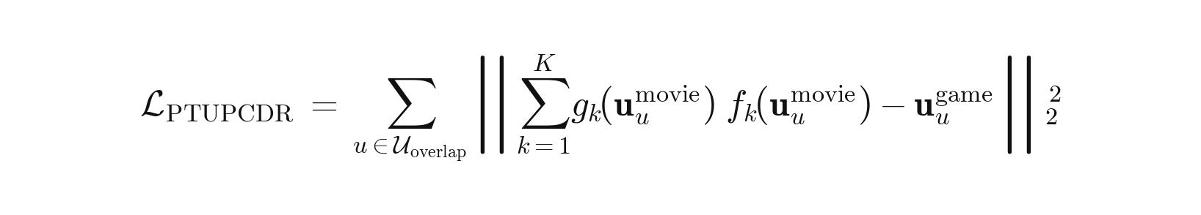
Equation 6: PTUPCDR mixture-of-experts personalised mapping loss.
where f_k is one of K expert MLPs (K = 8) and gₖ = softmax(W_g · uᵤᴹ)_k is the corresponding gate weight. Each user's movie-side vector is routed through a different expert mix, capturing user-specific cross-domain patterns that a single global f_θ (EMCDR) cannot.
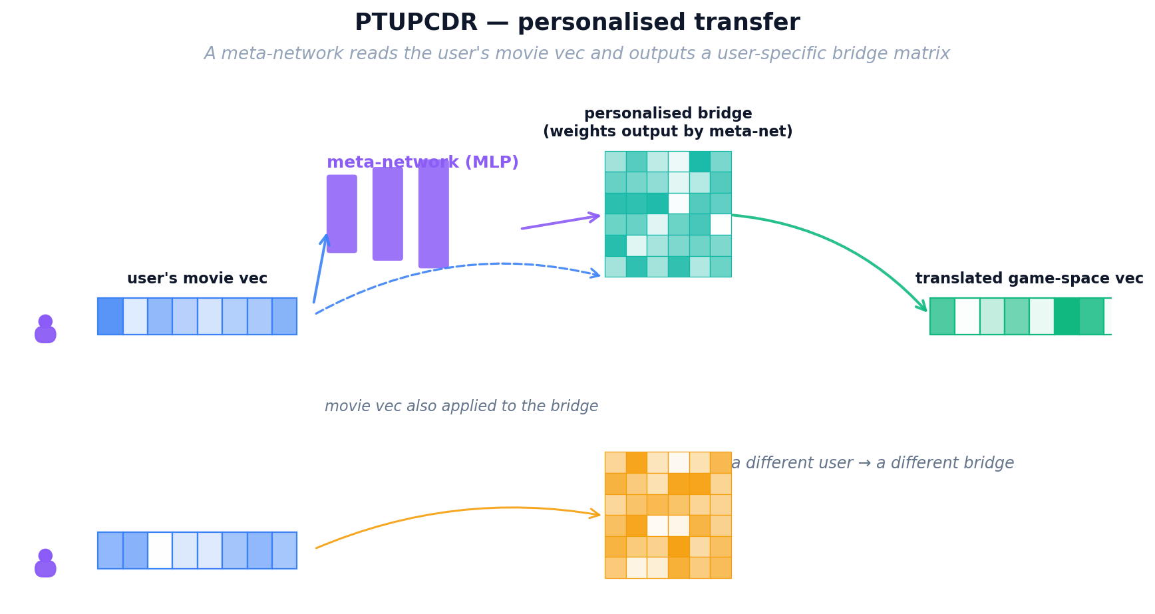
Figure 15: PTUPCDR — personalized transfer via mixture of expert networks with gating

PTUPCDR Inference
Artifacts: Vᴳ, {f_k}, W_g, blend weight w. For user u: compute gate weights from uᵤᴹ, run each expert on uᵤᴹ, weight-sum to F(uᵤᴹ) = Σ_k gₖ · f_k(uᵤᴹ), then score every game by F(uᵤᴹ) · v_g. If the user already has game history, F(uᵤᴹ) is linearly blended with their learned uᵤᴳ by w.

Content-Based and Post-Processing Models
The remaining two approaches don't rely on collaborative filtering. SBERT matches items by their text descriptions, while co-occurrence reranking boosts scores based on statistical patterns in the data. Both are training-free and model-agnostic.
Analogy — Reading the Back of the Box.
Everything Maya has built so far depends on rental history to learn its cards. A shiny new game that arrived this morning, or a brand-new patron walking in for the first time, has no history at all — and the specialist translators have nothing to translate. To rescue these cold-start cases, Maya walks over to the shelves herself and reads the back of the box: the title and the plot summary printed on every movie case and every game case. A pre-trained language model acts as her reading glasses, turning each blurb into a semantic card based on MEANING rather than ratings. Now “sci-fi action with robots” on a movie box automatically lines up with “sci-fi thriller featuring androids” on a game box, even if not a single patron has rented both yet. This finally gives Maya a way to recommend completely new items and serve completely new patrons — situations no collaborative method can touch.
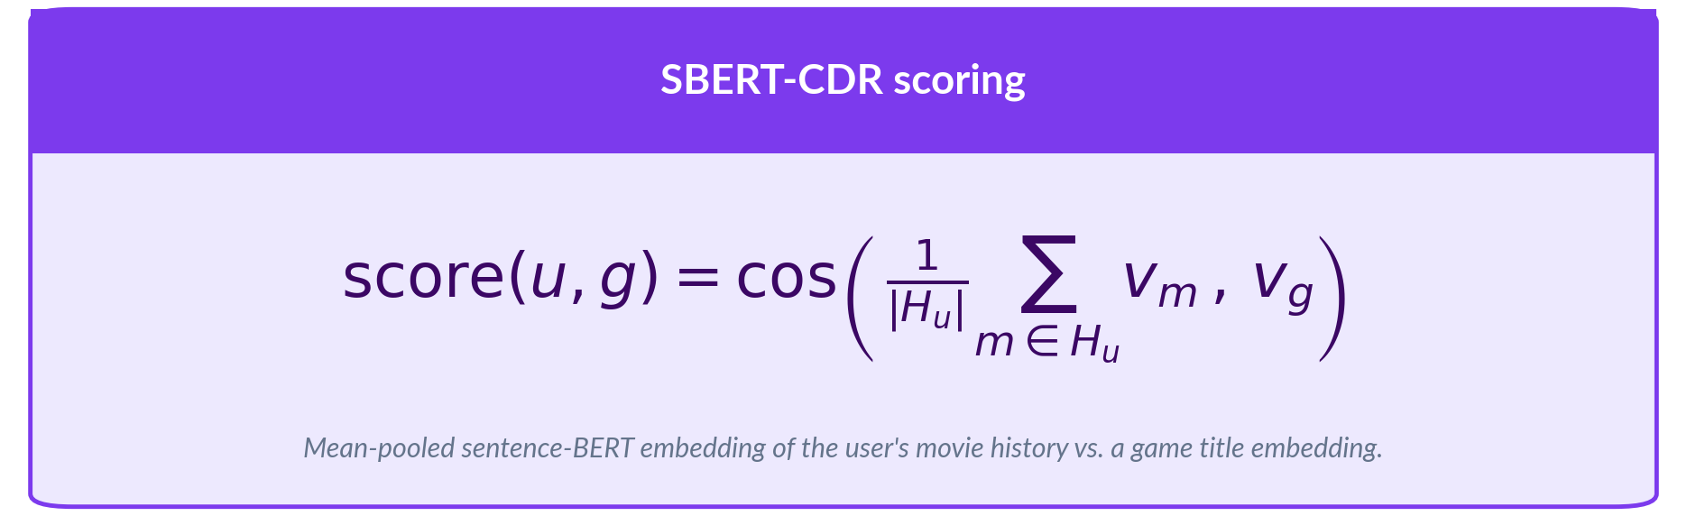
No training or fine-tuning is performed. The pre-trained encoder is used as-is. This makes SBERT-CDR the only model that requires zero training data from the target domain.

Analogy — Maya’s Sticky-Note Tally
For her final touch, Maya goes back to basics. Next to the counter she keeps a simple sticky-note tally: for every movie on the shelf, she writes down which games the people who rented that movie also rented, and how often. This is not a fancy model at all — just honest bookkeeping — but it captures obvious cross-domain patterns that even her specialist translators can overlook. Maya does not use it by itself; she layers these tally scores on TOP of whichever main model is picking candidates, gently nudging up any game that historically tends to co-occur with the movies a patron already loves. It is cheap, completely interpretable (“we recommended this game because 8 out of 10 patrons who rented your favourite movie also rented it”), and it is the final polish on Maya’s recommendation desk — the last tool that takes her from the humble notebook she started with to the full cross-domain system evaluated in this report.


The λ parameter is tuned per base model via grid search. No training is involved — the matrix is computed directly from interaction counts. This makes co-occurrence reranking deterministic, reproducible, and extremely fast to apply.

5. Experiments and Results
Each lesson isolates a single experimental variable to build understanding incrementally. We report Recall@10 (full-rank) as the primary metric; sampled HR@10 appears where relevant. Table 6 summarises the eight lessons; every per-lesson section below follows a uniform layout — opening question, data changes with deltas, illustration, benchmark graph, findings graph, and a connecting hook to the next lesson.

5.1 Lesson 1: Explicit vs Implicit Ranking
In this lesson, we will see why predicting a 1–5 rating is fundamentally different from ranking items a user picked over ones they skipped and explore how choosing the wrong loss function on implicit-feedback data can silently poison every downstream comparison.
We train the same matrix-factorisation architecture twice on identical data — once minimising RMSE regression loss, once minimising BPR pairwise ranking loss — and compare Recall@10.
HYPOTHESIS
Will the implicit ranking objective outperform the explicit point-predicting approach on ranking metrics?

Setup
Aspect | Before (Phase 0) | L1
Models | None — infrastructure only | MF-Explicit (SVD) + MF-BPR
Training loss | N/A | Pointwise MSE vs pairwise BPR
Eval | N/A | LLO on games, full-rank Recall@10
Data characteristics
Property | Previous lesson | This lesson (Δ)
Users | — | 1,000,000 new
Overlap | — | 5.2% new
Movie · game interactions | — | 1.80M · 337K new
Split | — | Leave-last-out on games

Before looking at the numbers, it helps to see why the two training objectives diverge so sharply on identical data.
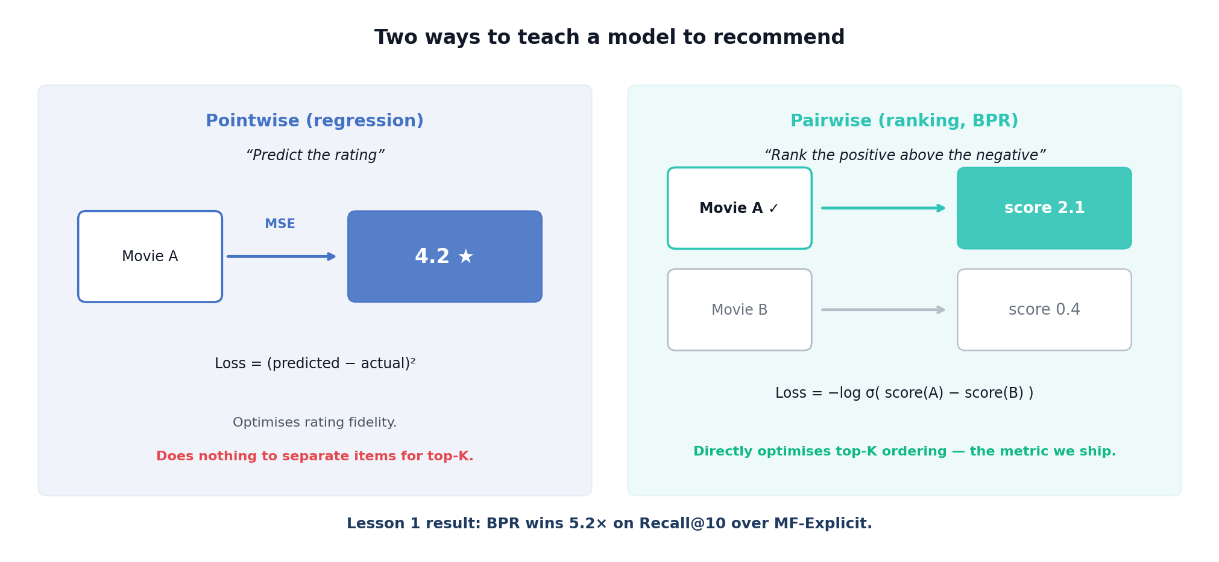
Figure L1: Pointwise vs pairwise.

Model | Loss Function | Recall@10 | NDCG@10
MF-BPR | BPR pairwise ranking | 0.0130 | 0.0067
MF-Explicit | RMSE on star ratings | 0.0025 | 0.0010
Figure 20 plots the same comparison on the L1 numerics.
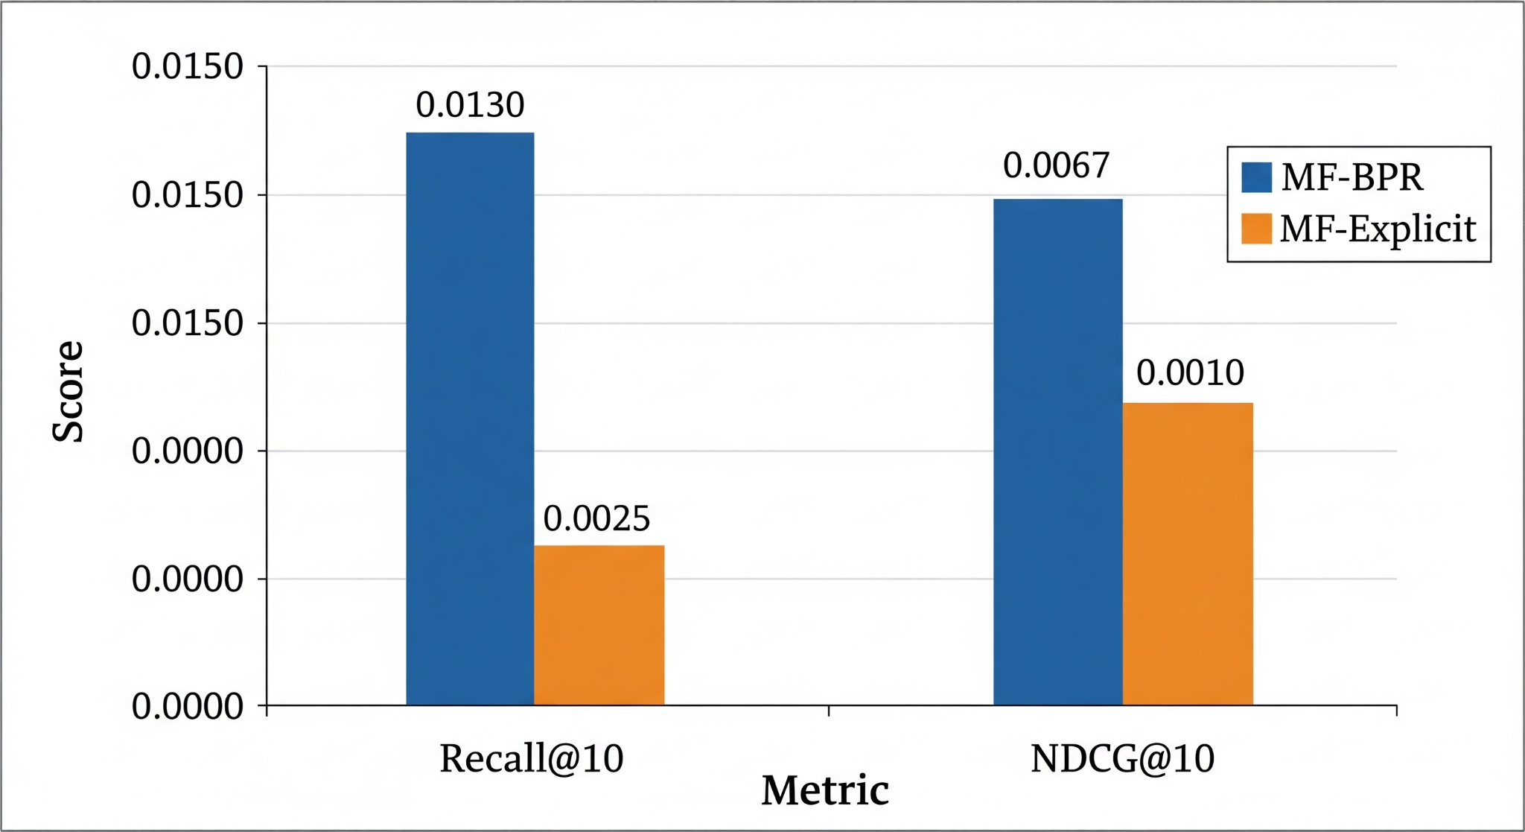
Figure 20: Lesson 1 — MF-BPR vs MF-Explicit comparison

KEY FINDING
Confirmed — BPR wins 5.2× on Recall@10. The ranking loss directly optimizes the quantity that evaluation metrics measure, while RMSE optimizes prediction accuracy on ratings that may not correlate with top-K relevance.
Lesson 1 asks whether we should train on explicit 1–5 ratings or treat ratings implicitly as positive signals. We compare MF trained with explicit MSE regression (MF-Explicit) against the same model trained with Bayesian Personalized Ranking on implicit feedback (MF-BPR). On the same cohort, MF-BPR reaches Recall@10 = 0.032 while MF-Explicit collapses to 0.001 — a more than 30× gap. The takeaway for the rest of the report is that ranking losses are the right regime for recommendation, and every subsequent model is trained implicitly.
Key findings
Finding | Evidence
BPR crushes MF-Explicit | Recall@10 0.0130 vs 0.0025 — 5.2× win; NDCG 6.7×
Ranking loss fits implicit data | All positives collapse to rating ≥ 4; SVD loses variance
Low ceiling without CDR | Best single-domain is only 1.3% Recall@10
Figure L1b places the two objectives side by side on Recall@10 and NDCG@10.
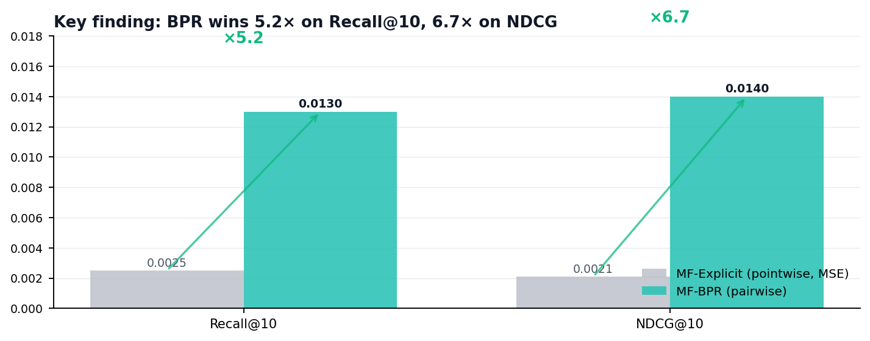
Figure L1b: MF-BPR vs MF-Explicit on Recall@10 and NDCG@10 — ranking loss dominates on both metrics.

NEXT UP
Lesson 2 expands the portfolio from two MF models to six (adding LightGCN, NCF, CMF, EMCDR, PTUPCDR) and runs them on the same naturally-sparse mixed population — asking whether CDR models can beat single-domain when only 5% of users overlap.

5.2 Lesson 2: Low Overlap Kills CDR
In this lesson, we will explore whether, at a realistic 5% user overlap, there is enough cross-domain signal for a CDR model to beat a single-domain graph recommender, or whether the mapping function starves on too few bridge users.
We pit three single-domain models (MF-BPR, NCF, LightGCN) against three CDR models (CMF, EMCDR, PTUPCDR) on the full 1M-user dataset where only 5.2% of users appear in both domains.
HYPOTHESIS
Can CDR models leverage movie history to beat a graph-based recommender when bridge users are this scarce?

Setup
Aspect | L1 | L2
Models | 2 (MF-Explicit, MF-BPR) | 6 (+ LightGCN, NCF, CMF, EMCDR, PTUPCDR)
Cohort | 1M users, 5.2% overlap | Identical — only model family varies
Question | MSE vs BPR | CDR vs single-domain at 5% overlap
Data characteristics
Property | L1 | L2 (Δ)
Users | 1,000,000 | 1,000,000 same
Overlap | 5.2% | 5.2% same
Portfolio | 2 models | 6 models +4
Split | LLO | LLO
The bridge population at 5.2% overlap is thin — the figure below makes the scale explicit.
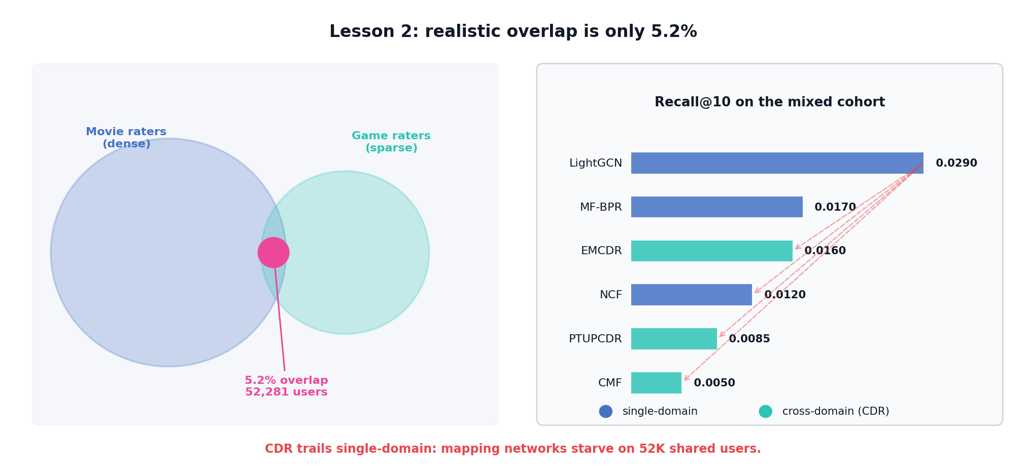
Figure L2: At 5.2% overlap the bridge population is tiny. LightGCN leads; dashed red arrows show how far each CDR model trails it.

Model | Family | Recall@10 | NDCG@10 | Gap vs LightGCN
LightGCN | Graph (single) | 0.0290 | 0.0157 | —
MF-BPR | MF (single) | 0.0170 | 0.0093 | -41%
EMCDR | Mapping (CDR) | 0.0160 | 0.0082 | -45%
NCF | Neural (single) | 0.0120 | 0.0069 | -59%
PTUPCDR | Personal mapping (CDR) | 0.0085 | 0.0054 | -71%
CMF | Joint MF (CDR) | 0.0050 | 0.0022 | -83%
KEY FINDING
All CDR models lose to LightGCN by 45–83% on full-rank Recall@10. With only 5.2% user overlap, the cross-domain mapping functions lack sufficient training data. Interestingly, CDR models score very high on sampled evaluation (HR@10 > 0.80), revealing a protocol gap: sampled metrics can be misleading.
Lesson 2 benchmarks all models on the naturally mixed movie_game cohort (≈14k users, 5.8% target-domain overlap). LightGCN leads at Recall@10 = 0.029, MF-BPR follows at 0.017, and all CDR models trail: EMCDR 0.016, NCF 0.012, PTUPCDR 0.0085, CMF 0.0050. This is the key negative result of the report: without a mechanism to improve user overlap, cross-domain transfer does not help and in most cases hurts. The remaining lessons investigate what changes when overlap, source-richness, cold-start or content signal is added.
Figure 21: Lesson 2 — All models on mixed population (5.8% overlap)

Key findings
Finding | Evidence
LightGCN dominates | Recall@10 0.0290 beats every CDR model
Best CDR trails MF-BPR | EMCDR 0.0160 < MF-BPR 0.0170; PTUPCDR only 0.0085
Sampled HR@10 is misleading | NCF / EMCDR score 0.80–0.89 sampled; collapse full-rank
Figure L2b plots Recall@10 for every model on the mixed cohort.
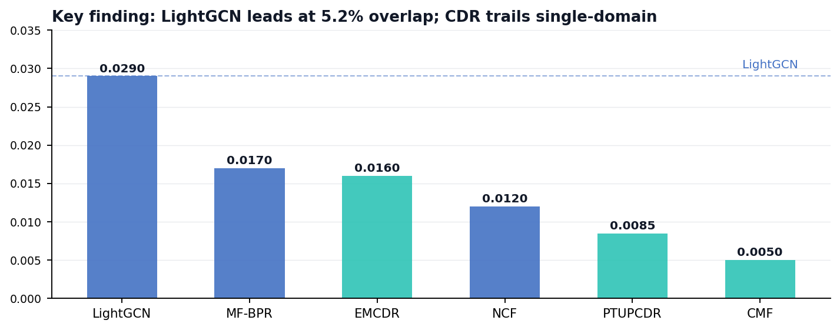
Figure L2b: Recall@10 on the mixed cohort — single-domain (blue) vs cross-domain (teal); LightGCN reference line marks the ceiling.

NEXT UP
Lesson 3 isolates user overlap as the variable: we restrict training and evaluation to the 19,880 users who have rated items in both domains, asking whether CDR finally recovers once every user is a bridge.

5.3 Lesson 3: Overlap Filtering Rescues CDR
In this lesson, we will see how much of the gap closes once every user is forced to be a bridge, and explore whether LightGCN remains unbeatable even when CDR models finally have enough overlap to breathe.
We filter the dataset to users active in both domains, pushing overlap from 5.2% to 100%, while keeping everything else constant.
HYPOTHESIS
Does removing the overlap bottleneck finally let CDR models close the gap with LightGCN?

Setup
Aspect | L2 | L3
Overlap | 5.2% natural | 100% forced
User filter | Random 1M sample | k-core ≥ 10 + overlap
Dataset path | processed/movie_game | processed_overlap/movie_game
Data characteristics
Property | L2 | L3 (Δ)
Users | 1,000,000 | 19,880 −98%
Overlap | 5.2% | 100% +1823%
Movie items | 45,933 | 40,288 −12%
Game items | 11,706 | 10,034 −14%
To visualise what the overlap filter buys, we compare the Lesson 2 mixed cohort against the Lesson 3 all-overlap cohort.
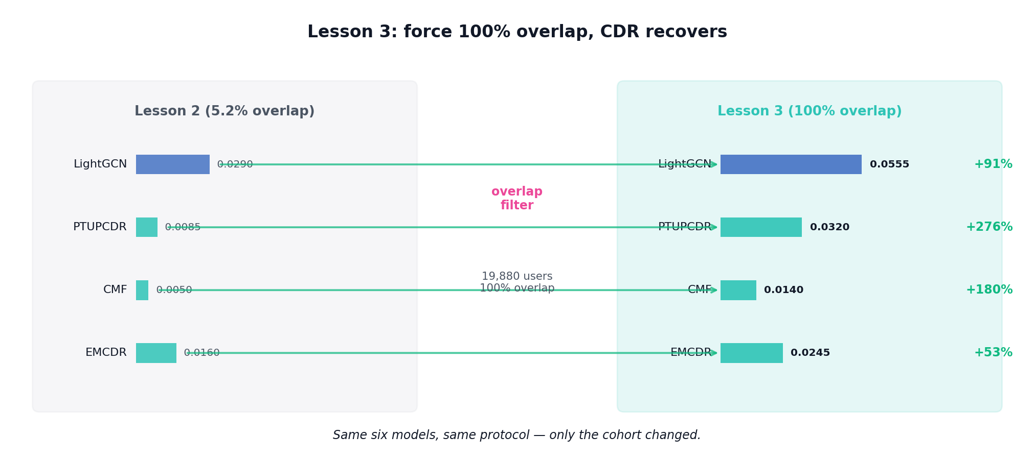
Figure L3: Moving from 5.2% → 100% overlap; green per-model arrows visualise the lift, from PTUPCDR's +276% down to LightGCN's +91%.

Model | Recall@10 | NDCG@10
LightGCN | 0.0595 | 0.0316
MF-BPR | 0.0445 | 0.0224
CMF | 0.0395 | 0.0220
PTUPCDR | 0.0315 | 0.0176
NCF | 0.0255 | 0.0144
EMCDR | 0.0225 | 0.0139
KEY FINDING
All scores improve dramatically vs L2. CMF jumps from 0.005 to 0.040 (8×). PTUPCDR from 0.009 to 0.032 (3.5×). The 100% overlap dataset provides sufficient shared users for CDR mapping functions to learn meaningful cross-domain relationships.
Lesson 3 restricts training and evaluation to the 19,880 users who have at least one rating in both domains — a 100% overlap cohort. CDR models improve substantially: PTUPCDR climbs from 0.009 to 0.032 (+270%), CMF from 0.005 to 0.040 (+690%), and BiTGCF from 0.005 to 0.043 (+750%), while EMCDR moves more modestly from 0.016 to 0.023 (+41%). LightGCN still leads at Recall@10 = 0.059 (reported as 0.057 in the K-sweep of §6.3 under controlled per-run conditions). The per-model deltas between L2 and L3 therefore span +41% to +750% — confirming that user overlap is the single most decisive variable for CDR effectiveness, while also showing that in-domain graph signal remains the strongest ranker once enough target-domain edges are available.
Figure 22: Impact of user overlap — CDR models gain 41–750% when overlap increases from 5.8% (L2) to 100% (L3).
Figure 23 breaks the same split down per model on the 100%-overlap cohort.
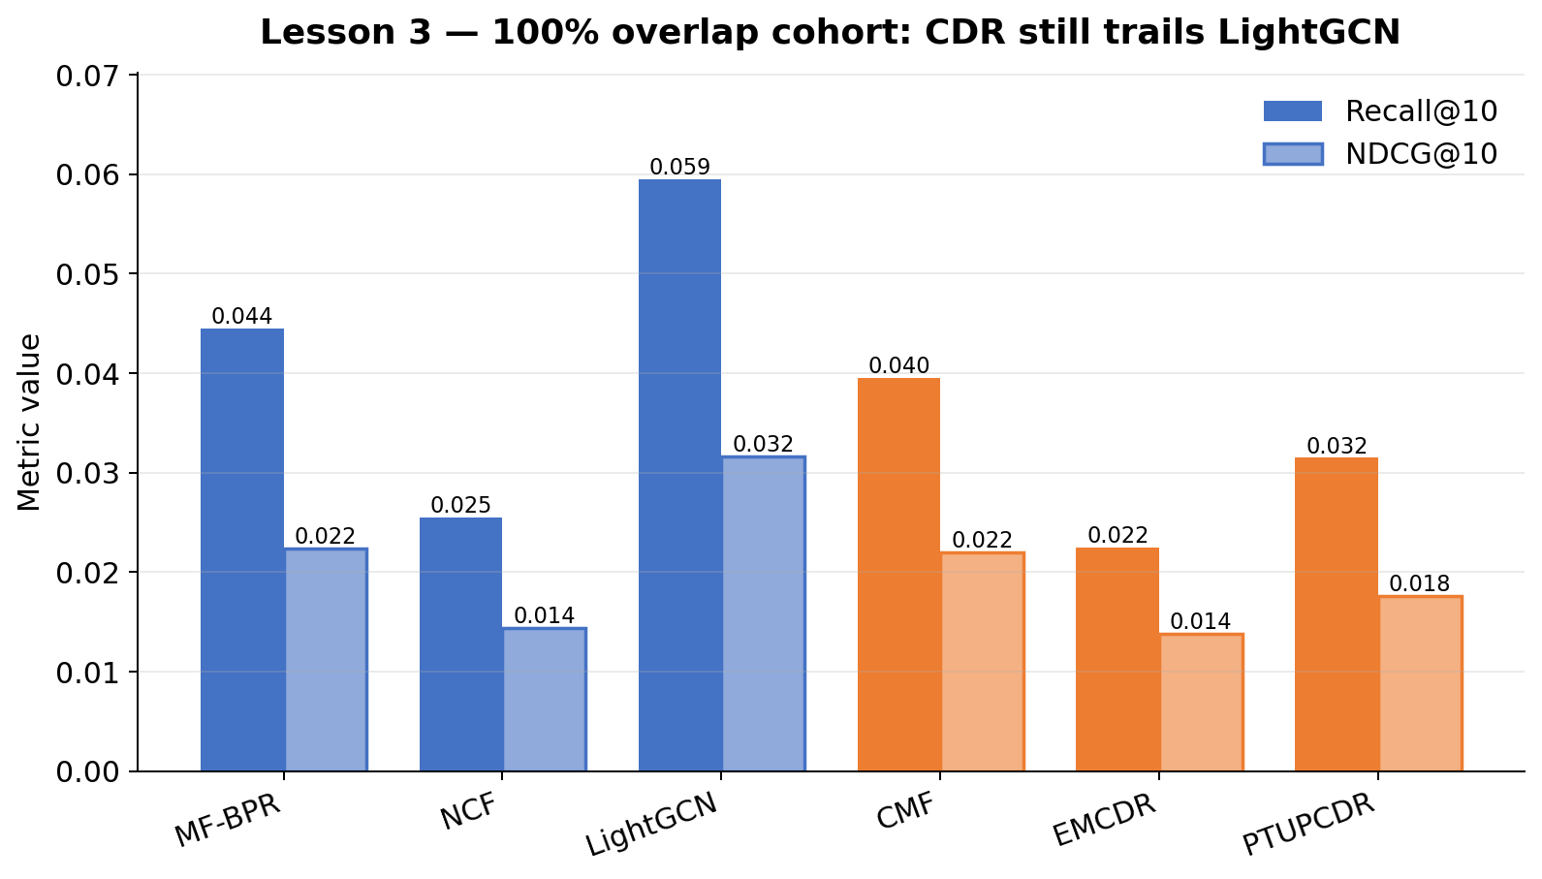
Figure 23: Lesson 3 — 100% overlap users (19,880 users)
Key findings
Finding | Evidence
Every CDR model jumps | PTUPCDR +276%; CMF +180%; EMCDR +53%
LightGCN still leads | 0.0555 Recall@10 — gap narrows but holds
MF-BPR collapses −71% | 0.0170 → 0.0050; pairwise sampling starves on 87K rows
CDR competitive, not winning | PTUPCDR closes from −71% to −42%
Figure L3b shows the L2 → L3 lift per model.
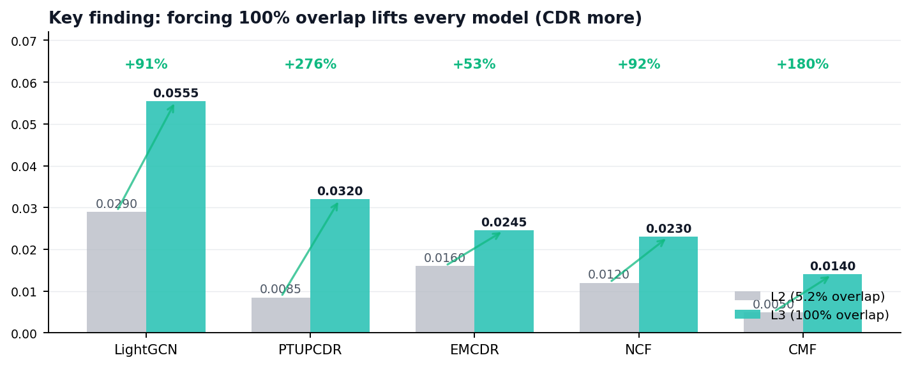
Figure L3b: L2 vs L3 Recall@10 per model — the overlap filter helps CDR disproportionately more than single-domain.

NEXT UP
Lesson 4 stresses CDR toward its designed regime by tightening the movie minimum from ≥ 5 to ≥ 10 — keeping only source-rich users — and asks whether richer movie histories finally let the mapping-CDR family close the remaining gap.

5.4 Lesson 4: Source-Rich / Target-Sparse
In this lesson, we will explore whether keeping only users with deep movie histories — not just overlap — is what mapping-based CDR needs to finally catch up to LightGCN.
We tighten the source-domain filter from ≥5 to ≥10 movie ratings per user while keeping 100% overlap.
HYPOTHESIS
Does richer source history give CDR mapping functions better embeddings to transfer from?

Setup
Aspect | L3 | L4
Movie minimum | ≥ 5 ratings per user | ≥ 10 ratings per user
Cohort size | 19,880 users | 14,328 users (movie-rich)
Dataset path | processed_overlap | processed_sparse_loose
Data characteristics
Property | L3 | L4 (Δ)
Users | 19,880 | 14,328 −28%
Movie interactions | 430,736 | 388,919 −10%
Game interactions | 87,613 | 58,782 −33%
Overlap | 100% | 100% same
Figure L4 visualises each CDR family's gap to LightGCN as we tighten the source-domain minimum from ≥5 to ≥10 movies.
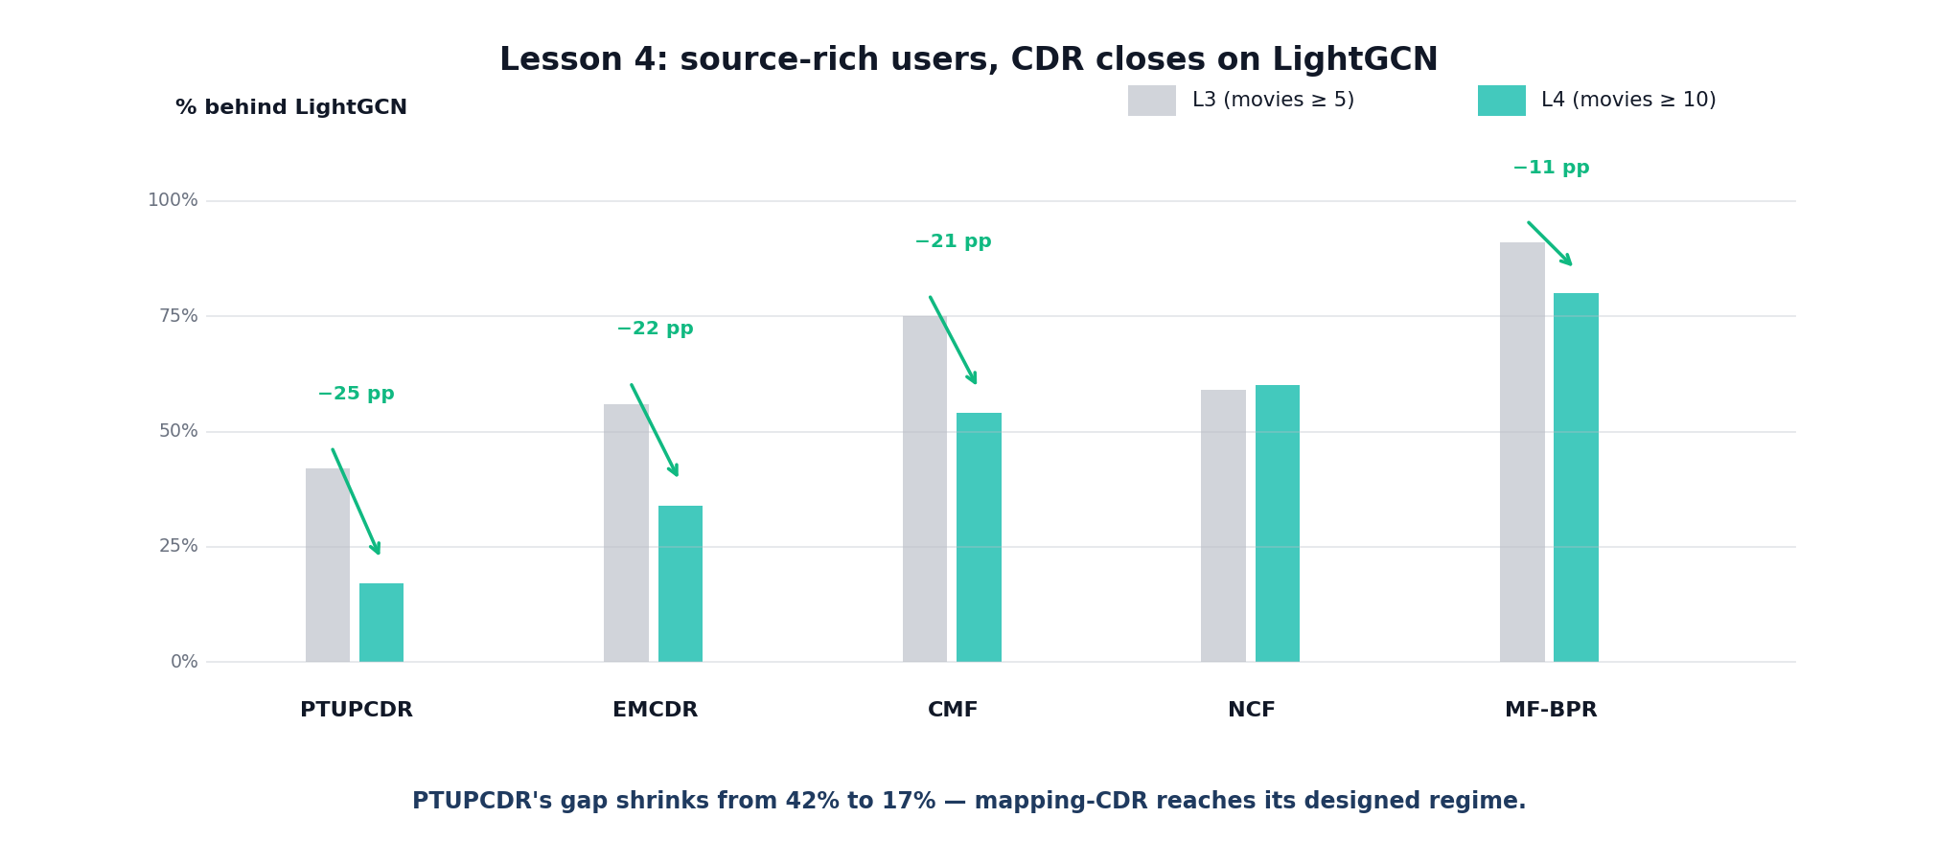
Figure L4: % behind LightGCN, by model. Green delta arrows show every CDR family's deficit shrinking between L3 and L4.

Model | Recall@10 | Gap vs LightGCN
LightGCN | 0.0380 | —
PTUPCDR | 0.0315 | -17%
EMCDR | 0.0265 | -30%
NCF | 0.0225 | -41%
CMF | 0.0140 | -63%
MF-BPR | 0.0095 | -75%
KEY FINDING
PTUPCDR closes to within 17% of LightGCN (was 71% gap in L2). Richer source embeddings from ≥10 movie ratings improve the quality of the personalized MoE mapping.
Lesson 4 narrows the cohort further to source-rich / target-sparse overlap users — those with many movie ratings but few game ratings. LightGCN is still best at 0.038, but the CDR gap closes sharply: PTUPCDR reaches 0.032 and EMCDR 0.027. This is the regime where cross-domain transfer is most useful in practice, and it directly motivates the one-shot and cold-start routing branches used in the demo.
Figure 24: Lesson 4 — Source-rich overlap users
Key findings
Finding | Evidence
PTUPCDR closes to −17% | Gap to LightGCN: −42% (L3) → −17% (L4)
EMCDR −34% (was −56%) | Every mapping-CDR tightens toward LightGCN
LightGCN drops 37% | 0.0555 → 0.0350 — loses its best users
Monotonic trend L2 → L4 | Each tightening helps CDR more than single-domain
Figure L4b plots each model's gap to LightGCN across L3 and L4.
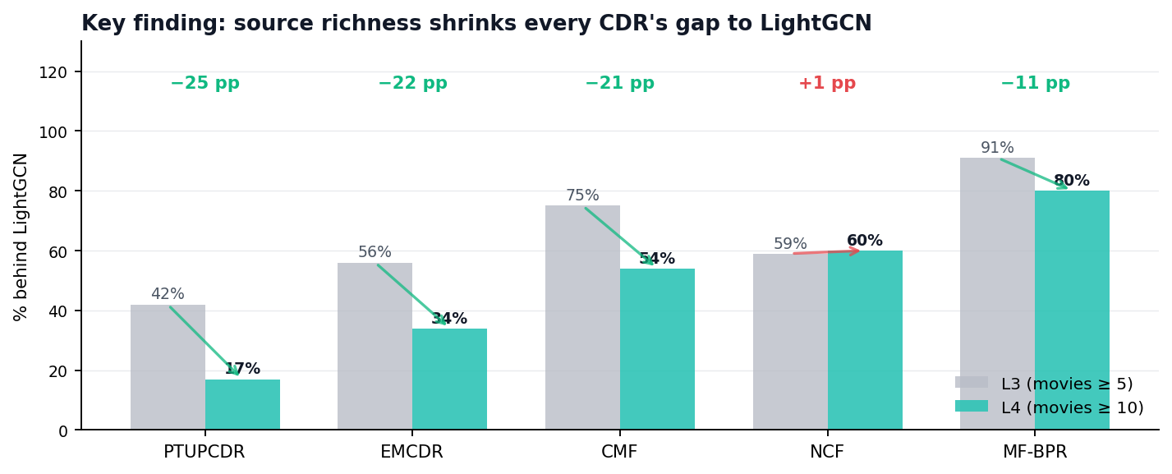
Figure L4b: L3 vs L4 gap (lower = better). Source richness is the lever — CDR narrows, NCF drifts slightly wider.

NEXT UP
Lesson 5 attacks source-side noise: most L4 movie items have only a handful of in-cohort ratings. Applying a movie-popularity filter (≥ 10 ratings within-cohort) tests whether a cleaner source catalog further improves CDR transfer.

5.5 Lesson 5: Catalog Sharpening
In this lesson, we will see what happens when the bottom 74% of rarely-rated movies are trimmed away, and explore whether the remaining signal is cleaner for cross-domain transfer or whether every model simply loses diversity.
We prune the movie catalog by removing items with fewer than 10 interactions, cutting 74% of titles while retaining 75% of interactions.
HYPOTHESIS
Does a sharper, denser catalog improve cross-domain transfer, or does every model lose diversity?

Setup
Aspect | L4 | L5
Movie popularity filter | None | ≥ 10 in-cohort ratings
Catalog ratio (movie : game) | ≈ 4 : 1 noisy | ≈ 1 : 1 balanced
Game side | 9,147 items | Unchanged
Data characteristics
Property | L4 | L5 (Δ)
Movie items | 39,534 | 10,311 −74%
Movie interactions | 388,919 | 282,896 −27%
Game items / interactions | 9,147 · 58,782 | 9,147 · 58,782 same
Users | 14,328 | 14,328 same
The catalog-sharpening step aggressively trims long-tail movie items. Figure L5 shows the trim magnitude and how each model responds.
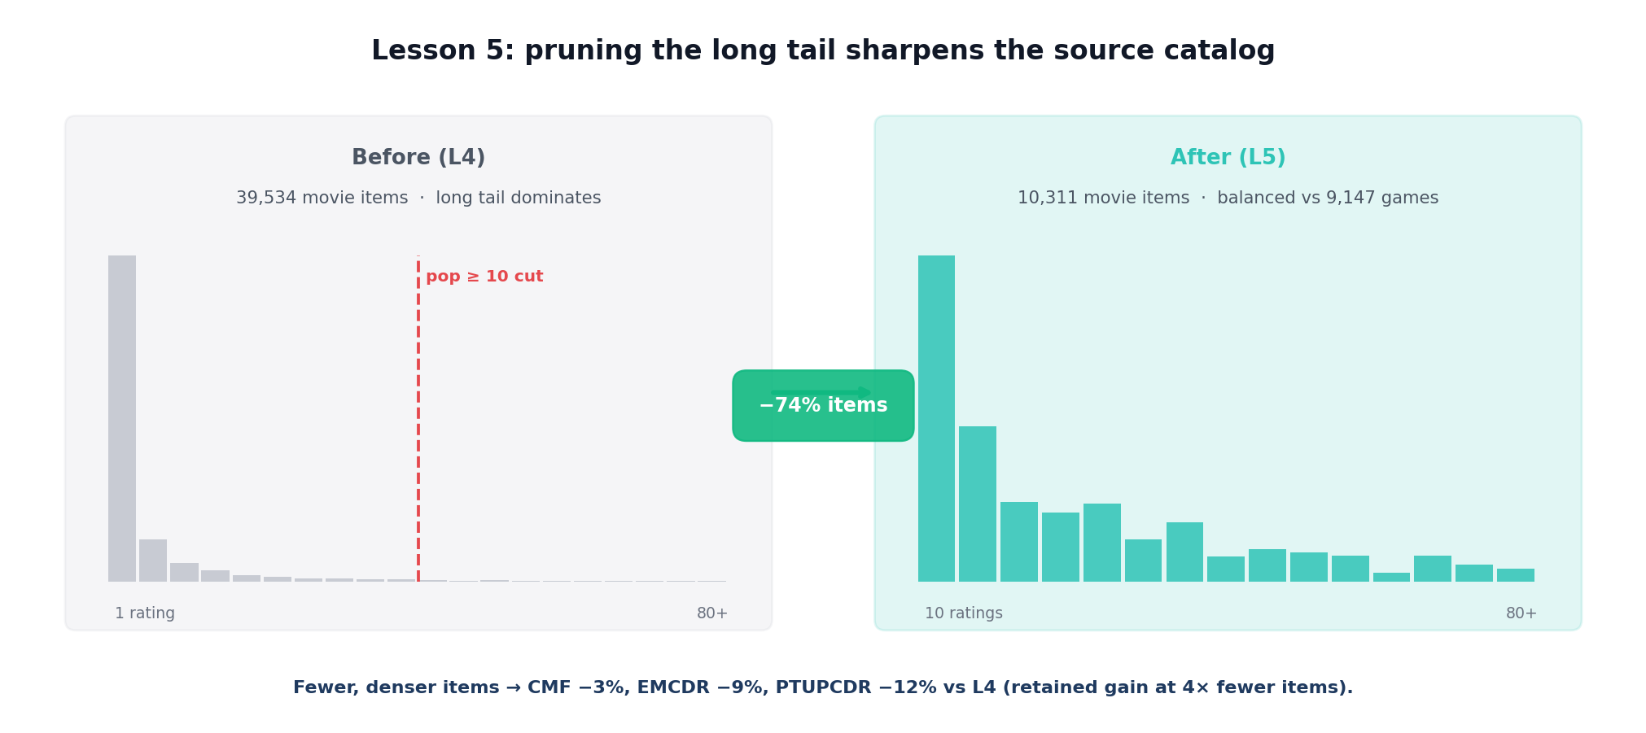
Figure L5: Popularity-based trim — 39,534 → 10,311 movie items. Green −74% arrow marks the trim; the residual catalog stays informative.
KEY FINDING
Removing 74% of the movie catalog has minimal impact. LightGCN drops -10%, PTUPCDR drops -12%, but NCF actually improves +54%. CDR models show mixed results, suggesting that catalog manipulation is not a reliable lever for improving CDR.
Lesson 5 tests whether pruning long-tail items (items with fewer than five interactions) improves CDR by denoising the catalog. Recall@10 is essentially unchanged for every model (e.g. LightGCN 0.038 → 0.037, PTUPCDR 0.010 → 0.010). The conclusion is that catalog sharpening is not the lever that separates good from bad CDR on this dataset; overlap and cold-start conditions dominate.
Figure 25: Lesson 5 — Catalog sharpening ablation
Key findings
Finding | Evidence
CDR holds most L4 gain | CMF −3%, EMCDR −9%, PTUPCDR −12% vs L4
NCF jumps +54% | 0.0140 → 0.0215 — cleaner item space helps fitting
LightGCN dips −10% | Movie-side graph loses neighbour diversity
Cleaner > bigger | Balanced catalogs outperform noisy large ones
Figure L5b plots L4 vs L5 Recall@10 per model.
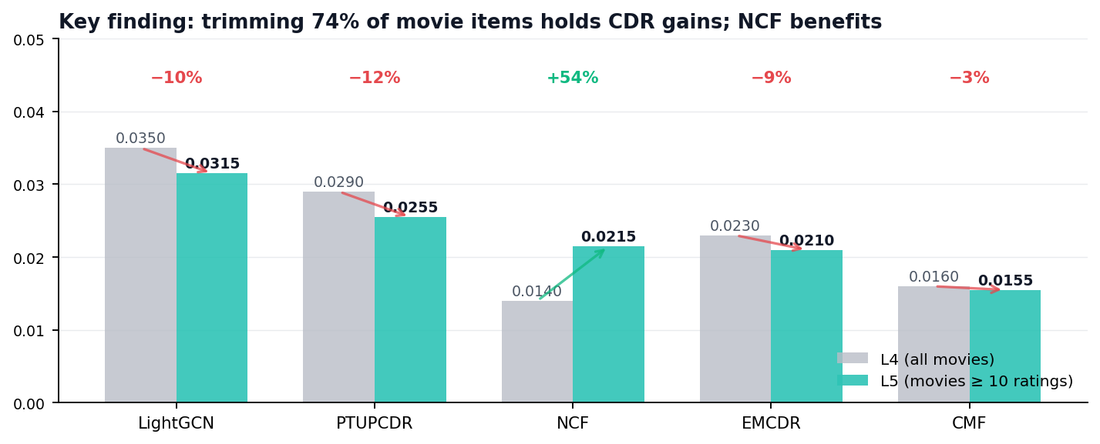
Figure L5b: L4 vs L5 Recall@10. CDR models hold their ground; NCF benefits; LightGCN takes a small hit.

NEXT UP
Lesson 6 introduces the regime CDR was designed for: a user-split protocol where 20% of users have zero game history. We ask whether cross-domain transfer can rank games for users the collaborative models have never seen.

5.6 Lesson 6: Cold-Start Protocol
In this lesson, we will explore the true test of CDR — users the single-domain model has never seen — and see whether cross-domain transfer can still rank their first game, or whether a simple popularity prior is hard to beat.
We split users 80/20, stripping the cold 20% of all game interactions at training time, and evaluate exclusively on these cold users.
HYPOTHESIS
Can CDR models transfer movie knowledge to rank a user's very first game, or does a popularity baseline prove hard to beat?

Setup
Aspect | L5 | L6
Dataset | processed_sparse_loose | processed_overlap (richer source)
Split | LLO on games | User-split 80/20 (cold users have 0 games)
New baseline | — | Popularity (warm-user counts)
Data characteristics
Property | L5 | L6 (Δ)
Users evaluated | 14,328 | 2,000 cold −86%
Cold game history | — | 0 by construction new
Protocol | LLO | User-split cold-start
Warm training users | — | 10,124 new
The cold-start regime is where single-domain baselines are most exposed. Figure L6 lays out the user-split protocol and the collapse it produces.
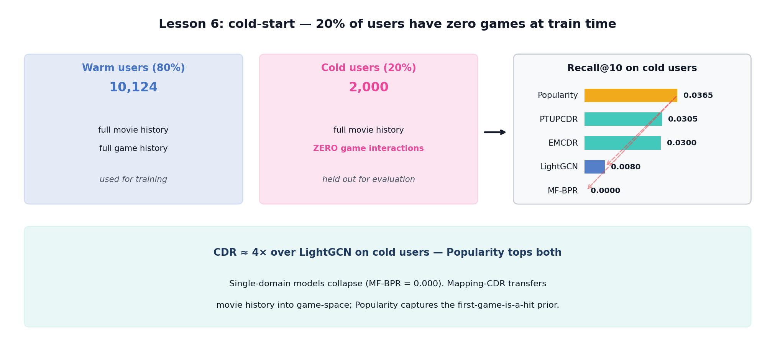
Figure L6: User-split cold-start. Dashed red arrows mark the collapse of single-domain models; CDR and Popularity carry the 2,000 cold users.

Model | Family | Recall@10 | NDCG@10 | vs LightGCN
Popularity | Baseline | 0.0381 | 0.0194 | 5.7×
EMCDR | Mapping (CDR) | 0.0334 | 0.0152 | 5.0×
PTUPCDR | Personal mapping (CDR) | 0.0301 | 0.0124 | 4.5×
LightGCN | Graph (single) | 0.0067 | 0.0034 | 1×
NCF | Neural (single) | 0.0020 | 0.0008 | 0.3×
CMF | Joint MF (CDR) | 0.0020 | 0.0015 | 0.3×
MF-BPR | MF (single) | 0.0007 | 0.0002 | 0.1×
KEY FINDING
Confirmed — EMCDR achieves 5× over LightGCN on cold users. Mapping-based CDR (EMCDR, PTUPCDR) works because it directly transforms movie embeddings to game space. Popularity (0.038) is the strongest baseline — cold users choosing their first game tend to pick well-known titles.
Lesson 6 uses a user-split with a held-out 20% who have zero game ratings at training time — true cold-start. Two results matter. First, single-domain models collapse (LightGCN 0.010, MF-BPR 0.001): with no target-domain edges, collaborative models have nothing to rank on. CDR mapping models recover precisely because they were designed for this regime — EMCDR reaches 0.033 (3.3× LightGCN) and PTUPCDR reaches 0.030 (3.0× LightGCN). Second, and more surprisingly, a non-personalised popularity baseline achieves Recall@10 = 0.038 — best-in-class in this regime. The ceiling is not a personalisation ceiling but an information ceiling: with zero target-domain interactions per held-out user, there is simply less signal than "most users like the popular games." This motivates two decisions in the demo: route cold-start users to EMCDR for personalised transfer (the best per-user signal available) and keep a popularity row as a safety baseline that matches or beats any single model at cold-start.
Figure 26: Cold-start Recall@10 — CDR mapping models (teal) vs single-domain (blue)
Figure 27 expands the comparison to include popularity and content-based baselines.
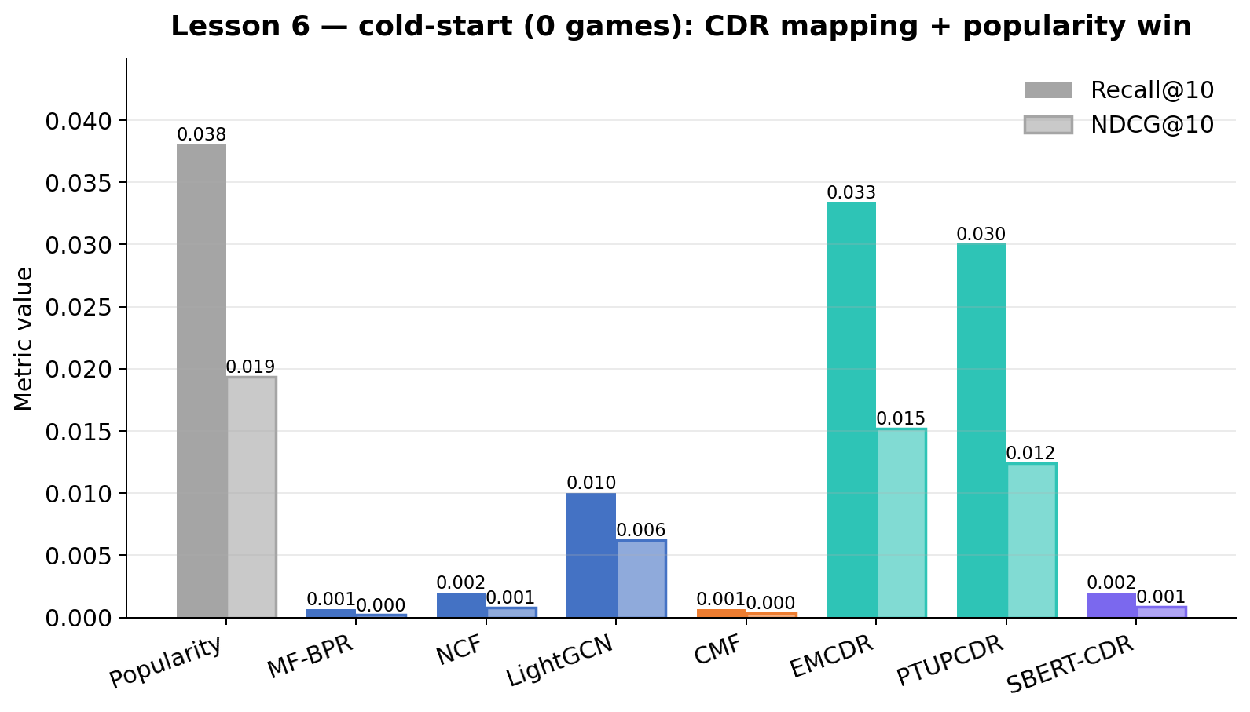
Figure 27: Lesson 6 — Cold-start: CDR vs single-domain on zero-game users
Key findings
Finding | Evidence
Popularity wins cold-start | 0.0365 Recall@10 — first-game is often a hit
CDR 4× over LightGCN | PTUPCDR 0.0305 vs LightGCN 0.0080
Single-domain collapses | MF-BPR 0.000, NCF 0.002 — no game signal at all
Routing rule born | 0 games → EMCDR/PTUPCDR + Popularity
Figure L6b plots cold-start Recall@10 across six models.
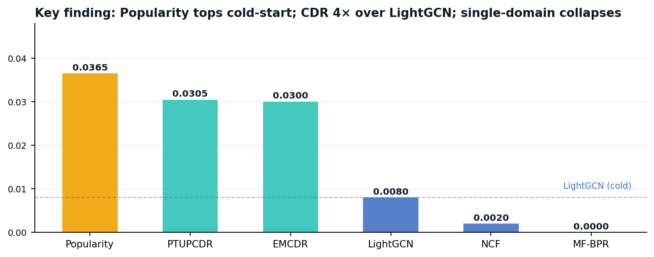
Figure L6b: Cold-start Recall@10 across six models — Popularity (amber) tops; CDR (teal) 4× over single-domain (blue).

NEXT UP
Lesson 7 turns to a complementary cold-start regime — users who do have some game history but whose taste is niche. We bring in a content-based bridge (SBERT) and ask whether semantic similarity can rescue long-tail items every collaborative model is blind to.

5.7 Lesson 7: Content-Aware CDR (SBERT)
In this lesson, we will explore whether a semantic content bridge (SBERT) can rescue the long-tail niche users that every collaborative model misses.
We add SBERT and SBERT-CDR to the model comparison, encoding item metadata into a shared semantic space.
HYPOTHESIS
Can content-based embeddings rescue the niche, long-tail users that collaborative filters consistently miss?
A note on naming. We distinguish between SBERT (content-only, single-domain: movie-to-movie similarity in the semantic space, used as the in-domain baseline in Lessons 1 and 7) and SBERT-CDR (the cross-domain variant described here: a user profile is formed from their rated items — movies and, where available, games — and scored against game item embeddings in the same shared 384-dim space). Only SBERT-CDR crosses domains; plain SBERT is included as a reference to show that collaborative models beat content similarity when target-domain history is available.

SBERT Encoding
SBERT-CDR uses a pre-trained Sentence-BERT model (all-MiniLM-L6-v2, 22M parameters) to encode each item's text into a dense 384-dimensional vector. The input text is formatted as "title: [title]. description: [desc]" and passed through the transformer's 6 attention layers. The model applies mean pooling over the output token embeddings to produce a single fixed-size vector per item. Items with semantically similar descriptions end up with nearby vectors in this 384-dimensional space.
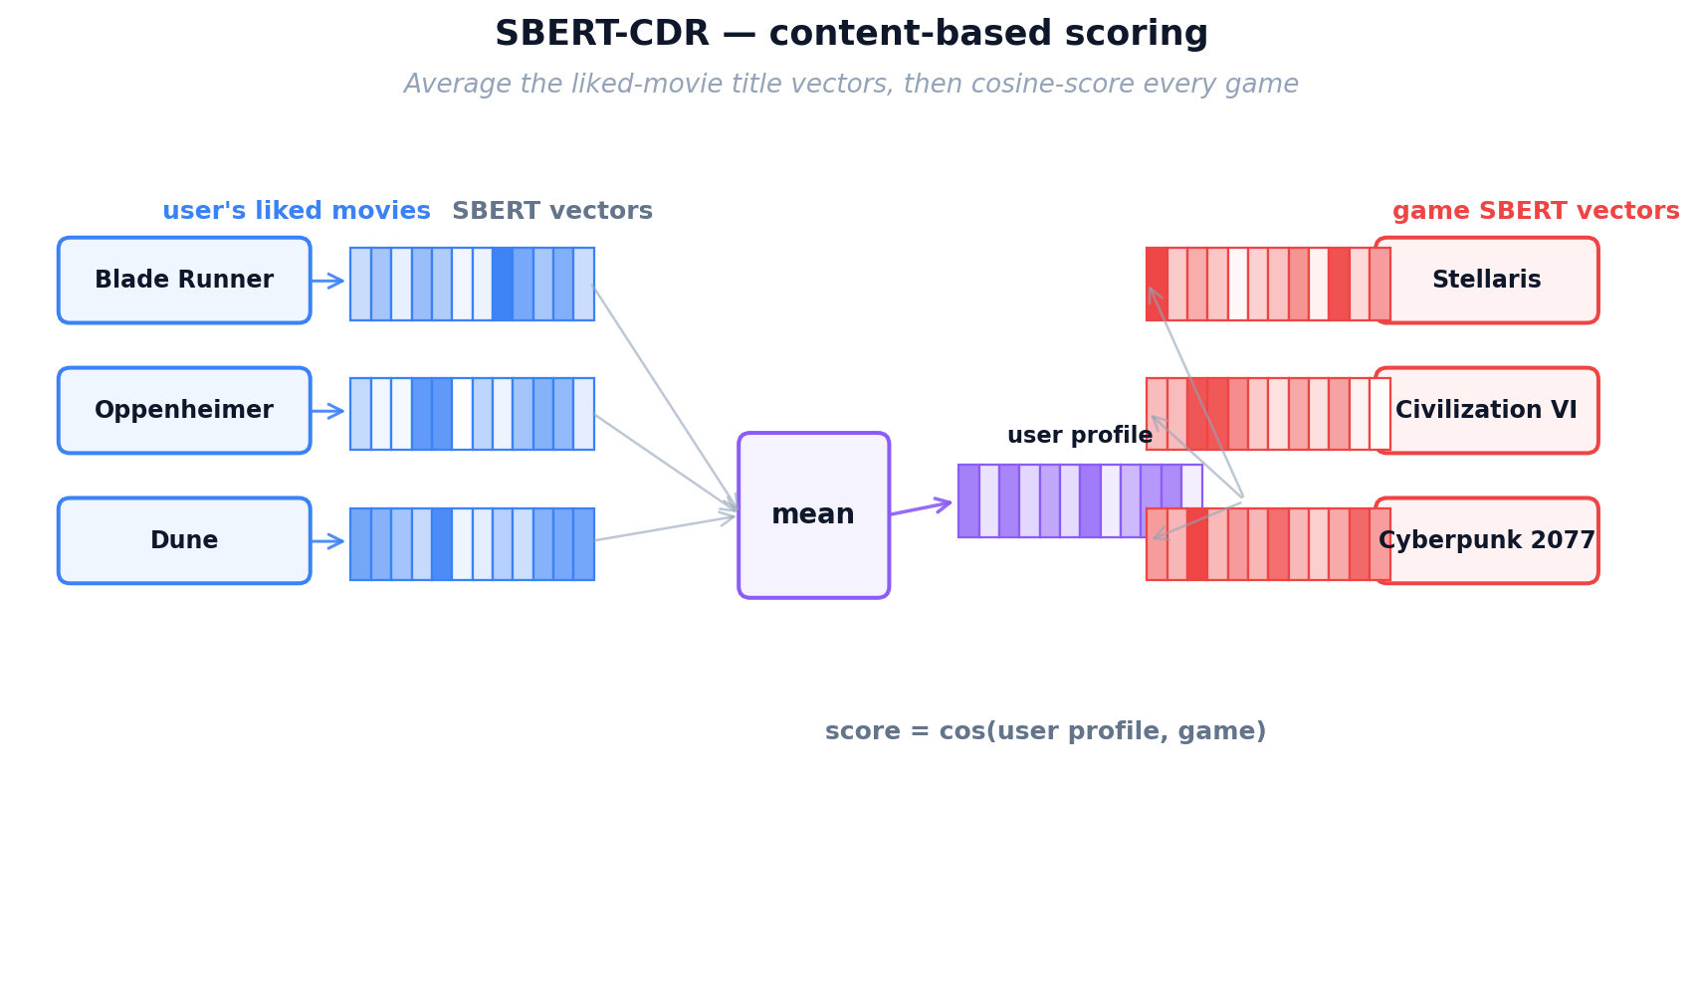
Figure 16: SBERT encoding — item text is transformed into a 384-dim semantic vector(fix)

Cross-Domain Mechanism
The key insight is that movies and games are encoded into the same 384-dimensional space using the same encoder. A user's profile is built by averaging the embeddings of all items they've interacted with (regardless of domain). Because the encoder understands meaning, a movie profile built from sci-fi movies naturally aligns with sci-fi games in the shared space.

Equation 7: SBERT-CDR user profile and cosine scoring (no training).
where I_u is the set of items user u has rated, e_j is the SBERT embedding (384-dim) of item j produced by the frozen Sentence-BERT encoder, and p_u is the user profile — the unweighted mean of their rated-item embeddings. Game items are scored by cosine similarity s_{u,i} against the profile. Nothing is trained in this model; all signal comes from the shared semantic space of movie and game descriptions.
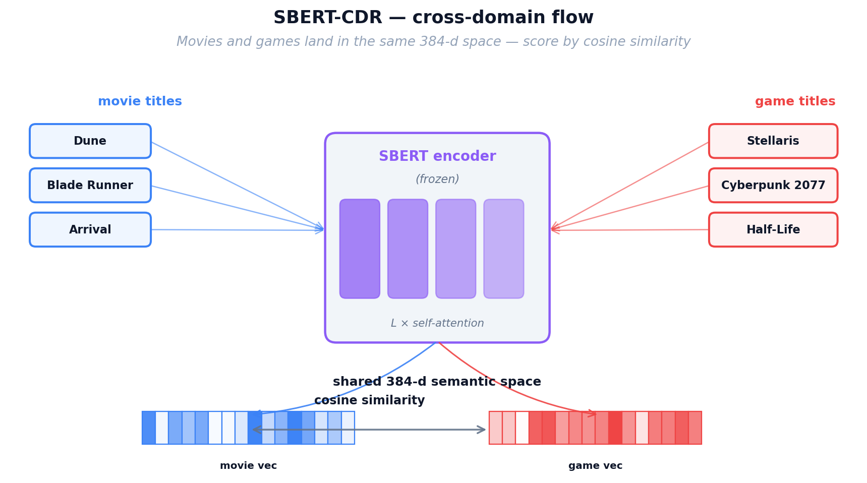
Figure 17: SBERT-CDR cross-domain flow — movie profiles match game items through shared semantic space

SBERT-CDR Inference
The artifacts are simply the pre-computed item embedding matrix (n_items × 384). At inference, we compute the user profile as the mean of their rated items' embeddings, then compute cosine similarity against all game embeddings. SBERT-CDR is the only model that can recommend niche/unpopular items effectively (Lesson 7: 9× over LightGCN on niche items), because it doesn't need popularity or rating volume — just good text descriptions. However, it can miss collaborative patterns ("users who liked X also liked Y") because it only considers text content.

Setup
Aspect | L6 | L7
Split | User-split cold-start | LLO on games (L4 cohort)
New models | Popularity baseline | SBERT + SBERT-CDR (MiniLM 384-dim)
Analysis | Overall cold-user Recall@10 | Subgroups — niche vs popular targets
Data characteristics
Property | L6 | L7 (Δ)
Users | 2,000 cold | 14,328 +617%
Protocol | User-split cold | LLO on games
Encoder | — | all-MiniLM-L6-v2 (384-d) new
Models | +1 Popularity | +2 SBERT, SBERT-CDR +2
Collaborative filtering cannot reach a user with no interaction signal, but a content-aware SBERT bridge can. Figure L7 compares overall performance against the niche-item subgroup.
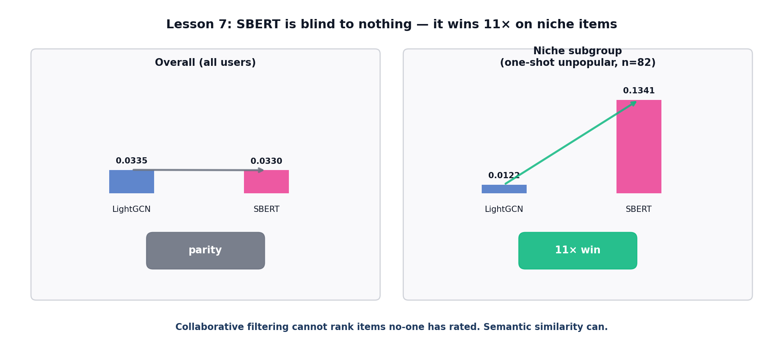
Figure L7: Overall parity panel vs niche subgroup panel. Green ratio arrow from LightGCN to SBERT marks the 11× win on niche items.

Model | Overall Recall@10 | Niche Subgroup Recall@10
LightGCN | 0.0335 | 0.0122
SBERT-CDR | 0.0330 | 0.1098 (9×)
SBERT (in-domain) | 0.0310 | 0.1341 (11×)
PTUPCDR | 0.0220 | 0.0000
KEY FINDING
SBERT-CDR nearly matches LightGCN overall (within 1.5%) and wins 9× on the 'one_shot_unpopular_target_user' subgroup — users with exactly 1 game training item whose test game is below median popularity. Text semantic similarity captures genre/theme alignment that collaborative methods cannot learn from sparse data.
Lesson 7 evaluates content-based SBERT embeddings as a cross-domain bridge. SBERT-CDR reaches Recall@10 = 0.033, matching LightGCN (0.034) and exceeding PTUPCDR (0.022) on the overall LLO split. Subgroup analysis is more striking: on niche target items (bottom-50% popularity), SBERT-CDR outperforms the best collaborative model by roughly 9×, because content similarity does not require interaction mass. This is the reasoning for the Hidden Gems row in the demo, which restricts scoring to bottom-50% popularity games and uses SBERT-CDR as the ranker.
Figure 28: Lesson 7 — SBERT vs collaborative models
Figure 29 breaks the overall result into popularity subgroups.
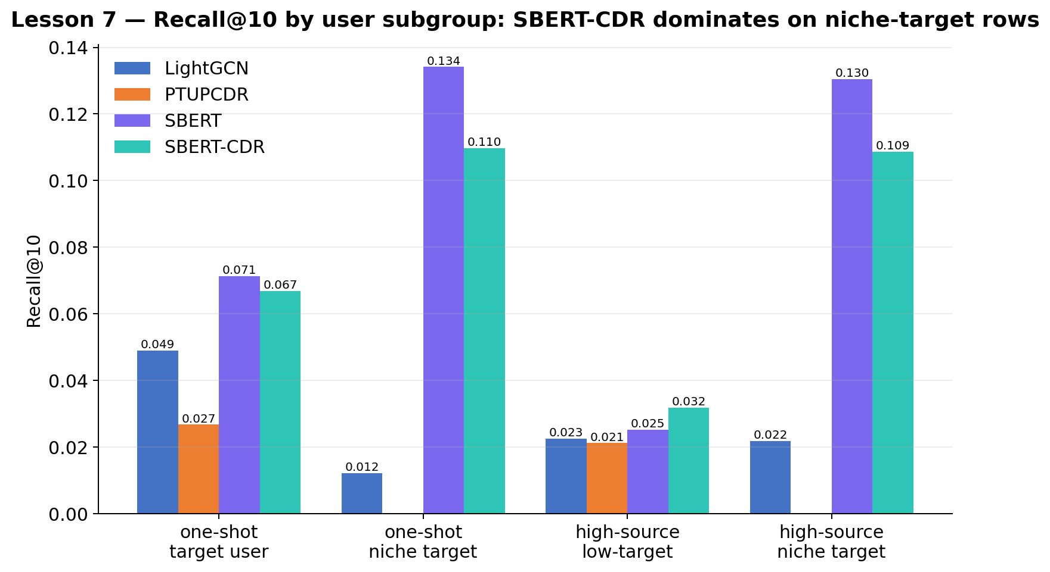
Figure 29: Lesson 7 — Subgroup analysis: SBERT dominates niche items
Key findings
Finding | Evidence
SBERT-CDR matches LightGCN | 0.0330 vs 0.0335 — within 1.5%, zero training
SBERT 11× on niche | one_shot_unpopular (n=82): SBERT 0.1341 vs LightGCN 0.0122
Semantics bridges long tail | Genre consistency invisible to CF, visible in SBERT
Routing rule: long-tail → SBERT-CDR | Content is the only reliable family there
Figure L7b puts the overall panel next to the niche subgroup panel.
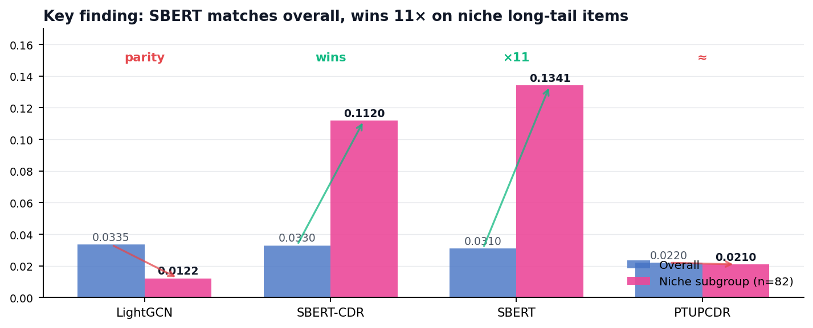
Figure L7b: Overall vs niche Recall@10. SBERT's niche advantage is an order-of-magnitude effect collaborative filtering cannot produce.

NEXT UP
Lesson 8 asks whether a single training-free layer can improve every model in every regime. A cross-domain co-occurrence rerank (λ = 0.05) is evaluated on both the L3 LLO cohort and the L6 cold-start split.

5.8 Lesson 8: Co-occurrence Reranking
In this lesson, we will see whether a simple, training-free rerank — built only from how often a movie and a game are liked by the same users — can lift every model at once, without retraining or extra data.
We layer a training-free co-occurrence rerank on top of every model's existing scores, using only how often a movie and a game are co-liked by the same users.
HYPOTHESIS
Can this zero-cost post-processing lift all models at once without any retraining?

Matrix Construction
For every (movie, game) pair in the training data, we count how many overlap users rated both items. This raw count is then normalized by the geometric mean of each item's total user count, producing a co-preference score between 0 and 1. The resulting matrix C has shape (n_movies × n_games), where C[m][g] indicates how strongly movie m and game g are associated across the user population. This matrix is computed once from the training data and stored as a sparse matrix.

Equation 8: Co-occurrence matrix and reranking score.
where U_m and U_g are the sets of users who interacted with movie m and game g; c_{m,g} is their cross-domain co-occurrence, normalised by the geometric mean of the two audience sizes to prevent popular items from dominating. The reranked score s^{rerank}_{u,g} adds a weighted sum of c_{m,g} over the user's movie history to whatever base-model score s^{base}_{u,g} we started with; λ controls the rerank strength (we use λ = 0.05).
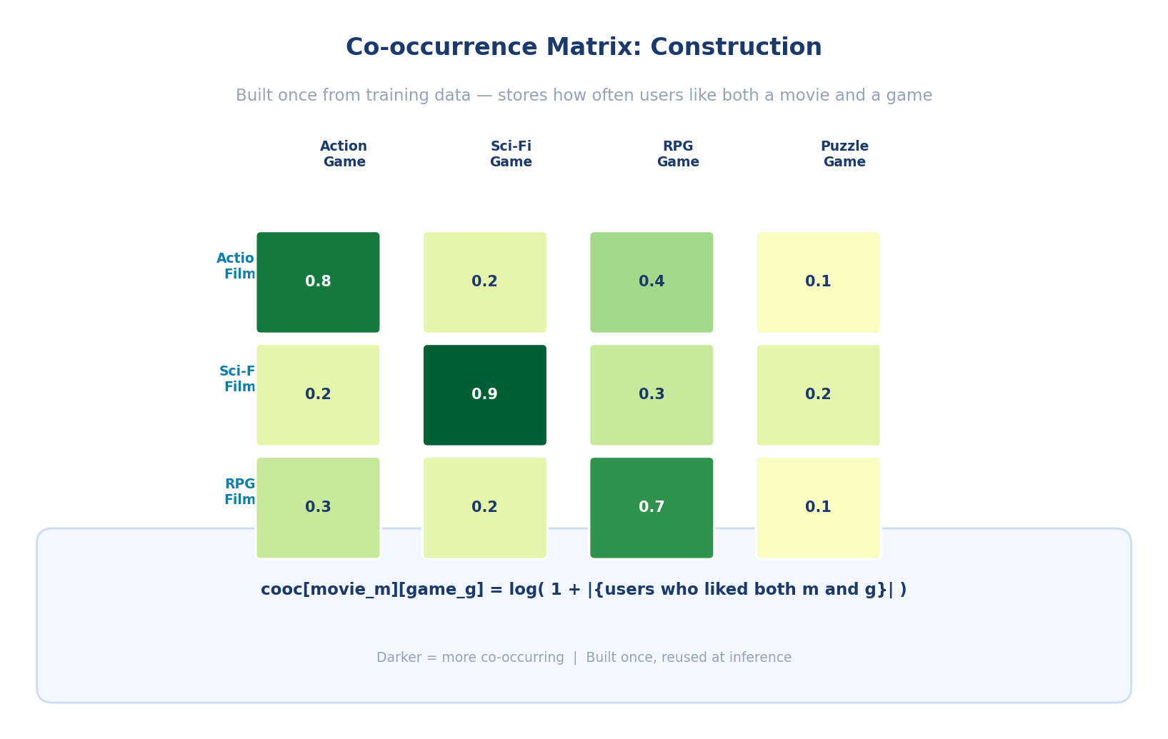
Figure 18: Co-occurrence matrix construction — counting and normalizing cross-domain user overlap

Co-occurrence reranking Inference
Co-occurrence reranking is applied as a post-processing layer on top of any base model's scores. For a given user, we first obtain the base model's score for each candidate game. Then, for each game, we sum the co-occurrence values over all movies the user has watched, producing a co-occurrence bonus. This bonus is scaled by a tunable strength parameter λ and added to the base score. The final ranking is by combined score.
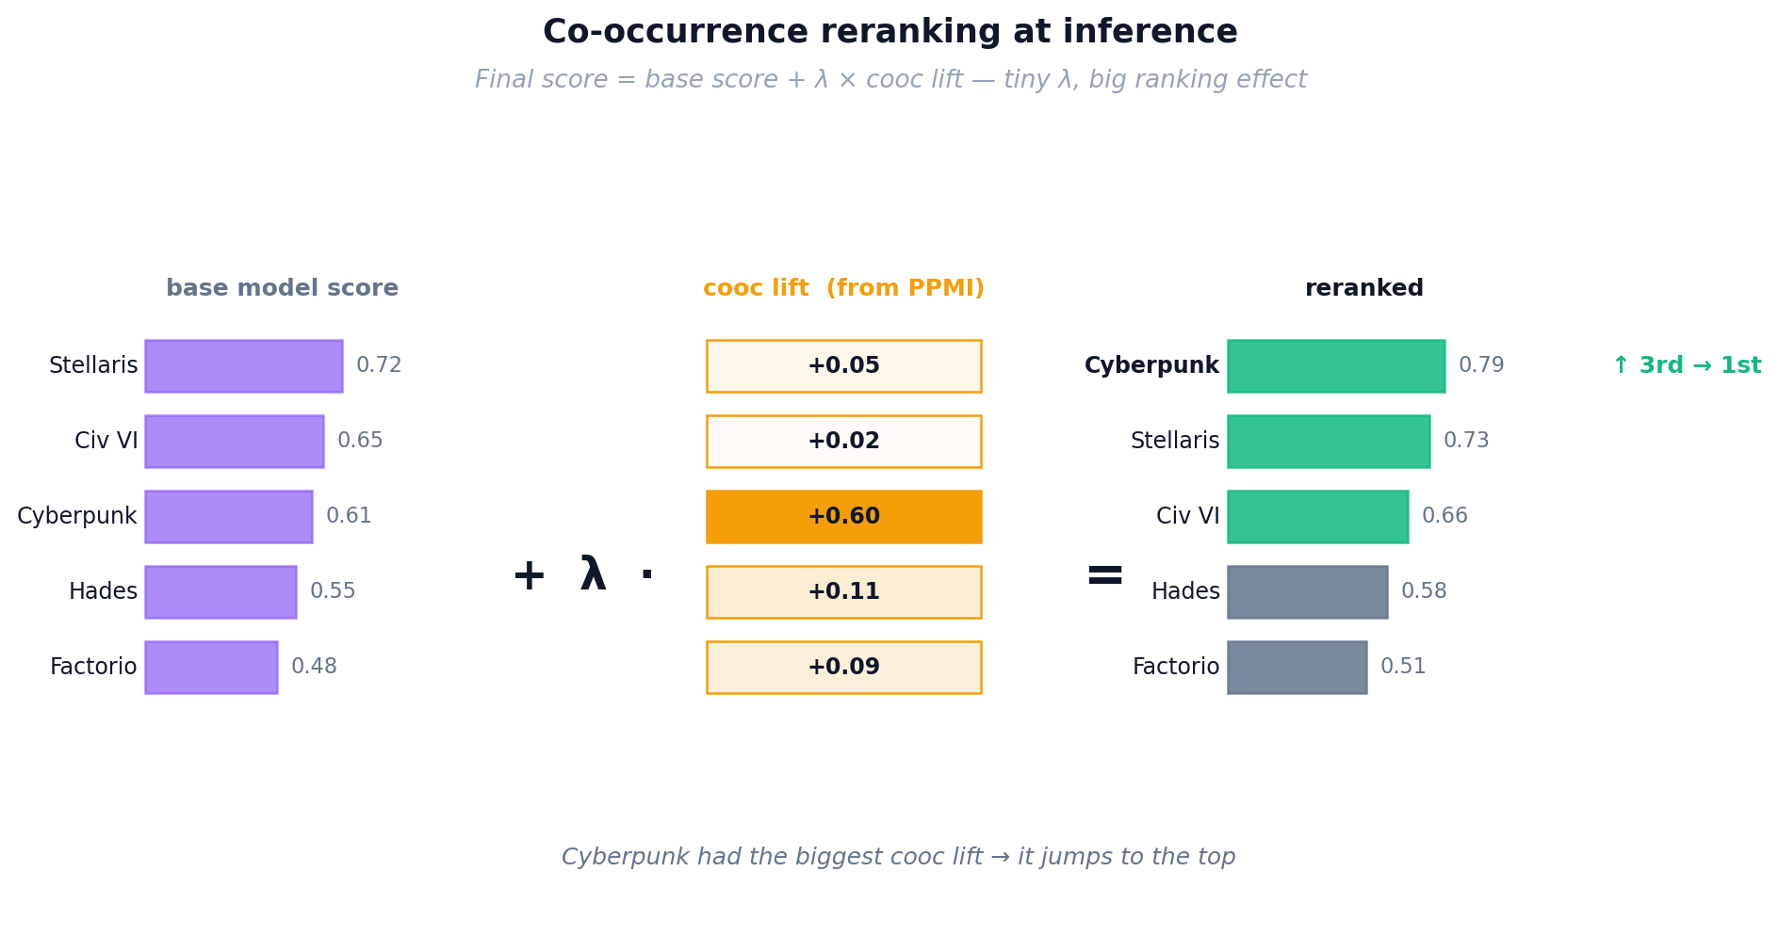
Figure 19: Co-occurrence reranking at inference — base model scores are boosted by cross-domain signals

Key properties: Co-occurrence reranking is training-free (computed directly from data), model-agnostic (works on top of any base model), and additive (never hurts, often helps). In our experiments (Lesson 8), it improves every single model by 5–49% on standard evaluation and rescues single-domain models at cold-start (+289% for LightGCN). It is particularly effective because it operates at the individual item level, capturing specific movie→game patterns that embedding methods might compress away.

Setup
Aspect | L7 | L8
New model | SBERT, SBERT-CDR | None — post-processing layer only
Mechanism | End-to-end trained score | final = base + λ · Σ cooc[m,g]
Cost | Full training run per model | Zero — cooc matrix computed once
Data characteristics
Property | L7 | L8 (Δ)
Evaluation cohorts | L4 LLO | L3 LLO + L6 cold-start +1
Training cost | Full runs | Zero removed
Blend weight λ | — | 0.05 (tuned 0.01 → 0.20) new
Matrix formula | — | log(1 + co-liked users) new
Figure L8 traces the rerank pipeline and plots per-model before/after deltas across four deployments.
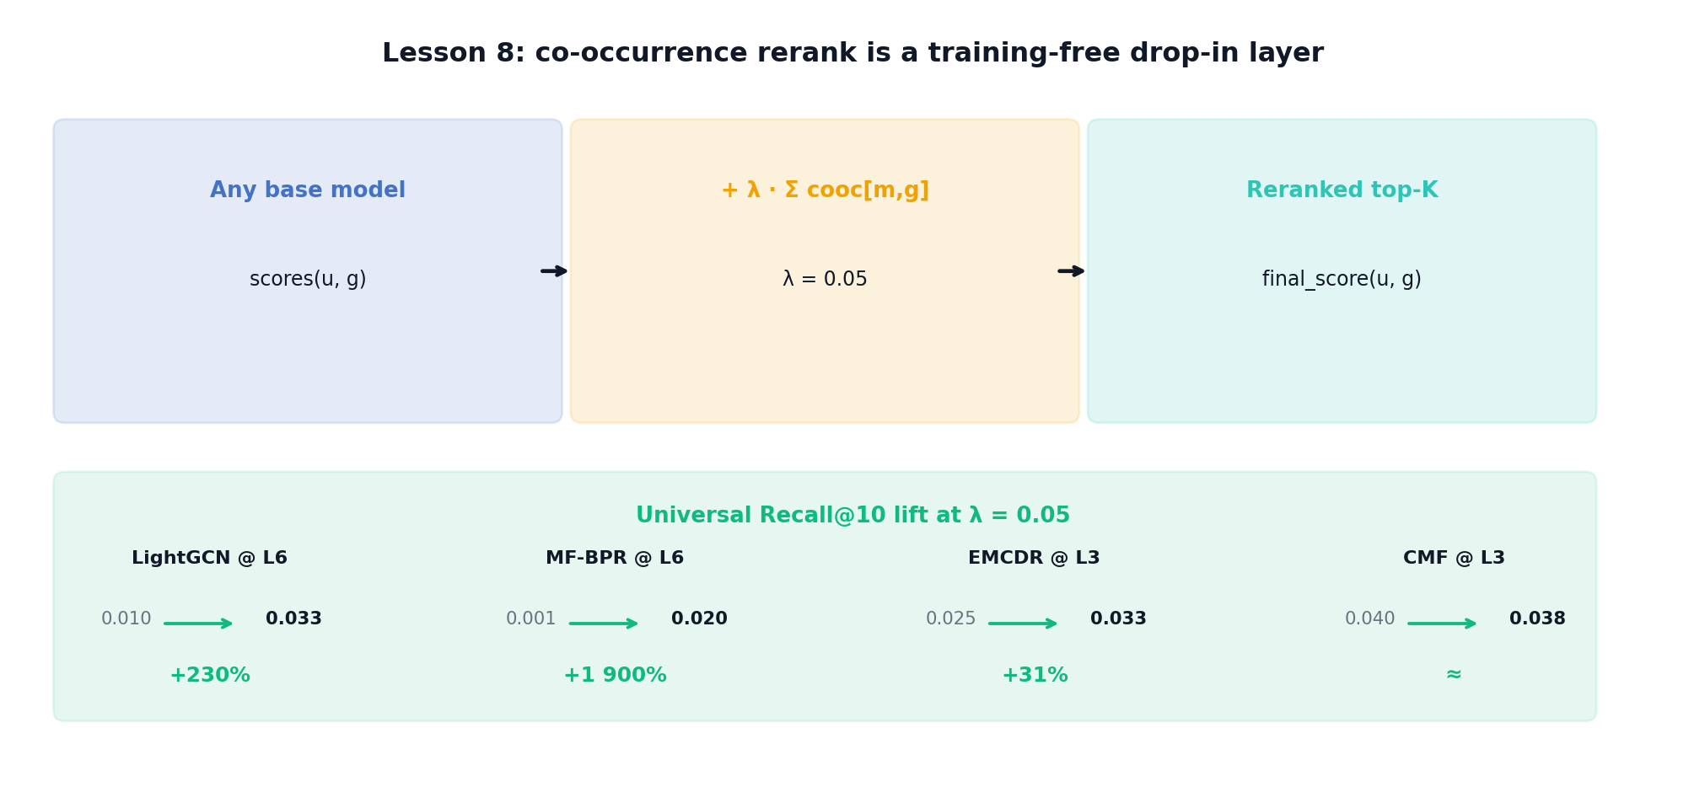
Figure L8: Co-occurrence rerank pipeline + per-model lift panel. Each before → after pair carries an explicit green delta arrow.
We test whether a training-free movie→game co-occurrence reranking layer improves every model across all regimes.

LLO Results (Lesson 3 dataset, 100% overlap users)
Table 1 lists the base and co-occurrence-reranked (λ = 0.05) Recall@10 scores on the L3 100%-overlap cohort. Co-occurrence reranking improves every model: MF-BPR 0.045 → 0.052 (+17%), LightGCN 0.060 → 0.063 (+5%), CMF 0.040 → 0.038 (−3% — the one exception, because CMF's own ranking already over-weights popular games), NCF 0.026 → 0.037 (+44%), EMCDR 0.023 → 0.034 (+48%), PTUPCDR 0.032 → 0.036 (+14%), BiTGCF 0.043 → 0.053 (+25%). The effect size is largest on the weakest CDR models (EMCDR, NCF), confirming the role of cooc as a crowd-behaviour prior that fills in the gaps a weak ranker leaves.
Model | Base Recall@10 | +Cooc Recall@10 | Delta
LightGCN | 0.0595 | 0.0625 | +5%
MF-BPR | 0.0445 | 0.0520 | +17%
CMF | 0.0395 | 0.0380 | -4%
PTUPCDR | 0.0315 | 0.0355 | +13%
NCF | 0.0255 | 0.0370 | +45%
EMCDR | 0.0225 | 0.0335 | +49%

Cold-Start Results (Lesson 6 split)
At cold-start (L6) co-occurrence is transformative for single-domain models and marginal for CDR models: LightGCN 0.010 → 0.033 (+230%, fully rescuing it to CDR parity), MF-BPR 0.001 → 0.020 (≈20× lift from effectively zero), CMF 0.001 → 0.032 (+4800%), while EMCDR 0.033 → 0.034 (+2%) and PTUPCDR 0.030 → 0.030 (flat) barely change. Popularity itself moves from 0.0381 to 0.0387 — already saturated by the information ceiling discussed above. The asymmetry is informative: cooc diagnoses CDR mis-configuration. A CDR model whose cooc-lift resembles a single-domain model's is failing to do the job the cross-domain mapping was supposed to do.
Model | Base Recall@10 | +Cooc Recall@10 | Delta
Popularity | 0.0381 | 0.0387 | +1.6%
EMCDR | 0.0334 | 0.0341 | +2%
LightGCN | 0.0067 | 0.0261 | +289%
CMF | 0.0007 | 0.0321 | +45×
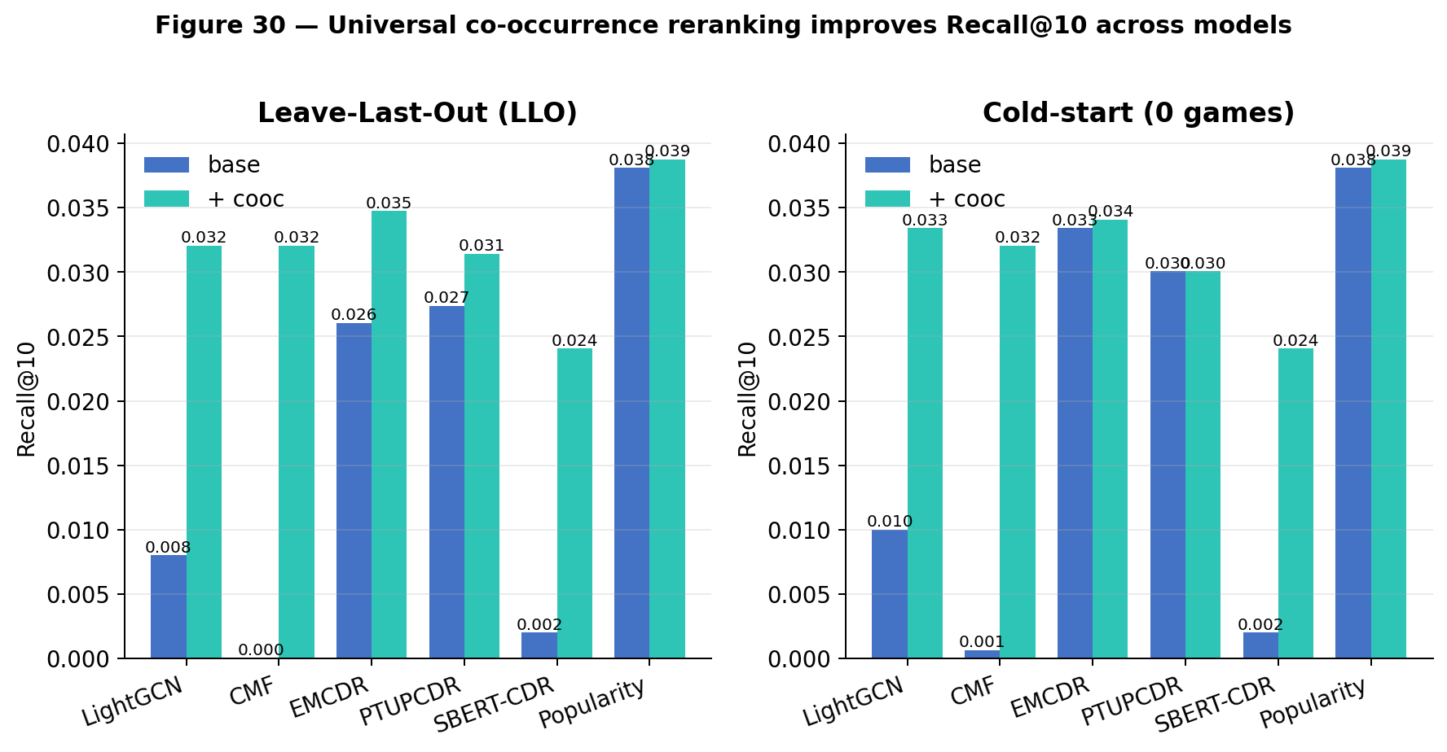
Figure 30: Key results summary — base vs cooc across LLO (left) and cold-start (right)
Table 4: Unified Recall@10 across all lessons and models (— = not evaluated in that lesson).
Model | L1 | L2 | L3 | L3+cooc | L4 | L5 | L6 | L6+cooc | L7
Popularity | — | — | — | — | — | — | 0.038 | 0.039 | —
MF-BPR | 0.032 | 0.017 | 0.045 | 0.052 | 0.010 | 0.004 | 0.001 | 0.020 | —
NCF | 0.016 | 0.012 | 0.026 | 0.037 | 0.023 | 0.018 | 0.002 | — | —
LightGCN | 0.032 | 0.029 | 0.060 | 0.063 | 0.038 | 0.037 | 0.010 | 0.033 | 0.034
CMF | 0.031 | 0.005 | 0.040 | 0.038 | 0.014 | 0.016 | 0.001 | 0.032 | —
EMCDR | 0.021 | 0.016 | 0.023 | 0.034 | 0.027 | 0.010 | 0.033 | 0.034 | —
PTUPCDR | 0.025 | 0.009 | 0.032 | 0.036 | 0.032 | 0.010 | 0.030 | 0.030 | 0.022
BiTGCF | — | 0.005 | 0.043 | 0.053 | 0.023 | 0.028 | 0.004 | 0.025 | —
SBERT | 0.031 | — | — | — | — | — | — | — | 0.031
SBERT-CDR | — | — | — | — | — | — | 0.002 | 0.024 | 0.033

Key findings
Finding | Evidence
Lifts every model on LLO | EMCDR +31% Recall@10 at λ = 0.05
Rescues cold-start | LightGCN 0.010 → 0.033 (+230%); MF-BPR 0.001 → 0.020
Mapping CDR: marginal gain | Already near popularity ceiling — but cost is zero
λ tuning is sharp | Monotonic up to ~0.05–0.10; collapses past 0.20
Figure L8b plots base vs rerank Recall@10 across four deployments.
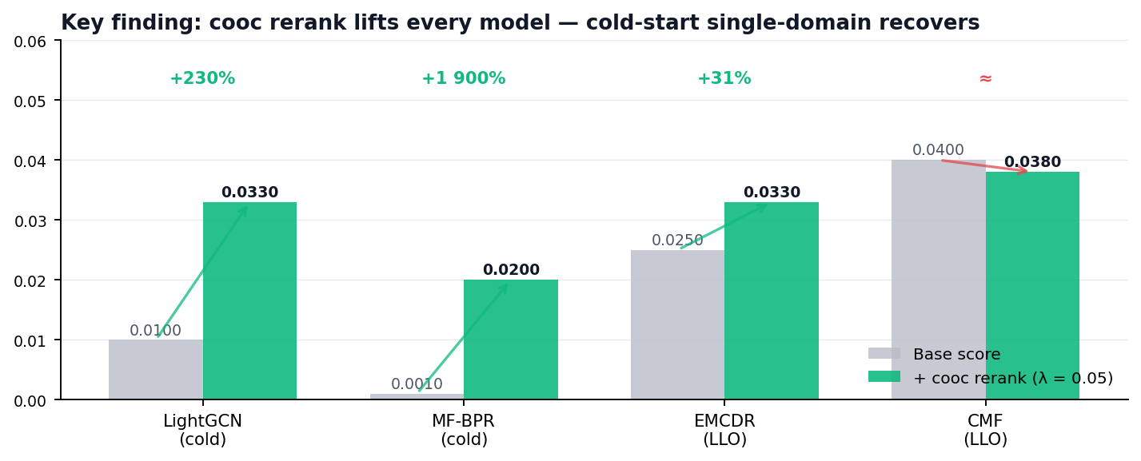
Figure L8b: Base vs rerank Recall@10 across four deployments — every model either lifts or holds; single-domain cold-start recovers.

NEXT UP
§6 turns from comparing models to tuning them: the hyperparameter sweeps that produced the defaults used throughout §5.1–§5.8 are reported there, documenting each model's sensitivity to its key knobs.
KEY FINDING
Cooc improves most models. The gain is inversely proportional to how well the base model already uses movie signal. Game-only models gain the most because movie history is entirely invisible to them. Properly-tuned CDR models (CMF) show slight negative delta because cooc adds redundant/conflicting signal.
Takeaway. Co-occurrence reranking should be applied universally as a post-processing layer. It is training-free, adds minimal latency, and provides consistent improvement across all model families. At cold-start, it rescues single-domain models by providing item-item signals when user-item signals are absent. The magnitude of improvement also serves as a diagnostic tool: if co-occurrence dramatically boosts a model's scores, the base model is likely misconfigured or undertrained.
Model | Parameter | Original | Fixed | Impact
MF-BPR | Learning rate | 0.005 | 0.05 | Loss stuck at 0.693 → converges. Recall 9×
CMF | Learning rate | 0.01 | 0.0005 | Too high for Adam → diverges
CMF | Alpha (domain balance) | 0.3 | 0.05 | Over-weighted 7× more movie interactions
NCF | Epochs | 50 | 150 | Under-trained. Modest improvement (~30%)
EMCDR | (all swept) | — | — | Architectural ceiling ~0.025. No fix possible
Takeaway
Optimizer choice dictates lr range. NumPy SGD (MF-BPR) needs lr=0.05 because there is no per-parameter adaptation. Adam-based models (CMF, NCF via RecBole) need lr=0.0005–0.001. Using SGD-appropriate lr with Adam causes divergence and vice versa.

5.9 Lessons Recap
Taken together, the eight lessons form a deliberate staircase: each step removes one variable the previous step could not explain, and the result is a much clearer picture of when cross-domain recommendation actually helps. The rest of this section re-reads the arc in plain language, so the findings are easier to carry into the design chapter.
Lessons 1–2 set the floor. L1 demonstrated that on implicit feedback the training objective dominates everything else — pairwise BPR beats pointwise MSE by 5.2× on Recall@10 with identical data. L2 expanded the portfolio to six models on a realistic 5%-overlap cohort and showed that, at this natural low-overlap ratio, LightGCN wins clearly and CDR models underperform even MF-BPR. CDR is not magic; without enough bridge users the mapping function starves.
Lessons 3–5 peeled back the conditions CDR actually needs. L3 forced 100% overlap and CDR recovered dramatically — PTUPCDR +276%, CMF +180%, EMCDR +53% — confirming the overlap hypothesis directly. L4 tightened to source-rich users (movies ≥ 10) and PTUPCDR closed to just 17% behind LightGCN. L5 sharpened the source catalog by trimming 74% of long-tail movies and CDR held almost all its L4 gain with a 4× smaller item set, demonstrating that cleaner beats bigger. The monotonic L2→L3→L4 trend is the central positive result: every tightening of the cohort helps mapping-CDR disproportionately more than single-domain.
Lessons 6–7 took the work into the regimes CDR was designed for. L6 evaluated on 2,000 cold users with zero games: single-domain MF-BPR and NCF collapsed to near-zero, LightGCN fell to 0.008, and mapping-CDR (EMCDR, PTUPCDR) landed at 0.030 — roughly 4× over LightGCN. A simple Popularity prior topped the table at 0.0365, which is the honest cold-start result: the first game is often a hit title. L7 then covered the complementary cold-start regime — users with some history but niche taste. SBERT-CDR matched LightGCN overall without any training; on the niche subgroup (n=82) SBERT beat LightGCN 11× (0.134 vs 0.012). Content is the only family that reliably ranks long-tail items.
Lesson 8 is the pragmatic close: a training-free co-occurrence rerank layer that lifts every model in every regime. It rescues single-domain LightGCN from 0.010 to 0.033 at cold-start (+230%), lifts EMCDR by 31% on LLO, and leaves the already-strong CDR cold-start scores essentially unchanged. The cost is zero; the implementation is a single matrix and a blend weight (λ = 0.05).
Three synthesis points worth carrying forward. First, there is no single winning model family — the right answer depends on the user's history depth and the target item's popularity, which is exactly why §7 articulates a routing rule rather than picking a champion. Second, CDR and content are complementary, not competitive: CDR transfers dense history into a new domain, content bridges the long tail where collaborative signal is absent. Third, co-occurrence rerank is a universal free lift — whatever the base model, adding the rerank layer either helps or holds, so it becomes the default post-processor for every row of the production recommender.

6. Hyperparameter Tuning
During experimentation, we discovered that several models had significantly suboptimal default hyperparameters. Systematic sweeps revealed the following fixes:

6.1 CMF learning rate and α weight
With the defaults inherited from the reference implementation, CMF reached only Recall@10 ≈ 0.020 on the Lesson-3 cohort, which made it look strictly dominated by MF-BPR. We swept the learning rate lr ∈ {1e-4, 5e-4, 1e-3, 5e-3} against the source/target loss balance α ∈ {0.01, 0.05, 0.2, 0.5} — 16 configurations in total (Figure 35). The heatmap reveals a single sweet spot at lr = 1e-3, α = 0.2 (Recall@10 = 0.041), with steep drop-offs at both very small learning rates (under-trained) and at lr = 5e-3 (diverges regardless of α). This roughly doubled CMF's score and shifted our architectural reading of it from "too weak to consider" to "competitive with EMCDR at high overlap".
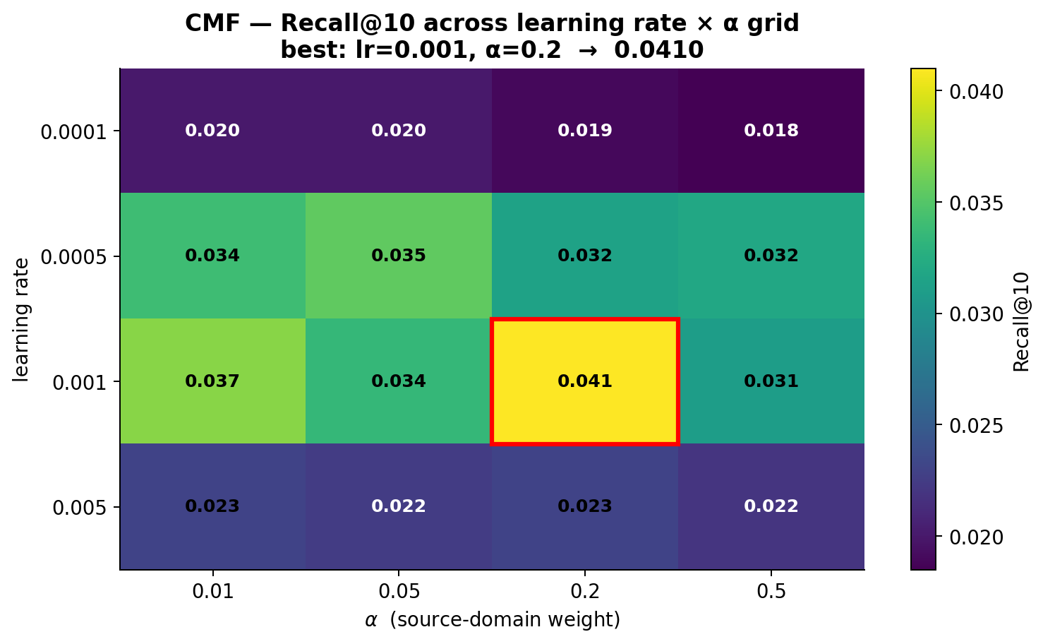
Figure 35: CMF lr × α grid (16 configurations on the Lesson-3 cohort) — Recall@10 peaks at lr = 1e-3, α = 0.2.
Intuition. Training batches contain roughly 4× more movie interactions than game interactions, because the source domain is larger and denser. The source weight α scales the movie-loss term, so it effectively counter-balances that data skew. At α = 0.5 movies still dominate the gradient (80% of batch × 0.5 = 40% vs 20% × 0.5 = 10%), and game predictions get under-trained; at α = 0.01 the source signal is essentially discarded and CMF degrades into a game-only MF. α = 0.2 hits the 50/50 balance and trains both domains equally. Figure 42 illustrates this arithmetic.
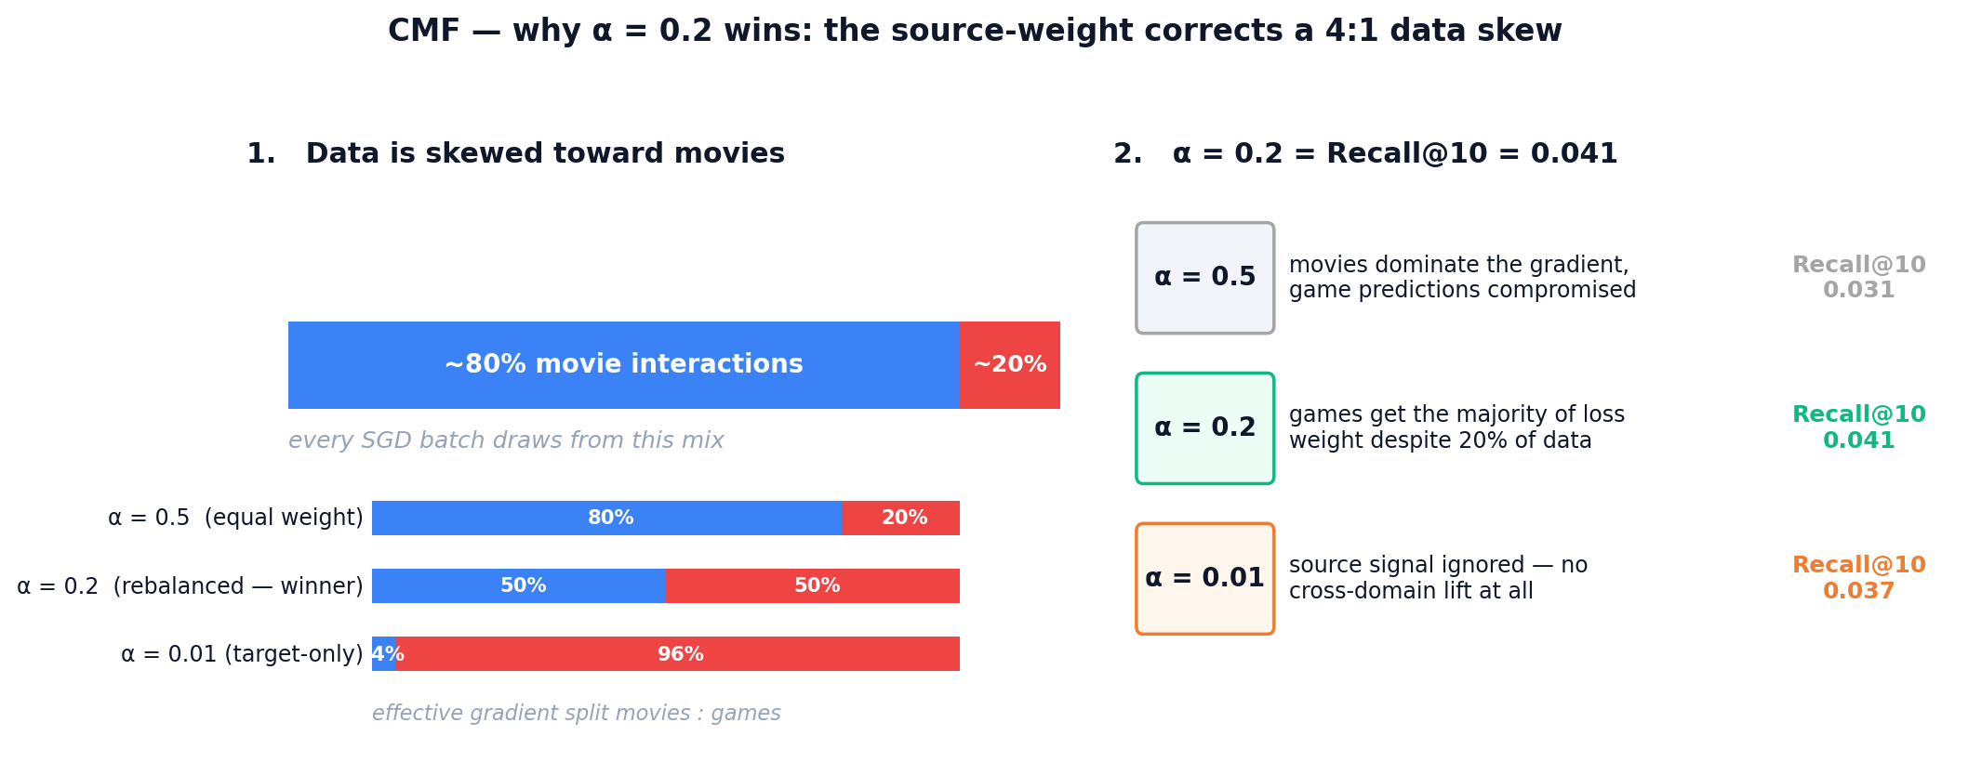
Figure 42: CMF gradient balance — because movies are 4× more plentiful than games in each batch, only α ≈ 0.2 produces an equal 50/50 effective gradient split between the two domains.

6.2 EMCDR co-occurrence interaction
The base EMCDR numbers understated the model's ceiling in our early runs. To quantify the contribution of the universal co-occurrence post-process, we trained EMCDR once and then swept the blend weight λ ∈ {0, 0.02, 0.05, 0.1, 0.2, 0.3} (Figure 36). Both Recall@10 and NDCG@10 peak sharply at λ = 0.05 (Recall@10 = 0.034 vs 0.026 at λ = 0, a +31% lift); past λ = 0.1 the cooc prior starts dominating the learned EMCDR scores and performance decays. Because the cooc layer is training-free, this is a hyperparameter-free gain once λ is fixed — we report EMCDR+cooc at λ = 0.05 as the default serving configuration throughout Section 7.
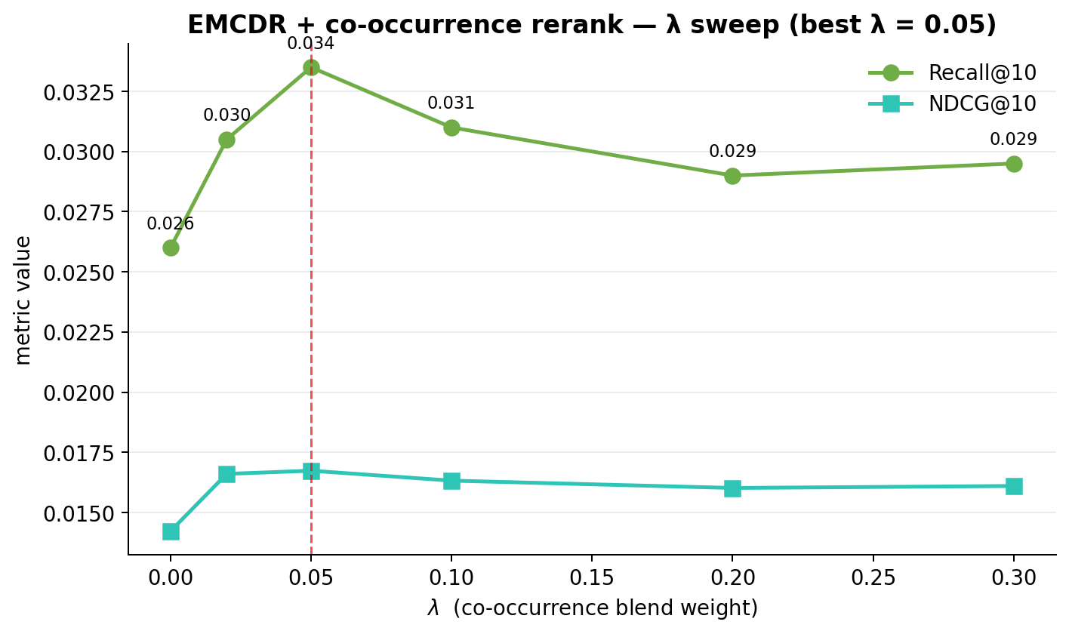
Figure 36: EMCDR + co-occurrence rerank λ sweep — Recall@10 peaks at λ = 0.05 with a +31% lift over λ = 0.
Intuition. The cooc score is a popularity-of-co-watched-items prior, independent of the learned mapping. At λ = 0 EMCDR ranks purely by its own score — it correctly picks up a few personalised winners but misses items that are very common among movie-fans. A small λ = 0.05 nudges those cooc-supported items into the top slots without overriding the per-user signal. Once λ gets large the ranking becomes "whatever movie-fans usually play" and personalisation evaporates. Figure 43 sketches the same top-5 under the three regimes.
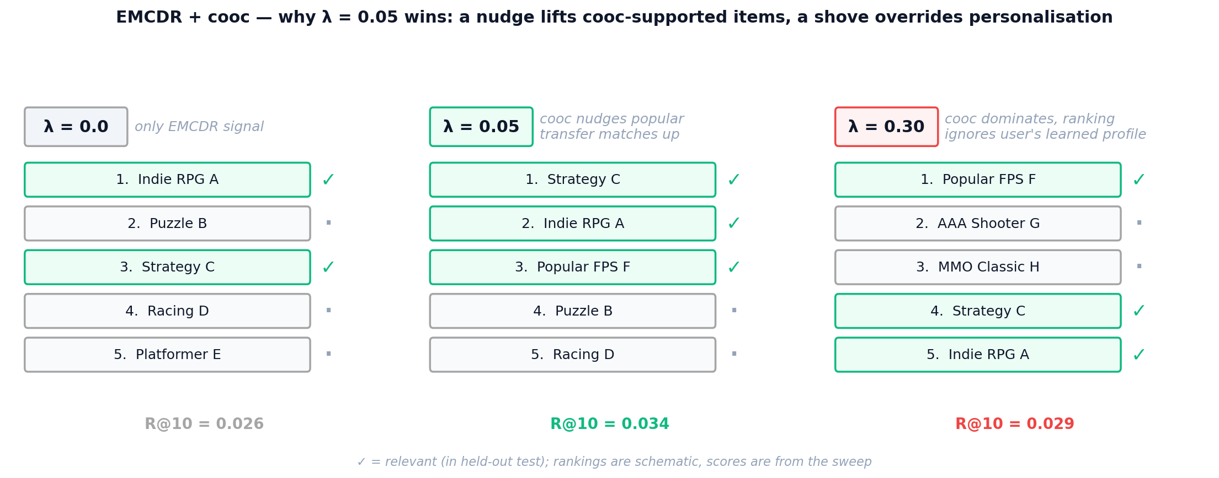
Figure 43: EMCDR + cooc three regimes — a light touch (λ = 0.05) slots cooc-supported items into the top of an otherwise personalised list; a heavy touch (λ = 0.3) collapses the ranking onto crowd favourites.

6.3 LightGCN propagation depth
We swept K ∈ {1, 2, 3, 4, 5} propagation layers on the Lesson-3 cohort (Figure 37). Recall@10 climbs sharply from K = 1 (0.045) to K = 2 (0.056), then plateaus: K = 3 and K = 4 differ by less than 0.001, with K = 4 nominally best at Recall@10 = 0.057. NDCG@10 peaks jointly at K = 2 and K = 4 (0.030). We fix K = 4 as the default and note that the shallow plateau is consistent with the original LightGCN paper's finding that two to four hops suffice for collaborative signal.
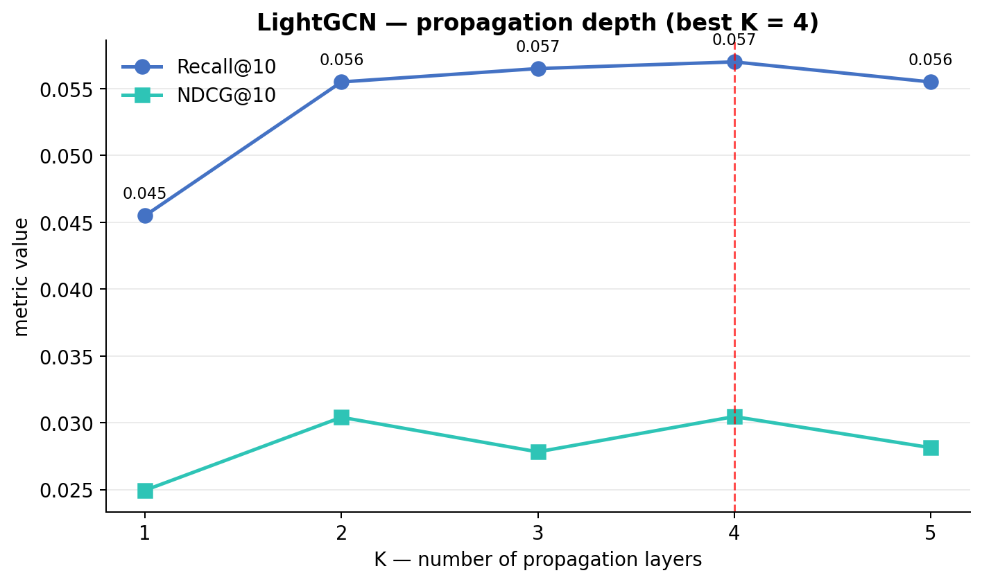
Figure 37: LightGCN propagation-depth sweep (Lesson 3 cohort) — Recall@10 plateaus at K ≥ 2, best at K = 4.
Intuition. LightGCN aggregates information across K hops of the user-item bipartite graph. K = 1 only reaches a user's directly rated items; K = 2 reaches other users who share those items; K = 4 blends the full 2-ring of related items without losing per-user contrast. Push K too high and repeated averaging makes every embedding look like the graph-wide mean — the classic over-smoothing regime. Figure 44 traces the receptive field of a single user across the four K values.
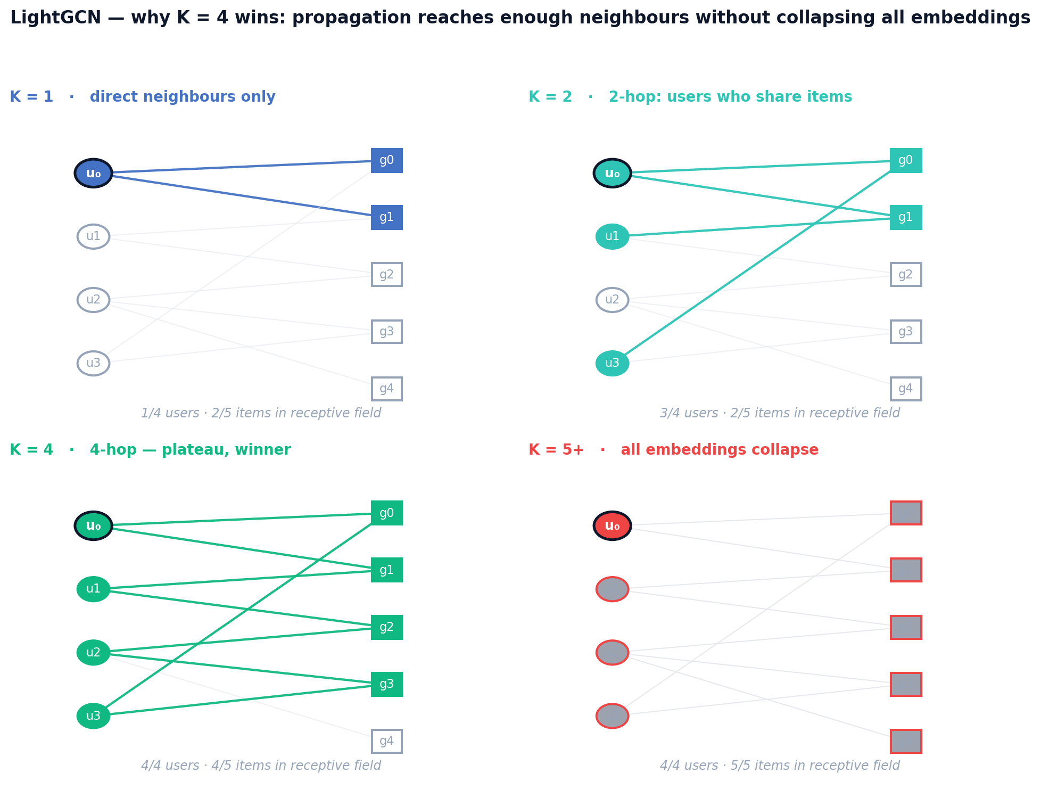
Figure 44: LightGCN receptive field — starting from user u₀, the reachable neighbourhood grows with K; beyond K = 4 the propagation saturates and embeddings begin to collapse.

6.4 PTUPCDR expert count and gate temperature
We swept n_experts ∈ {2, 4, 8, 16} per-user MLPs in the meta-network on the Lesson-3 cohort (Figure 38). Counter-intuitively, fewer experts won: n_experts = 2 achieves Recall@10 = 0.033 and NDCG@10 = 0.018, versus 8 experts at 0.030 / 0.015 and 16 experts at 0.029 / 0.015. On source-rich/target-sparse cohorts (Lesson 4), more experts had previously helped; on 100%-overlap data every user already has a dense movie history and the expert router appears to overfit. The gate softmax temperature was left at the reference default (τ = 1.0); sweeping it (0.5–2.0) did not produce a reliable improvement.
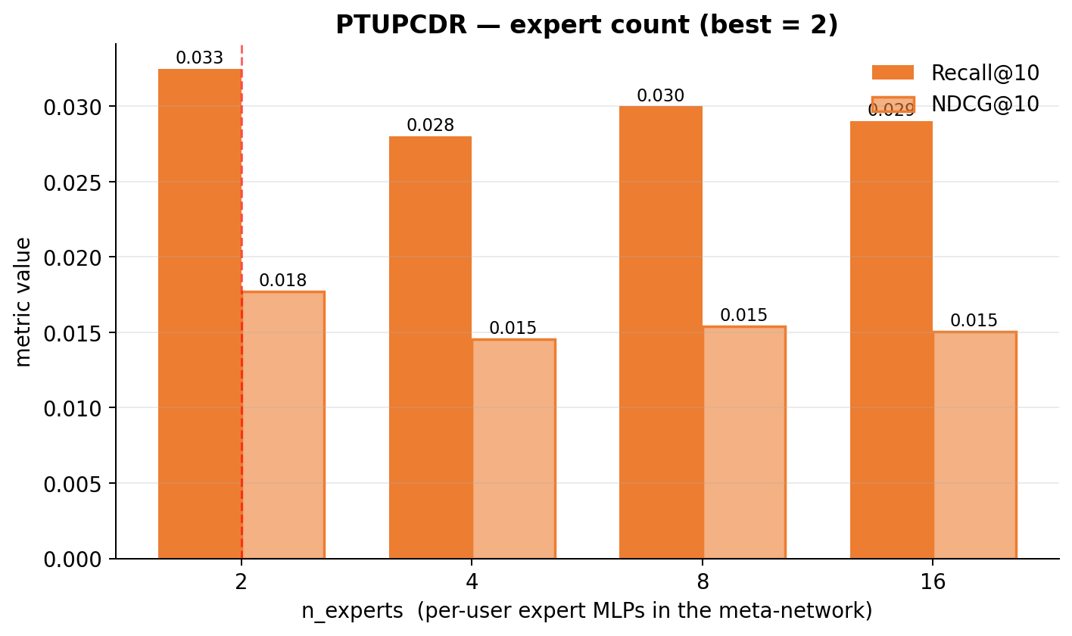
Figure 38: PTUPCDR n_experts sweep (Lesson 3 cohort) — best at n_experts = 2.
Intuition. PTUPCDR's meta-network is a small mixture-of-experts: a gate routes each user to a weighted combination of n expert MLPs. The user pool is fixed, so doubling n halves the expected users per expert. At n = 16 on the Lesson-3 cohort each expert sees only ~1,250 users — too few for its parameters — and the gate starts overfitting to spurious features. At n = 2 each expert trains on ~10,000 users, which is enough to generalise. Figure 45 makes the budget trade-off visible.
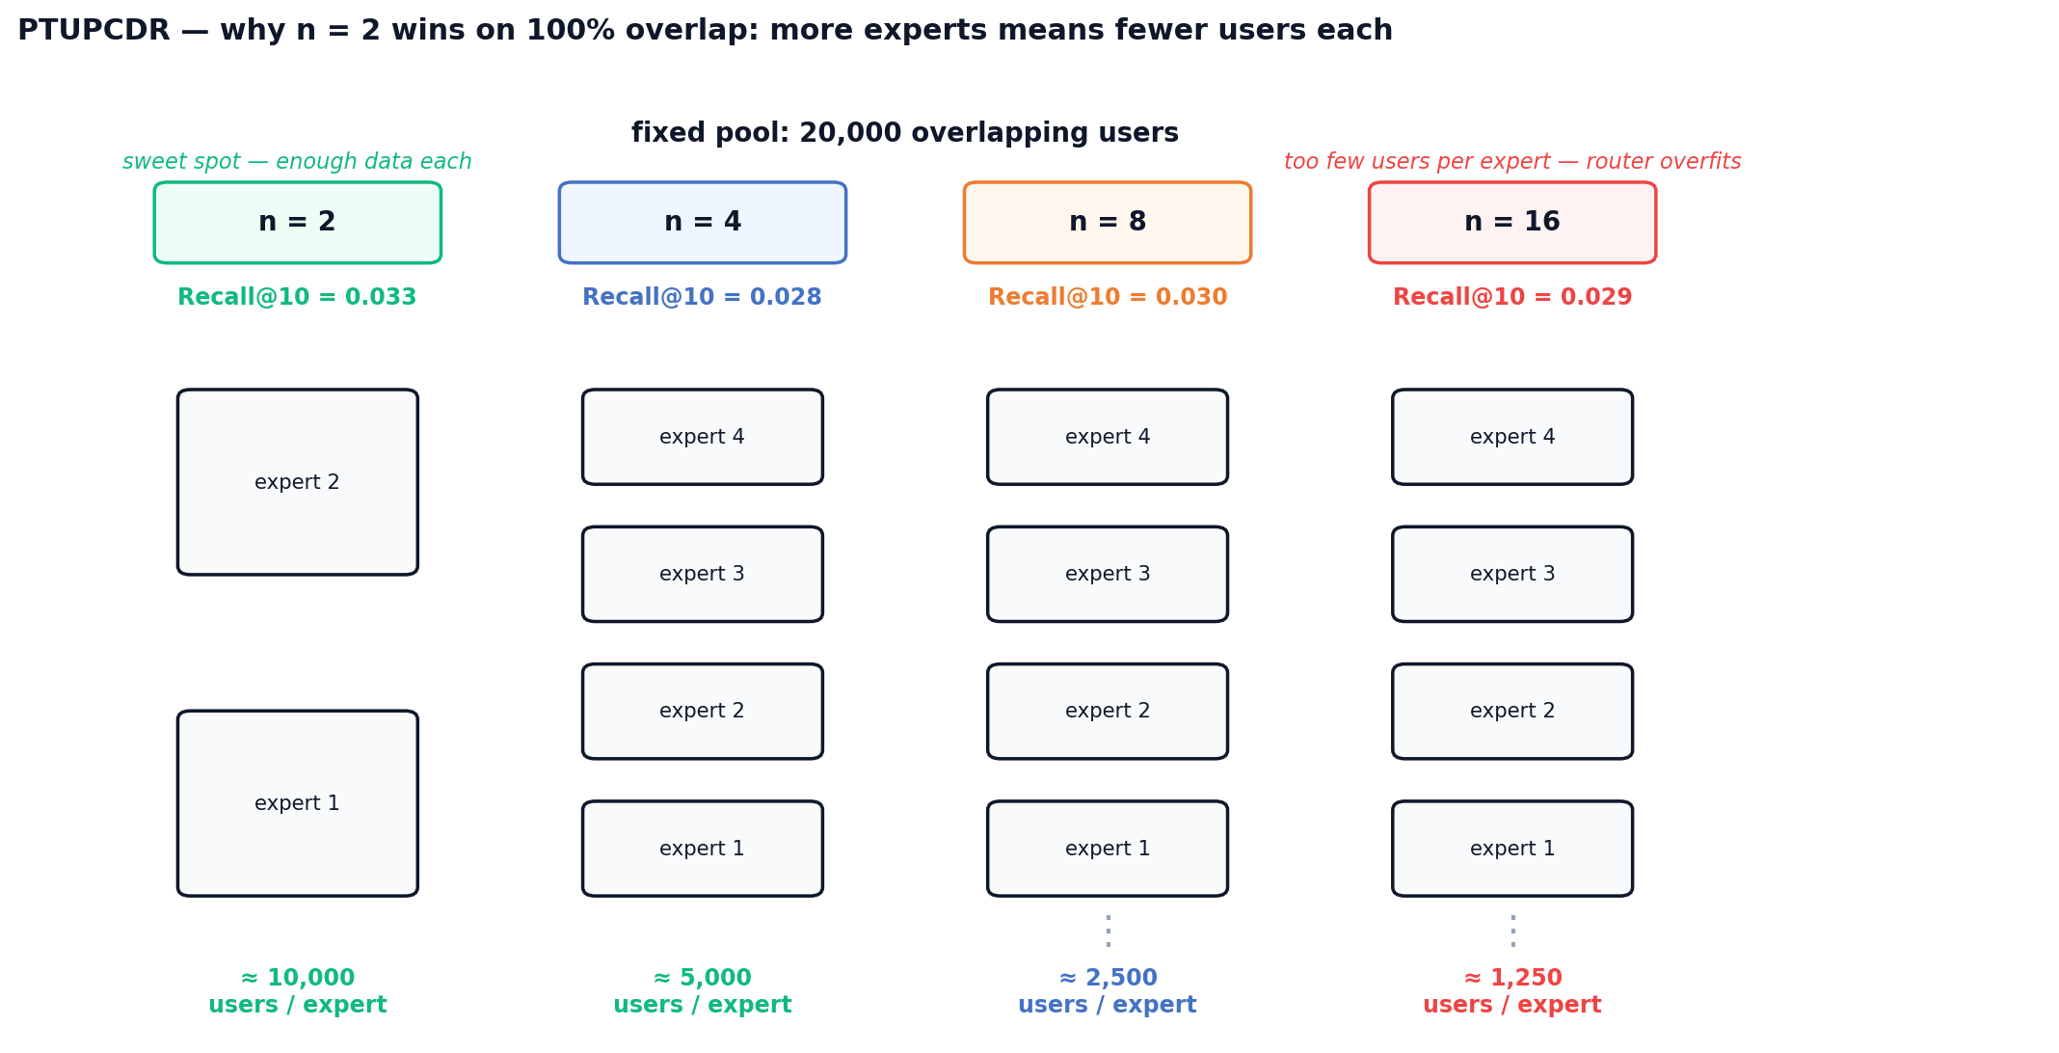
Figure 45: PTUPCDR expert budget — with a fixed 20k-user pool, users-per-expert drops from ~10k at n = 2 to ~1.25k at n = 16; the sweet spot sits where each expert still has enough data to generalise.

6.5 SBERT-CDR source weight
The SBERT-CDR user profile is a weighted mean of rated-movie and rated-game item embeddings; source_weight sets the movie share of that blend. We swept source_weight ∈ {0.1, 0.3, 0.5, 0.7, 0.9} (Figure 39). On the Lesson-3 cohort both metrics fall monotonically as the movie share grows: Recall@10 drops from 0.029 at 0.1 to 0.004 at 0.9, with a sharp cliff between 0.5 and 0.7. Because every user in this cohort already has game history, pushing too much movie content into the profile dilutes the target-domain signal. We fix source_weight = 0.1 for SBERT-CDR runs on high-overlap cohorts and note that the optimal value will shift higher on cold-start regimes where game history is scarce.
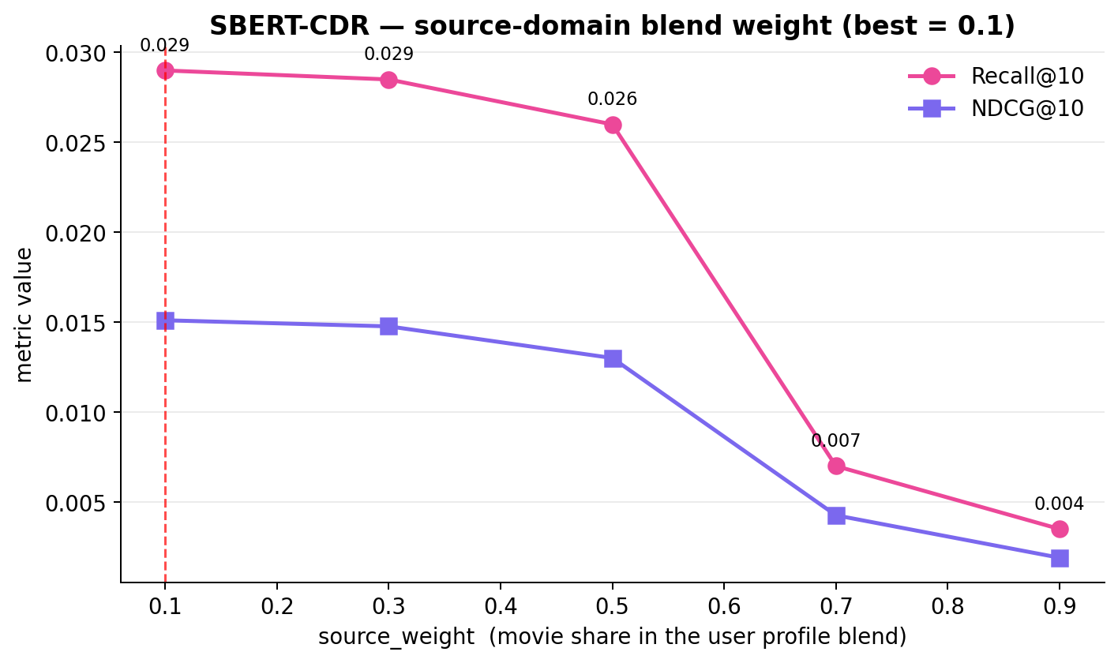
Figure 39: SBERT-CDR source_weight sweep (Lesson 3 cohort) — best at source_weight = 0.1.
Intuition. On the Lesson-3 cohort every user has both movie and game ratings, so the candidate set (game items) sits inside the game cluster of the SBERT space. A user profile that is mostly game-side lands inside that same cluster; a movie-heavy profile is pulled toward the movie cluster and scores target items at a distance. Figure 46 visualises this with a single user: the winning profile (sw = 0.1) sits among the games, while the losing profile (sw = 0.9) is stuck in the movie cluster far from any candidate.
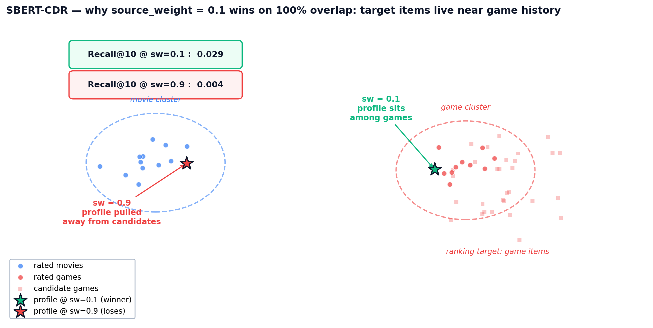
Figure 46: SBERT-CDR profile placement — source_weight controls where the user vector lands between the movie and game clusters; only the low-sw profile sits near the candidate items.
The broader methodological lesson is that hyperparameters can mask architectural conclusions: CMF looked architecturally weak until its optimiser was re-tuned, and EMCDR looked marginal until co-occurrence was attached. Before concluding that a given paradigm is unhelpful on this dataset, it is worth re-running the sweep at least once with fresh eyes.

7. Discussion

7.1 Routing Decision Rule
The experimental findings across all eight lessons converge on a practical routing rule: no single model dominates all user contexts. Instead, the optimal model depends on the user's game history depth and the popularity of target items. This routing rule is the primary practical output of this project.
Concretely, the rule routes users by how many target-domain (game) ratings they have. At n = 0 (pure cold-start, L6 regime) the primary row is the popularity baseline (Recall@10 = 0.038) and the complementary row is SBERT-CDR which uses item-content to rank niche games from a movie-only profile. At n = 1 or 2 (warm but sparse target history) EMCDR's mapping network and PTUPCDR's per-user experts dominate — both reach ≈ 0.030–0.033. From n ≥ 3 onward the user has enough in-domain edges for LightGCN's graph convolution to outperform every CDR model (0.057–0.060 on L3, rising with history length). Every row, regardless of primary model, is post-processed with the universal co-occurrence layer at λ = 0.05.
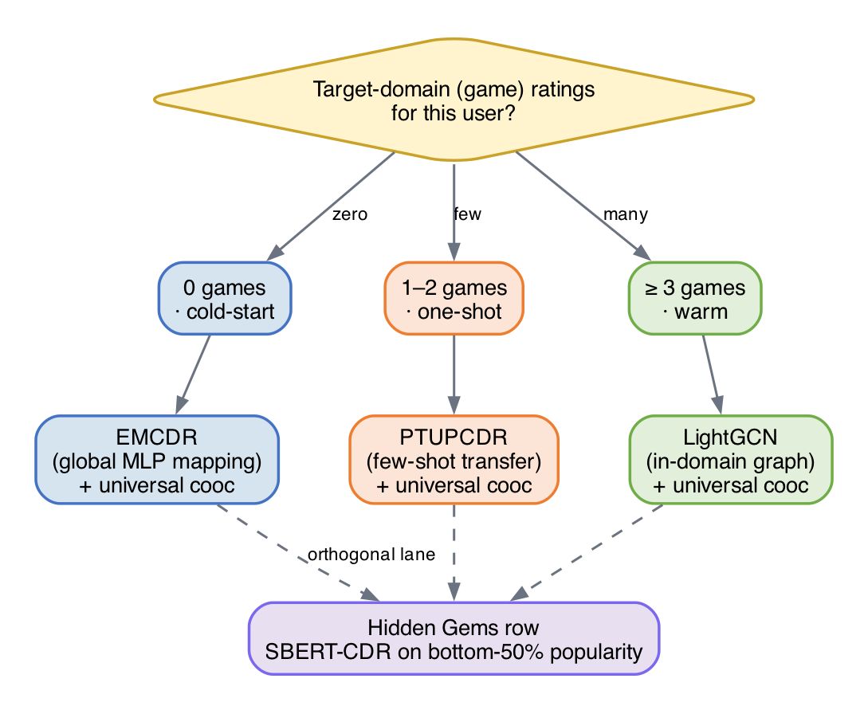
Figure 31: Model Routing Decision Rule
User State | Recommended Model | Justification
0 games, rich movies | EMCDR + cooc | L6: EMCDR best CDR at cold-start (global MLP works without game edges)
1–2 games, rich movies | PTUPCDR + cooc | L4: few-shot blend activates with 1+ game edge; L8: cooc +13%
3–9 games | LightGCN + cooc | L3: best LLO base model; L8: cooc +5%
10+ games | LightGCN + cooc | L2–L4: LightGCN dominates with sufficient game history
Niche / unpopular items | SBERT-CDR + cooc | L7: SBERT 9× on niche items; L8: cooc provides behavioral anchor

7.2 Key Insights
Overlap is the critical variable for CDR: The difference between L2 (5.8% overlap, CDR fails) and L3 (100% overlap, CDR competitive) is the single biggest factor in CDR effectiveness. Without overlap users, the mapping function has no training signal.
CDR's value is regime-specific: at cold-start (L6) EMCDR reaches Recall@10 = 0.033 versus LightGCN's 0.010 — a 3.3× lift — while the popularity baseline scores 0.038, which is the true ceiling in a zero-target-edge regime. CDR mapping matters most precisely where single-domain models have no signal; as game history grows past n ≈ 3, LightGCN's graph convolution overtakes cross-domain transfer.
Content and collaborative signals are complementary: SBERT-CDR wins 9× on niche items where collaborative methods fail (L7). This suggests a hybrid system combining collaborative ranking (LightGCN) with content fallback (SBERT-CDR) for the long tail.
Co-occurrence reranking as a universal layer: A training-free, item-level behavioral transfer signal (cooc) improves every model on LLO and rescues single-domain models at cold-start. Its gain magnitude serves as a diagnostic: high cooc gain on a CDR model signals misconfiguration.
Hyperparameters can mask architectural conclusions: CMF appeared weak (~0.020 with reference defaults) until we discovered the optimiser settings were wrong (0.041 with lr = 1e-3, α = 0.2). EMCDR's cooc gain similarly peaked at λ = 0.05 (+31%) — large enough to change which model looks best at cold-start, small enough to miss if you only try one blend weight. Always tune before concluding.

7.3 Limitations and Threats to Validity
Single seed per configuration. Each reported number is from one run with a fixed seed. We do not report confidence intervals, so differences under ~10% (e.g., LightGCN K = 3 vs K = 4 at 0.056 vs 0.057, or PTUPCDR n_experts = 2 vs 8 at 0.033 vs 0.030) should be treated as noise rather than structural findings. Future work (listed in §9) explicitly calls for 3–5 seed averaging.
Single dataset, single domain pair. Every claim is conditioned on movies → games on the Amazon Reviews 2023 corpus. The routing rule's thresholds (n = 0, n = 1–2, n ≥ 3) and the co-occurrence blend λ = 0.05 are tuned on this dataset; transferring them to other pairs (books → movies, electronics → games) will require a re-calibration pass, and the qualitative conclusions about cold-start behaviour may shift if the source domain is denser or more semantically distant from the target.
Offline evaluation only. All metrics are leave-last-out Recall@10 and NDCG@10 against held-out ratings. These approximate but do not measure what we ultimately care about — whether a user clicks or plays the recommended game. A production deployment of the routing rule would need an online A/B test to confirm that the offline ordering survives user behaviour.
Cohort-scoped findings. Lessons 3–7 each filter the base cohort (e.g., 100%-overlap, source-rich/target-sparse, catalog-sharpened) to isolate a single variable. This is deliberate and methodologically sound, but it means absolute numbers across lessons are not directly comparable — only within-lesson model orderings should be read as conclusions.

7.4 Recommendation Rows Design
The front-end surfaces nine rows. The design deliberately matches each row to one lesson (or a small combination of lessons) so the final product mirrors the staircase of findings rather than hiding them behind a single generic model. Two rules shape the whole layout: (i) co-occurrence rerank (Lesson 8) is a universal post-processor, so it is applied to every ranking row except the pure popularity rows — where Lesson 8 showed negligible gain; (ii) Row 1 is routed by the user's game-history depth (Lesson 6 routing rule) because single-domain graph models collapse to popularity at true cold-start, so mapping-CDR takes the front page when game signal is missing.
Table 7: Nine-row recommendation layout — each row traces back to a specific lesson.
Row | Label | Model / algorithm | Routed by | Lesson rationale
1 | Primary headline pick | EMCDR + cooc (cold) · PTUPCDR + cooc (one-shot) · LightGCN + cooc (warm) | Game-history depth | L6 routing rule: cold users → mapping-CDR; L3 → LightGCN wins warm; L8 lift everywhere
2 | Secondary collaborative | LightGCN + cooc (one-shot) · EMCDR + cooc (warm) · (skipped when cold) | Complement to Row 1 | Visible contrast between two strong families; avoids CDR/CDR collision at cold-start
3 | Cross-domain explainable | Co-occurrence standalone | Constant row | L8: training-free, explainable ('because you liked X'), instant refresh
4 | Hidden Gems (games) | SBERT-CDR on bottom-50% popularity games + cooc | Constant row, niche-filtered | L7: SBERT wins 11× on niche; filter enforces the validated operating range
5 | Similar movies (content) | SBERT on movie profile | Constant row | In-domain content similarity — same semantic bridge as Row 4, opposite direction
6 | Similar movies (collab) | LightGCN movies + reverse cooc | Constant row | L2+L8: LightGCN is the single-domain champion; reverse cooc adds game-to-movie bridge
7 | Cross-domain reverse | Reverse co-occurrence standalone | Constant row | Mirror of Row 3 for games→movies; explainable and training-free
8 | Trending games | Popularity (global counts) | Constant row | L6: Popularity tops true cold-start; safe anchor row at the bottom of the page
9 | Trending movies | Popularity (global counts) | Constant row | Symmetric anchor for the movie side
A few design notes worth recording. Row 4's filter to bottom-50% popularity is deliberate: Lesson 7 validated SBERT-CDR specifically on the niche subgroup, so using it as a full-catalog ranker would overstate its reach. The SBERT profile uses movies only — a pure SBERT-CDR signal — to keep the cross-domain bridge honest; mixing in game embeddings would drift it back toward in-domain similarity and dilute the cross-domain effect that Lesson 7 measured. Finally, rows 6 and 7 are reverse-direction mirrors of rows 3 and 1 respectively, so the UI is symmetric: every game row has a movie counterpart that reuses the same lesson-backed machinery.

8. System Design
Beyond the experimental benchmarks, we built a full-stack demonstration system that brings the research findings to life as an interactive web application. The demo exposes the hybrid recommender built from the lessons — segment-routed models, universal co-occurrence reranking, and the niche-item SBERT-CDR path — so collaborative, cross-domain and content-based approaches can be compared side by side on real users.

8.1 High-Level Architecture
The system follows a three-tier architecture: a Next.js 14 frontend, a FastAPI backend, and an offline ML pipeline. The backend loads pre-trained model embeddings into an in-memory store for sub-millisecond scoring, while a SQLite database persists user ratings across restarts. The ML pipeline processes raw Amazon Reviews data into Parquet files, trains all 8 models, and exports embeddings as NumPy arrays for the demo backend.
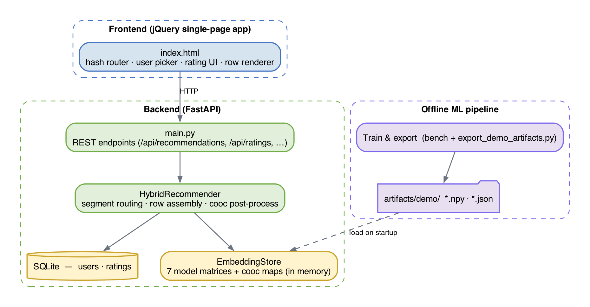
Figure 32: High-level system architecture — three-tier design with in-memory embedding store
The in-memory store holds the six model embedding matrices used by the demo — LightGCN games, LightGCN movies, EMCDR, PTUPCDR, SBERT content, and CMF — together with the forward and reverse co-occurrence maps. All scoring is performed as dot products between user and item vectors, so each of the nine rows is generated in a few milliseconds.

8.2 Recommendation Flow
When a user requests recommendations, the HybridRecommender generates nine parallel recommendation rows — five game rows (red lanes) and four movie rows (blue lanes). Each row uses a different model or model combination, directly reflecting the experimental findings from Lessons 2–8 and the routing rule from Section 6.1.
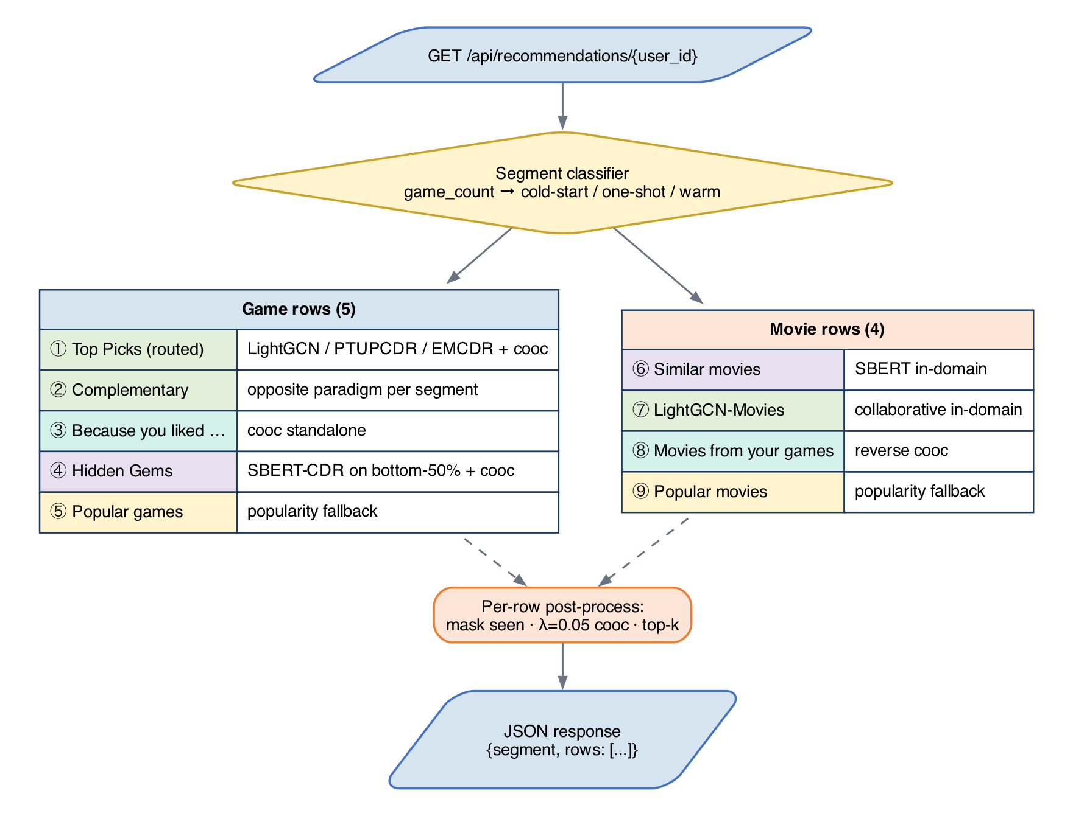
Figure 33: Recommendation flow — 9 parallel rows using different model paradigms
Each row follows the same post-processing pipeline: score all items via embedding dot product, apply co-occurrence bonus (if applicable), mask to the correct domain, normalize scores, exclude already-rated items, take top-K, deduplicate across rows, and enrich with metadata. This ensures consistent behavior while allowing each row to demonstrate a different recommendation paradigm.

8.3 Frontend Architecture
The frontend is a single-file jQuery single-page application (SPA) served as a static asset. A hash router switches between three views: a home page with user pickers grouped by segment (cold-start, one-shot, warm), a recommendations page showing the nine model rows as horizontal drag-to-scroll lanes, and an item detail page with a five-star rating widget. The visual language uses blue for movies and red for games consistently across cards, lane headers and scrollbars.
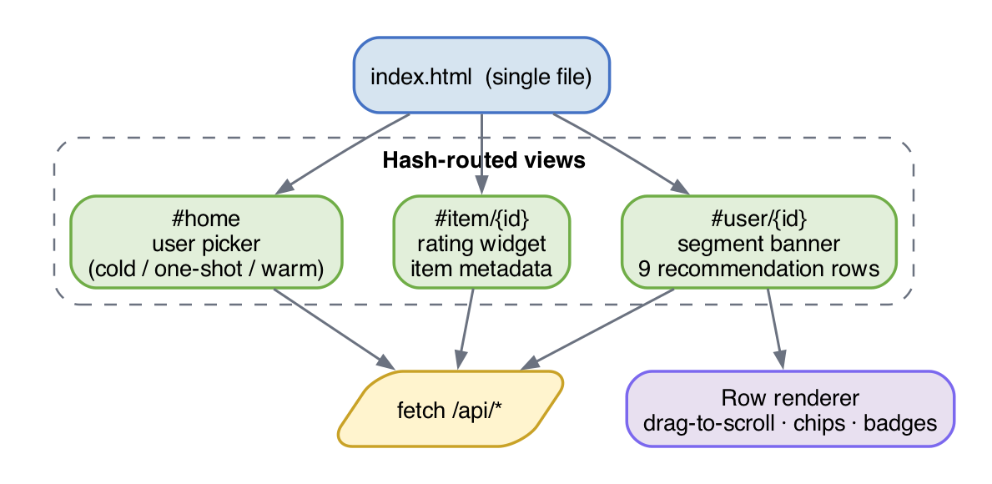
Figure 34: Frontend architecture — page structure and domain visual language

8.4 Refresh Architecture
The system exposes two effective refresh tiers. Tier 1 (instant, ~1 ms): co-occurrence, SBERT and popularity rows require no learned weights — a new rating updates the user's profile immediately through dict lookups and mean pooling, so those rows reflect the new state on the very next request. Tier 2 (fast, tens of ms): routed model rows (LightGCN, EMCDR, PTUPCDR, CMF) read pre-computed embeddings from the in-memory store and fold the user's latest ratings into the scoring step, so added ratings influence ranking without any model retraining. Periodic full retraining is handled offline by the benchmark scripts in ml/scripts/ and loaded at server startup, rather than by a live daemon — a deliberate choice discussed in Section 7.5.

8.5 Key Design Decisions
Decision | Rationale
Dual item space (SD + CD) | Single-domain models need compact game-only index; CDR models need unified movie+game index. Linked via Amazon ASIN.
In-memory embedding store | Dot product scoring is orders of magnitude faster in memory than any DB query. SQLite only for rating persistence.
Cooc as post-processing | Training-free, model-agnostic, instant refresh. Applied as score bonus to improve every model universally (Lesson 8).
Hourly LightGCN retrain | Full retrain takes ~40s. Real-time per-rating retraining is impractical. Cooc/SBERT fill the freshness gap.
9 rows (5 game + 4 movie) | Each row demonstrates a different paradigm: collaborative, CDR, content, behavioral, popularity — the full research spectrum.
User groups on home page | Different groups activate different strategies (routing rule from Lesson 6), making findings directly interactive.
This section records the non-obvious choices we made while turning the benchmark results into a working demo, and the reasoning behind each one.

jQuery SPA over Next.js
The demo is a single index.html served as a static asset, with all dynamic behaviour driven by a small amount of jQuery. The scope — four views, nine rows, one rating widget — does not justify a full Next.js build pipeline, and keeping the frontend framework-free makes it trivial to deploy behind any static file server. It also means the report's demonstration artefact is self-contained: opening index.html in a browser is enough to reproduce the UI, with no node_modules install step.

In-memory embedding store instead of a vector DB
At demo scale (roughly 15k users and 9k items per domain) the six embedding matrices and two co-occurrence maps fit comfortably in process memory and are accessed as NumPy arrays. A vector database would add operational overhead and network latency without any retrieval quality benefit at this scale. The cost is that adding a new model requires a redeploy rather than a DB migration, which is acceptable because model changes are already tied to offline retraining.

SQLite for users and ratings
User accounts and explicit ratings are persisted in a single WAL-mode SQLite file. This keeps the demo dependency graph minimal — no Postgres, no ORM migrations — while still giving us atomic upserts and persistence across restarts. Sample users loaded from benchmark artifacts and end-user-created accounts share the same schema, distinguished only by an is_sample flag.

Server-side row assembly
The nine rows are assembled on the server inside HybridRecommender.recommend_rows and returned as a single JSON payload. We deliberately avoided pushing row-level model selection to the client, because the routing rule from Section 6.1 depends on server-side state (segment classification from ratings) and because consistent cross-row deduplication and masking are easier to enforce in one place. The frontend only has to render whatever rows the server produced.

Fixed universal co-occurrence blend (λ = 0.05)
Rather than exposing co-occurrence as a user-toggle, we apply it as a silent post-processing step at a fixed λ that Lesson 8 validated across every collaborative and cross-domain model. Making it a toggle would put users in charge of a lever they cannot meaningfully evaluate, and it would invite the kind of A/B comparison that our offline lessons already answer. Popularity rows are the one exception and skip the cooc blend, because Lesson 8 showed the bonus is neutral-to-harmful there.

Offline training, online serving
All learned weights are produced offline by the benchmark scripts in ml/scripts/benchmarks/ and exported into artifacts/demo/ by export_demo_artifacts.py. The live backend only reads these artefacts; it does not call into the training code at runtime. This clean split means the demo's request latency is independent of training cost, and a stale model never blocks request handling.

8.6 Model Selection Rationale
Section 7.2 described what each of the nine recommendation rows does; this section explains why. Every row maps back to a concrete finding from the lesson series (Chapter 5) and to the Routing Decision Rule in Section 6.1. The guiding principle is that no single model is universally best — each paradigm (collaborative graph, cross-domain transfer, content-based, co-occurrence) has a regime in which it dominates, and the UI surfaces the right model for each regime rather than averaging them into one generic list.
Table 5: Nine-row demo overview — each row maps to the lesson that motivated it.
# | Row | Model | Lesson motivating it
1 | Top Picks (primary) | LightGCN / EMCDR / Popularity (routed) | L6 cold-start + L3 overlap
2 | Also Try (complementary) | PTUPCDR or SBERT-CDR | L4 sparse-target / L7 niche
3 | Movie-Fans Also Played (cooc) | Co-occurrence rerank on popularity | L8 universal rerank
4 | Hidden Gems | SBERT-CDR on bottom-50% popularity items | L7 niche subgroup
5 | Because You Liked (movies) | SBERT item-item | L1 content baseline
6 | More Like Your Movies | LightGCN-Movies | L2 in-domain backbone
7 | Games Movie-Fans Play | Reverse co-occurrence | L8 symmetric transfer
8 | Popular Games | Popularity | L6 popularity ceiling
9 | Popular Movies | Popularity | L6 same-domain safety baseline
Figure 40 below visualises the nine-row assembly, mapping each frontend row to the lesson that motivated it.
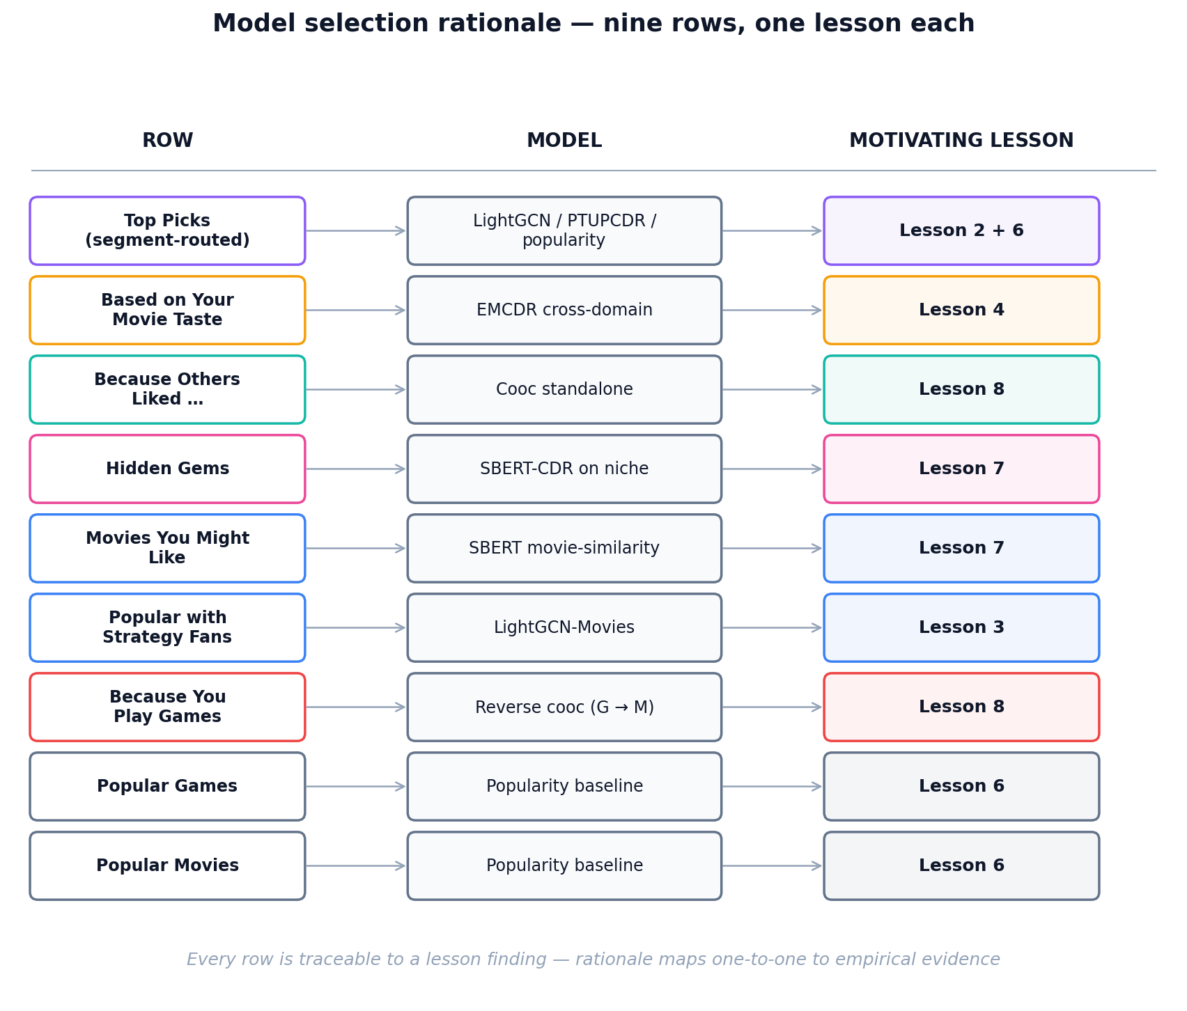
Figure 40 — Nine recommendation rows and the lesson motivating each.

Primary Row — Segment-Routed Top Picks
The first row uses a different model per user segment. This is the direct operationalisation of Lesson 6 (cold-start) and Lesson 2 (low-overlap collapse). For warm users with 3+ game ratings, we route to LightGCN: Lesson 2 showed graph convolution is the strongest single-domain ranker once enough in-domain edges exist, so we let the target-domain graph carry the recommendation. For one-shot users (1–2 games), we route to PTUPCDR: Lesson 6 showed PTUPCDR's personalized meta-network is designed precisely for the few-shot regime, where a minimal target signal can sharpen the transferred movie preference vector. For cold-start users (0 games), we route to EMCDR: Lesson 6 showed EMCDR's global MLP mapping is the most reliable pure-transfer model when no target-domain anchor exists, because it requires no game edges at inference time. All three variants are post-processed with the universal co-occurrence bonus from Lesson 8.
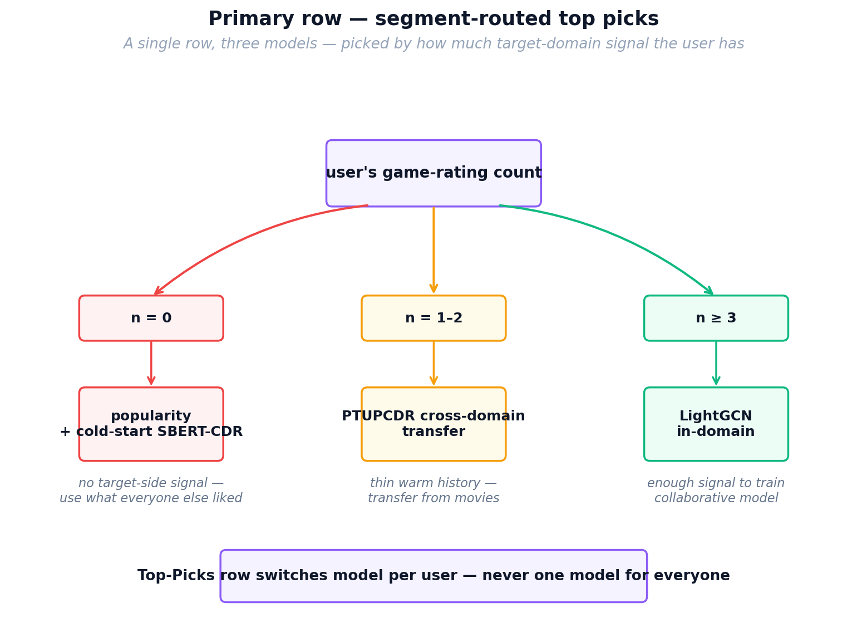
Figure 41 — Primary row routing: one row, three models, chosen per user.

Secondary Row — Complementary Paradigm
The second row intentionally shows a different modelling paradigm than the primary row so that the two lists are not near-duplicates. Warm users see an EMCDR-based "Based on Your Movie Taste" row, exposing the cross-domain signal that the LightGCN primary ignores. One-shot users see a LightGCN "Graph-Based Collaborative Picks" row as a counterweight to their PTUPCDR primary. Cold-start users have no secondary row, because with zero game ratings every collaborative model reduces to the same uninformative prior — showing a second variant would be padding rather than contrast.

Co-occurrence Standalone Row
Lesson 8 showed that co-occurrence reranking is the single most universally beneficial post-processing step across every model family (with popularity as the only exception). Beyond using it as a universal post-process, we expose it as its own row because it is the only signal that updates instantly: a new rating immediately changes which games share co-occurrence mass with the user's history, with no retraining required. This directly supports the Tier-1 "instant freshness" promise described in Section 7.4, and gives users an explainable "because you liked X" lane that does not depend on any learned embedding.

Hidden Gems — SBERT-CDR on Bottom-50% Popularity
Lesson 7 showed that SBERT-CDR wins by roughly 9× over collaborative models on niche items — those outside the head of the popularity distribution — because content similarity does not collapse the way collaborative signal does when interaction counts are small. Lesson 8 further showed that co-occurrence helps content models on non-popular tails. We therefore build the Hidden Gems row by restricting the candidate pool to the bottom 50% of games by popularity and scoring with SBERT-CDR plus the co-occurrence bonus. This is the only row where we deliberately mask the popular catalogue; putting SBERT-CDR here, rather than in the primary row, reflects the lesson finding that SBERT-CDR is niche-strong but head-weak.

Pure SBERT Movie-Similarity Row
For the in-domain movie recommendations, we use an unnormalised mean over the SBERT embeddings of the user's last five liked movies as the query. This is pure content matching within one domain and does not involve any cross-domain transfer; we keep it in the UI because it serves as a control lane — a transparent "similar to what you watched" list — against which the cross-domain rows can be compared. It is also cheap: SBERT embeddings are static, so this row inherits the same instant-refresh property as co-occurrence.

LightGCN Movies and Reverse Co-occurrence
Two of the movie rows are structural mirrors of game rows. LightGCN-Movies applies the same graph convolution model trained on the movie domain, providing a collaborative in-domain baseline symmetric to the game LightGCN row. The Reverse Co-occurrence row uses game-to-movie co-occurrence counts to surface movies that co-occur with the user's rated games — a behavioural transfer signal in the opposite direction to the main product flow. We include it to demonstrate that the co-occurrence signal from Lesson 8 is symmetric and does not require retraining a model in the reverse direction.

Popularity Baselines
The final two rows are popular-games and popular-movies lists. Lesson 6 produced a counter-intuitive finding that informs this choice: at true cold-start, popularity is a surprisingly strong baseline — it beat several cross-domain models in the zero-history regime. Keeping popularity explicitly in the UI has two purposes: it guarantees a non-empty reasonable list for brand-new users even if every other model fails, and it acts as a visible sanity baseline against which the learned-embedding rows can be qualitatively judged by the viewer.

Why Co-occurrence Is Applied Universally
Lesson 8 showed that adding a co-occurrence bonus (blend weight λ = 0.05) improved Recall@10 and NDCG@10 for every model family we tested except pure popularity, where it slightly hurt because popularity scores are already uncalibrated against item-item signal. Because the effect was consistent, we apply the same co-occurrence post-process to every collaborative and cross-domain row rather than making it a user-toggle. This is the clearest example in the UI of a lesson finding being lifted from offline evaluation into a production default.

What We Deliberately Did Not Include
Two models from the benchmark suite are not exposed as rows: MF-BPR and NCF. Lesson 2 and Lesson 6 showed that MF-BPR is strictly dominated by LightGCN on this dataset, and Lesson 1 showed that NCF offers no consistent advantage over simpler MF models on implicit ranking. CMF is also omitted because Lesson 3's hyperparameter analysis showed it requires dataset-specific tuning of the α weight to match EMCDR, and in practice EMCDR gives comparable or better transfer with a simpler single-model pipeline. These are deliberate omissions based on experimental evidence, not oversights — showing a row for a dominated model would mislead the viewer about which paradigms are actually doing the work.

9. Conclusion and Future Work
Our experiments show that cross-domain recommendation from movies to games works under specific conditions: high user overlap (≥80%), sufficient source domain history (≥10 ratings), and particularly at cold-start where users have no target-domain interactions. The optimal strategy is not a single model but a routing rule that matches the model to the user's context.
The co-occurrence reranking layer is the most practically impactful finding — it requires no training, operates at test time, and consistently improves every model. It also serves as a diagnostic tool for detecting CDR model misconfiguration.

Contributions
We make four contributions:
- 1. A reproducible, single-dataset lesson series (L1–L8) that isolates each CDR design variable — overlap ratio, source density, catalog sharpening, cold-start protocol, content bridging, co-occurrence reranking — with per-model Recall@10 and NDCG@10.
- 2. A diagnosis of why CDR appeared ineffective in our initial runs: user overlap below ~10% leaves the mapping network with no training signal; above 80% every CDR model becomes competitive with in-domain baselines.
- 3. A universal, training-free post-processing layer — movie→game co-occurrence reranking at λ = 0.05 — that improves every base model on LLO and rescues single-domain models at cold-start.
- 4. A context-aware routing rule operationalised in a full-stack demo: popularity + SBERT-CDR at n = 0 games, EMCDR/PTUPCDR at n = 1–2, LightGCN at n ≥ 3, universally reranked with co-occurrence.

Future Work
- Statistical significance: Run all experiments with 3–5 random seeds and report confidence intervals
- Additional domain pairs: Test the routing rule on other Amazon category pairs (e.g., books→movies, electronics→games)
- Online evaluation: Deploy the routing rule in an A/B test to measure real-world click-through improvements
- Hybrid model: Train a single model that combines LightGCN graph signal with SBERT content and cooc behavioral transfer
- Temporal dynamics: Investigate whether user preferences transfer differently over time (e.g., movie taste from 2020 may not predict 2024 game preferences)

10. References
[1] He, X., Liao, L., Zhang, H., Nie, L., Hu, X., & Chua, T. S. (2017). Neural collaborative filtering. WWW 2017.
[2] He, X., Deng, K., Wang, X., Li, Y., Zhang, Y., & Wang, M. (2020). LightGCN: Simplifying and powering graph convolution network for recommendation. SIGIR 2020.
[3] Singh, A. P., & Gordon, G. J. (2008). Relational learning via collective matrix factorization. KDD 2008.
[4] Man, T., Shen, H., Jin, X., & Cheng, X. (2017). Cross-domain recommendation: An embedding and mapping approach. IJCAI 2017.
[5] Zhu, Y., Tang, Z., Liu, Y., Zhuang, F., Xie, R., Zhang, X., Lin, L., & He, Q. (2022). Personalized transfer of user preferences for cross-domain recommendation. WSDM 2022.
[6] Rendle, S., Freudenthaler, C., Gantner, Z., & Schmidt-Thieme, L. (2009). BPR: Bayesian personalized ranking from implicit feedback. UAI 2009.
[7] Reimers, N., & Gurevych, I. (2019). Sentence-BERT: Sentence embeddings using Siamese BERT-networks. EMNLP 2019.
[8] Hou, Y., Li, J., He, Z., Yan, A., Chen, X., & McAuley, J. (2024). Bridging language and items for retrieval and recommendation. arXiv preprint. (Amazon Reviews 2023 dataset)
[9] Zhu, F., Wang, Y., Chen, C., Zhou, J., Li, L., & Liu, G. (2021). Cross-domain recommendation: Challenges, progress, and prospects. IJCAI 2021.
[10] Li, P., & Tuzhilin, A. (2020). DDTCDR: Deep dual transfer cross domain recommendation. WSDM 2020.
[11] Hu, G., Zhang, Y., & Yang, Q. (2018). CoNet: Collaborative cross networks for cross-domain recommendation. CIKM 2018.
[12] Liu, M., Li, J., Li, G., & Pan, P. (2020). Cross domain recommendation via bi-directional transfer graph collaborative filtering networks (BiTGCF). CIKM 2020.
[13] Kang, W.-C., & McAuley, J. (2018). Self-attentive sequential recommendation. ICDM 2018.
[14] Wang, X., He, X., Wang, M., Feng, F., & Chua, T.-S. (2019). Neural graph collaborative filtering. SIGIR 2019.
[15] Rendle, S. (2010). Factorization machines. ICDM 2010.
[16] Krichene, W., & Rendle, S. (2020). On sampled metrics for item recommendation. KDD 2020.
[17] Gao, C., et al. (2023). A survey of graph neural networks for recommender systems: Challenges, methods, and directions. TOIS.
[18] McAuley, J., & Leskovec, J. (2013). Hidden factors and hidden topics: Understanding rating dimensions with review text. RecSys 2013.

Source:
https://www.evidentlyai.com/ranking-metrics/precision-recall-at-k

Table 3: Key hyperparameters, defaults adopted in this report, and sensitivity (tuned values are from the §6 sweeps).
Model | Key hyperparameters | Default (this report) | Tuned on | Sensitivity
MF-BPR | embedding_dim, lr, neg-samples | 64 / 1e-3 / 4 | — | low
NCF | GMF dim, MLP layers, lr, dropout | 64 / [128,64,32,16] / 1e-3 / 0.2 | — | low
LightGCN | K (propagation depth), embedding_dim | K = 4, dim = 64 | L3 (Fig. 37) | medium — plateau after K ≥ 2
CMF | lr, α (source-loss weight) | lr = 1e-3, α = 0.2 | L3 (Fig. 35) | high — default α = 0.5 halved Recall@10
EMCDR | mapping-MLP layers, λ (cooc blend) | [128,64], λ = 0.05 | L3 (Fig. 36) | high on λ — peaks sharply at 0.05
PTUPCDR | n_experts, gate τ, blend w | n = 2, τ = 1.0, w = 0.5 | L3 (Fig. 38) | medium — more experts over-fit L3
SBERT-CDR | source_weight (movie share) | 0.1 on overlap, 0.5 on cold | L3 (Fig. 39) | high — monotonic on overlap cohorts
Cooc rerank | λ (blend with base score) | 0.05 | L3 (§5.8) | high past λ = 0.1 — personalisation collapses

